**Targeting Rab7 and TBC1D15 to Normalise Cellular Cholesterol Distribution in NPC1 Disease**

**Mai Khanh Linh Nguyen1**, Thomas Grewal1, Kim Seifert1, Maya Nikenich1, Dr Eric Sparkes1, A/Prof Andrew J Hoy2, Dr Ann Na Cho3, Prof Dai Hibbs1, Dr Jonathan Du1, A/Prof Thomas Grewal1

1School of Pharmacy, Faculty of Medicine and Health, University of Sydney1, Sydney, NSW Australia.2School of Medical Sciences, Faculty of Medicine and Health, The University of Sydney

3School of Biomedical Engineering, Faculty of Engineering, The University of Sydney

**Background and aims.** Niemann-Pick type C1 (NPC1) is a lethal neurological disease characterised by cholesterol accumulation in late endosomes/lysosomes (LE/Lys), caused by mutations in the NPC1 gene encoding a cholesterol transporter. Activation of alternative cholesterol transporters in LE/Lys could overcome NPC1 deficiency. We previously demonstrated that loss of the scaffold protein annexin A6 (AnxA6), which recruits the Rab7-GTPase activating protein TBC1D15 to LE/Lys, elevated Rab7-GTP levels and stimulated cholesterol transfer via the transporter StARD3 to the endoplasmic reticulum for storage as cholesteryl ester in lipid droplets (1). We hypothesised that the pharmacological development of small molecules that increase endogenous Rab7-GTP levels could overcome cholesterol transport defects in NPC1 deficiency.

**Methods.** Using molecular modelling and virtual ligand-based in silico screening of compound libraries, we identified a panel of small molecules that interact with the Rab7/TBC1D15 interface with the potential to compromise their assembly and thereby increase Rab7-GTP levels. Candidate compounds were tested in various cell types, including Chinese Hamster Ovaries cells, NPC1 patient fibroblasts, human neuroblastoma cells, and human brain organoids. Western blotting, pulldown assays, and immunofluorescence microscopy were used to assess Rab7-GTP levels and cholesterol accumulation.

**Results.** Several compounds significantly reduced cholesterol accumulation in NPC1 mutant cells, as determined by fluorescence microscopy. Pulldown assays showed that these compounds increased Rab7-GTP levels and disrupted Rab7-GTP/TBC1D15 complex formation. Notably, they also normalised autophagy and mTORC1 signaling in NPC1 mutant cells, evidenced by reduced levels of autophagy markers p62 and LC3-II, and decreased phosphorylation of mTORC1 effectors p70-S6 kinase and 4-EBP1/2.

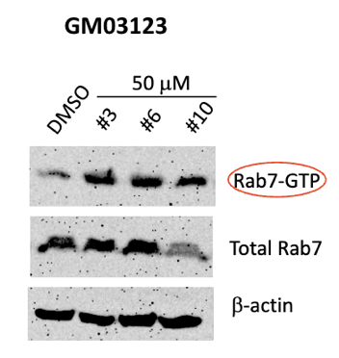

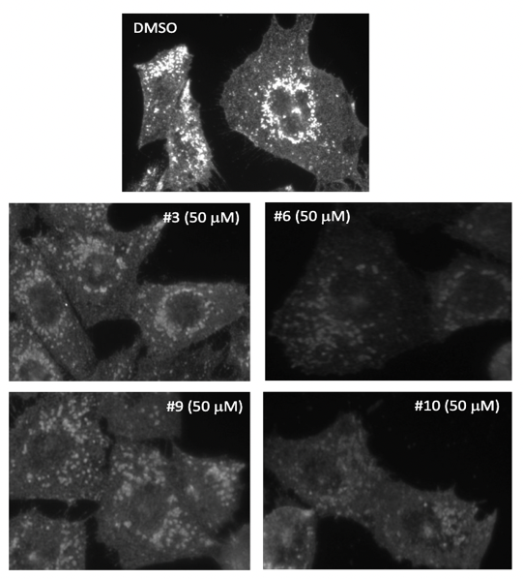

**Figure 1.** Drug candidates #3, 6, 9, 10 reduced cholesterol accumulation (GST-PFO staining intensity) in Chinese Hamster Ovary NPC1 mutant (CHO M12) cells. **Figure 2.** Drug candidates #3, 6, 10 elevated Rab7-GTP levels in NPC1 patient fibroblasts​.

**Conclusion/Discussion.** These findings identify small molecules that enhance Rab7-GTP activity as promising lead compounds to restore cholesterol homeostasis in NPC1 mutant cells. Targeting TBC1D15 and Rab7 offers a novel therapeutic strategy for NPC1 and potentially other neurological disorders involving dysregulated Rab7-GTP hydrolysis, such as Parkinson’s disease and Charcot-Marie-Tooth type 2B.

**References:** (1) Meneses-Salas, E. et al (2020) Cell Mol Life Sci 77(14):2839-2857