TIR8 modulates IgE dependent activation of mast cells and allergic inflammation
Prince Ofori¹, Mansour Seaf¹, Cecilia Garlanda², Alberto Mantovani², Francesca Levi-Schaffer¹. 1. School of Pharmacy, the Hebrew University of Jerusalem, Jerusalem¹, Israel. 2. IRCCS Humanitas Clinical and Research Center², via Manzoni 56, 20089 Rozzano Milan, Italy.
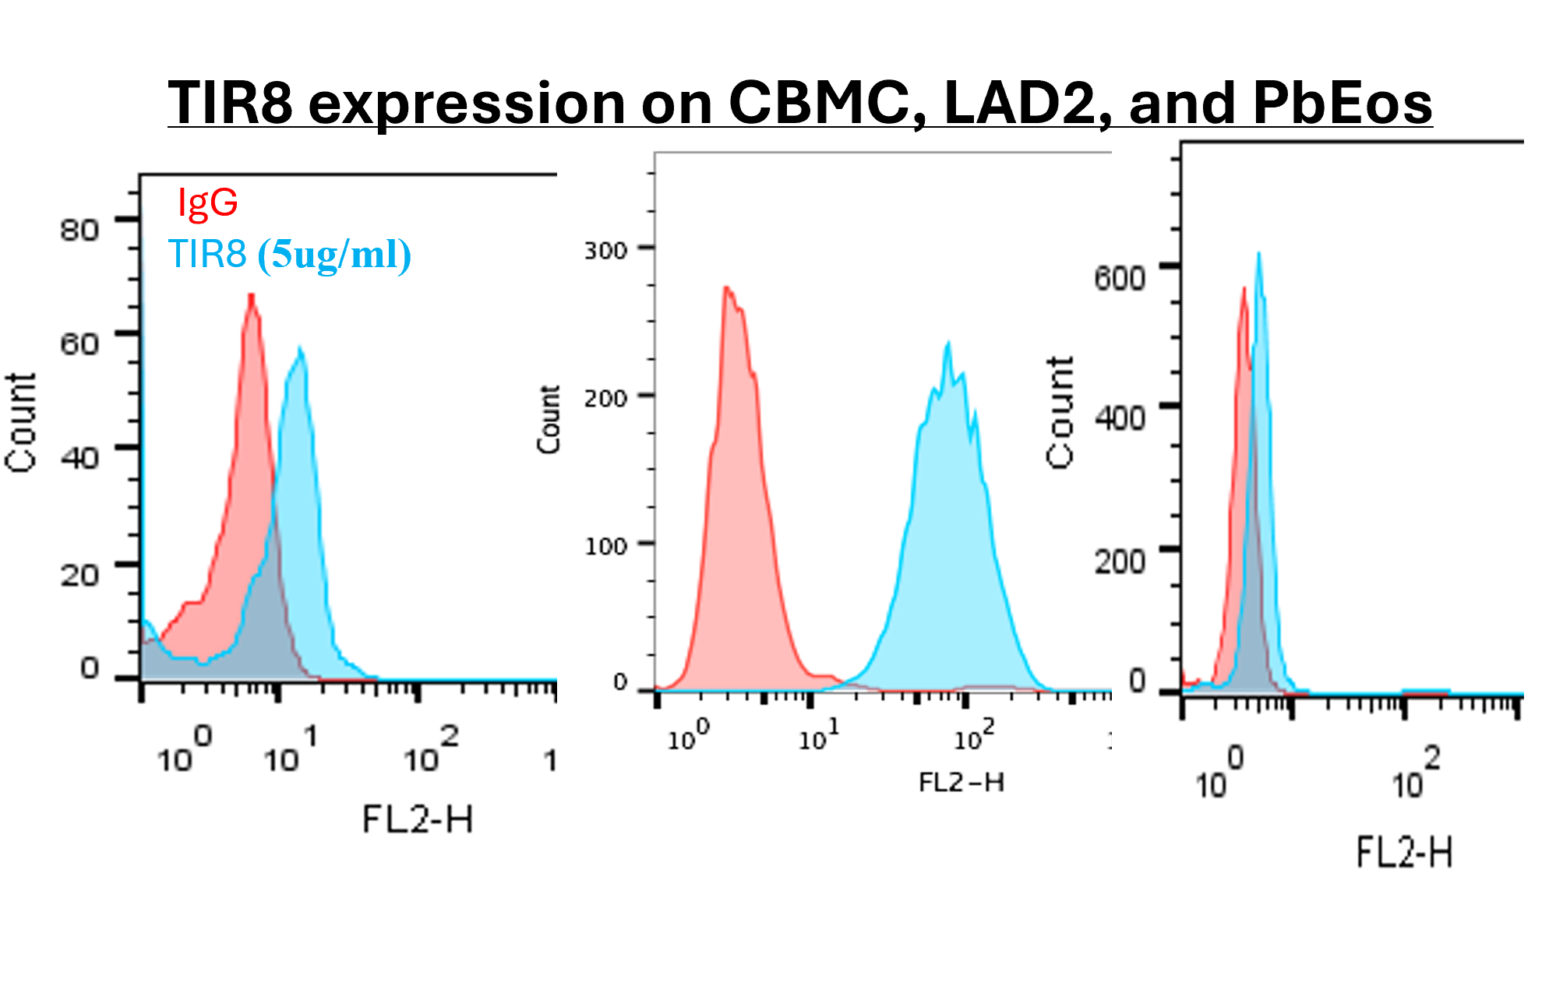
Introduction: Mast cells (MCs) and Eosinophils (Eos) are key crucial players in allergic inflammation. While the inhibitory receptor IL-1R8 (TIR8) is known to suppress inflammation in various cells via toll-like receptors [1], its role in MCs and Eos and in allergic diseases has been unexplored.
Aim: We aimed to investigate the expression and function of TIR8 on human MCs and Eos and its role in a mouse model of allergic inflammation.
Methods: mRNA levels and protein expressions of TIR8 in human MCs (Cord blood MCs (CBMCs) and LAD2 cell line) and in human peripheral blood Eos were assessed by RT-PCR and flow cytometry. The inhibitory function of TIR8 on anti-IgE/LPS/papain dependent activation of MCs or Eos respectively was assessed by ELISA and enzymatic assays. TIR8-KO mice were employed to study its role in anti-IgE induced allergic peritonitis (AP).
Results: Our study shows that TIR8 is highly expressed in human MCs and to lesser extent in Eos. When TIR8 was blocked on CBMCs, it led to a significant (p<0.05) increase of tryptase and TNF-α release upon IgE, LPS or papain induced MCs activation. However, this effect was not detected on Eos where blocking of TIR8 did not alter IL-8 release. These data were confirmed in an AP mice model where TIR8-KO exhibited more inflammation with increased tryptase, TNF-α release and higher numbers of infiltrating cells (especially MCs, B cells, macrophages, and Eos). These results collectively indicate that TIR8 might serves an inhibitory role.
Discussion: This study establishes TIR8 as a novel inhibitory receptor on MCs and Eos that is a crucial negative regulator of allergic inflammation. This suggest that TIR8-mediated regulation of MCs or Eos could serve as a potential therapeutic target for inflammatory and allergic diseases.

[1] D. Supino, R. Garuti, and C. Garlanda, “Beyond Negative Regulation: IL-1R8 and IL-1R2 as Novel Immune Checkpoints,” Eur J Immunol, vol. 55, no. 9, Sep. 2025, doi: 10.1002/EJI.70050.

