Efficacy Quantitative Evaluation of Targeted Pulmonary Hypertension Drugs based on MBMA
Aixin SHI, Zhixing CHEN, Panpan XIE, Clinical Trial Center, Beijing Hospital, National Center of Gerontology; Institute of Geriatric Medicine, Chinese Academy of Medical Science, Beijing, PRC

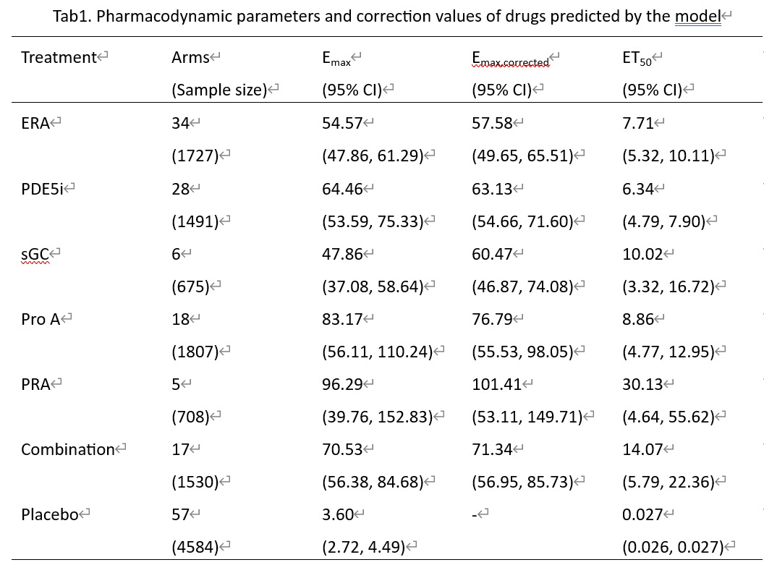
Introduction. The Model-based meta-analysis (MBMA) method has many advantages and can be used for quantitative evaluation of drug efficacy and provide basis for clinical drug use.
Aims. In this study, we will utilize the MBMA method to establish a pharmacodynamic model for the targeted Pulmonary Hypertension (PH) drugs, and evaluate the efficacy of drugs quantitatively and obtain the time-effect relationship for providing guidance for clinical drug use.
Methods. The change in 6-minute walk distance (6MWD) from baseline was utilized as the efficacy index. Based on the nonlinear mixed-effect model, a pharmacodynamic model was developed to describe the time-effect relationship of drugs in PH patients, respectively. The stepwise covariate model was utilized to screen covariates and determine influencing factors on drug efficacy.
Results. A total of 108 trials comprising 7938 participants were included in the analysis. Five classes of targeted drugs were evaluated including endothelin receptor agonists(ERA), phosphodiesterase type V inhibitors(PDE5i), soluble guanylate cyclase stimulators(sGC), prostacyclin analogues(Pro A) and prostacyclin receptor agonists(PRA). The findings revealed that the drug efficacy was Pro A > PRA > PDE5i > drug combination > ERA > sGC. E_{max} (Maximum drug effect) value of Pro A was 101.41 meters (95% CI: 53.11, 149.71), higher than other drugs significantly. PDE5i had the shortest onset time with 6.34 weeks compared to other drugs.
Discussion. This study utilized MBMA method to evaluate the efficacy and influencing factors of targeted PH drugs quantitatively. The results of this study show the difference in the efficacy of these 6 types of targeted drug therapy for PH, and provide important quantitative information for the clinical application of targeted therapy for PH.

