3D printed tablets for personalised doses of prednisone using selective laser sintering
Zheng Zheng¹, Liam Krueger¹, Angus C. F. Harrop¹, Benjamin P. Ross¹, Amirali Popat¹, Jared A. Miles¹*. School of Pharmacy, The University of Queensland¹, Woolloongabba, QLD 4102, Australia.

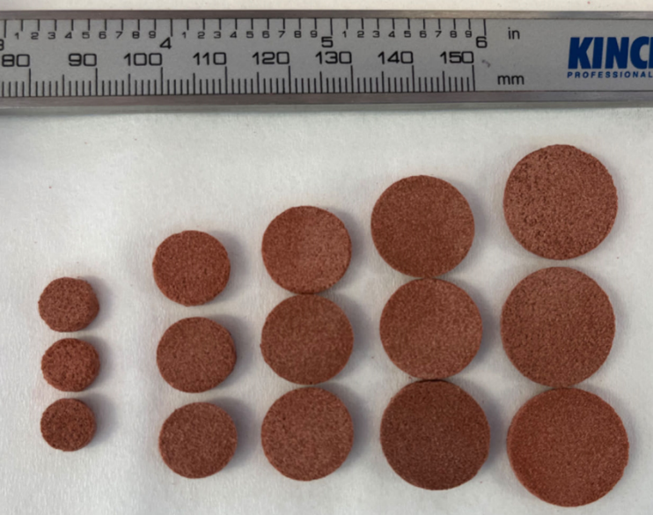
Introduction. The recent emergence of three-dimensional (3D) printing in pharmaceutical development has enabled a shift away from standardised medication dosing and towards more precise and personalised medicines and treatments. However, few studies have demonstrated the translational ability of these developments using therapeutic doses of clinically relevant drugs.
Aims. Utilising the steroidal drug prednisone, this study aims to demonstrate the capability of selective laser sintering (SLS) 3D printing to produce custom tablets of various clinically relevant doses with high accuracy.
Methods. A Sintratec Kit SLS 3D Printer was used for powder feedstock printing. Formulation stability, printed tablets’ morphology, content uniformity, disintegration and dissolution were tested.
Results. Across the five distinct dosage groups ranging between 5 and 25 mg, the formulation and 3D printing process produced highly accurate and uniform tablets, with less than 6% deviation in weight and less than 4% variation in prednisone content. The SLS printed tablets had a release rate comparable to the commercially available prednisone tablets, with both achieving 100% release within 25 minutes. The formulation also proved to be highly stable throughout SLS 3D printing, confirmed with HPLC, Fourier-transform infrared spectroscopy, differential scanning calorimetry, and thermogravimetric analysis.
Discussion. Utilising a single feedstock formulation for all tablet doses showed that it is feasible to produce customised prednisone tablets by changing the size of the 3D model in silico. This proof-of-concept study demonstrated the capability of SLS 3D printing to create therapeutic doses of clinically relevant medications, showing the viability of translation to clinical practice for the provision of personalised medications.

