**Engineering Novel Xerogels for Colon Targeting: Determination of Strain Sweeps**

**Partha Sarathi Roy1**

Department of Pharmaceutical Chemistry, School of Pharmacy Sister Nivedita University1, Kolkata, West Bengal, India

**Background and aims.** In order to explore new options for colon targeting, this study designs new polyelectrolyte complex (PEC) coacervate xerogels of chitosan (Ch) with *Albizia procera* (AP). Rheological characterizations experiments were carried out for the pH independent coacervates and 1:5 coacervate was found to be having the highest G/ value in the strain sweep experiment. In the frequency sweep experiments the coacervate (1:5) with the highest storage modulus (G/) values was produced at pH 4.5.

**Methods.** Using cone plate geometry on a peltier plate, rheological tests of the coacervates were conducted using an Anton Paar rheometer. Cone dimensions were 40 mm in diameter, 40 00/ 22// in cone angle, and 121 μm in truncation. At 25 °C, the trials were conducted. We encased the sample chamber inside a box with a single hole for the sample cell axis and continuously supplied nitrogen gas flow into the box since it was challenging to enclose the entire rheometer in a glovebox in an inert atmosphere. There were two different kinds of studies carried out: a % strain sweep and a frequency sweep. To identify the linear viscoelastic zone, the amplitude strain sweeps (0.1−100%) were examined at an angular frequency (ω) of 10 rad s−1. When the value of G/ or G// did not change for at least three consecutive experimental points as the strain percent increased, the region was deemed linear viscoelastic on the modulus−strain percent plots. The nonlinear viscoelastic region was thought to have begun at the linear viscoelastic region's final experimental point. It was determined that the modulus- strain percent curve's steepest downward inflection point began to characterize the nonviscoelastic zone the best. The frequency sweep studies were conducted within an expanded 0.1−100 rad s−1 angular frequency (ω) domain. The equipment software yielded the storage modulus (G/) and the loss modulus (G//) in every scenario. The experimental data was plotted using Origin Scientific Graphing and Analysis Software version 8.5 (OriginLab Corp., Northampton, MA, USA) to create plots of G/ − strain %, G// −strain %, G/ −ω, and G// −ω.

**Results.** In order to ascertain the linear viscoelastic range of the pH-independent Ch−AP PEC coacervates, strain sweeps were conducted for 1:4, 1:5, and 1:6 systems at an angular frequency (ω) of 10 rad s−1. The linear viscoelastic area was found in all of the systems up to a maximum strain percent of 10, according to the G′ data (Figure 1a-c). A linear zone with a constant value of G/ at low strain % and a strong downward inflection in G/ at larger strains are characteristics of the PECs. The movement of the inflection point indicates the amount of stress that the PEC can bear before breaking, which may indicate the PEC body dissolution. Additionally, depending on the structure network inside the systems, bonds break and reformat at various rates when strains surpass that of the linear viscoelastic zone, resulting in a variation in G/ values. The critical strain (% γ) values for pH 1:5, 1:6, and 1:4 systems are 13.86, 8.0, and 7.52, respectively, determined by finding the junction of the two linear sections of the G/ vs. % strain plot. The linear viscoelastic region's storage modulus (G/) magnitudes exhibit a falling order of 1:5 (986 Pa) > 1:6 (780 Pa) > 1:4 (676 Pa). Given that G/ and critical strain have the same sequence, it can be deduced that the 1:5 system has the maximum mechanical strength, the 1:4 system the lowest, and the 1:6 system the intermediate strength. Its increased mechanical strength is clearly explained by the maximum degree of contact between the biopolymers in the 1:5 system. Figure 1 presents a comparison of the pH independent coacervates' loss modulus (G//) vs strain behavior. The curves exhibit comparable patterns and forms to the G//−strain percent curves. In the linear viscoelastic area, the loss modulus values were 1:5 (265 Pa) > 1:6 (154 Pa) > 1:4 (32 Pa), arranged in descending order. It was evident that the value of G/ was much bigger than G// at a given strain percent in the linear viscoelastic zone, suggesting a dominantly elastic nature for the PEC [3-6].

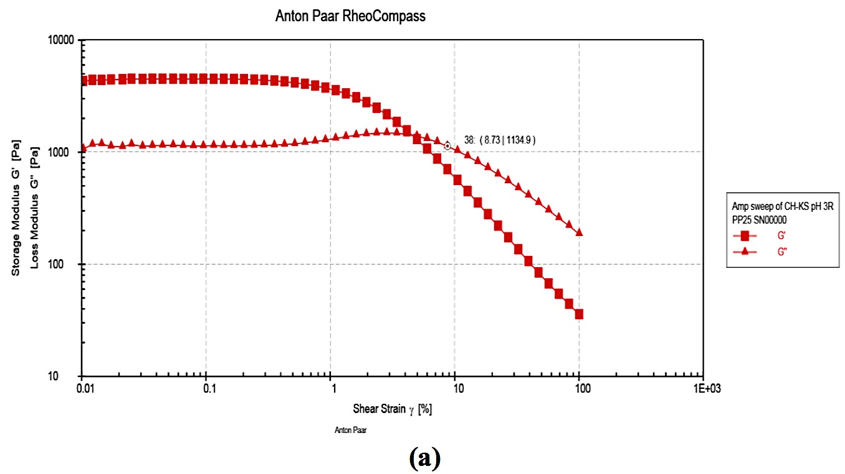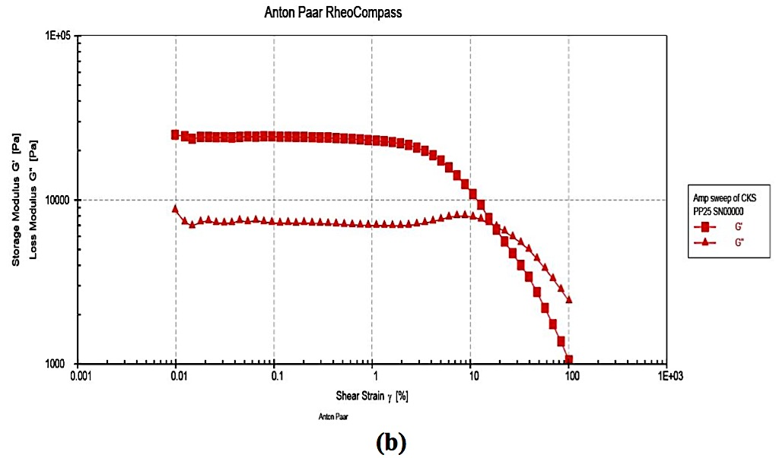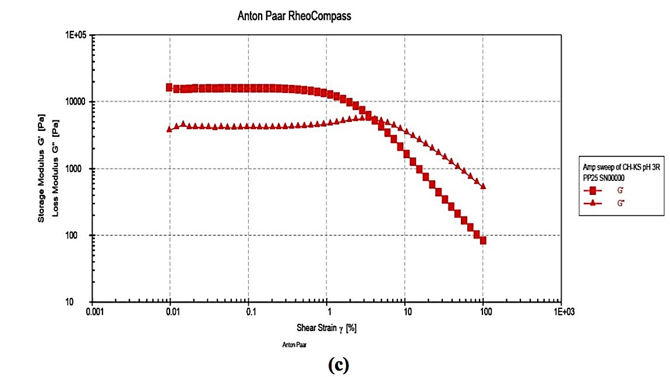

**Figure 1.** pH-independent Ch−AP Variation [1:4 (4.6 ± 0.0), 1:5 (4.2 ± 0.1), and 1:6 (3.6 ± 0.0)] were the original pH values. As a function of strain percentage, PEC exacerbates the following rheological properties: (a) storage modulus G/ and loss modulus G// for 1:6 system; (b) G/ and G// for 1:5 system; (c) G/ and G// for 1:4 system.

**Conclusion/Discussion.** The electrostatic complex coacervates of chitosan with *Albizia procera* that we prepared in our experiments are promising as potential materials for colon targeting. The greatest findings of elastic mechanical strength were found for a 1:5 complex coacervate system, according to the pH-independent strain sweep curves.

**References:**

[1] Bungenberg de Jong. et al (1929) Proc. Koninkl. Med. Akad. Wetenschap32: 849−856.

[2] Sanchez, C. et al (2002) Langmuir18:10323−10333.

[3] Wang, Q. et al (2010) Nature463:339−343.

[4] Tiitu, M. et al (2002) Macromolecules35: 5212−5217.

[5] Nijenhuis, K. (1997) Adv. Polym. Sci.130: 1−267.

[6] Burchard, W. et al (1990)Elsevier Applied Science: London, UK, 1990.