Bacteriophage Conjugates to Overcome Antimicrobial Resistance
Huiping Huang¹, Jonathan Iredell^{2,3,4} and Hien T.T. Duong¹
School of Pharmacy, Faculty of Medicine and Health, the University of Sydney¹, Sydney, NSW, Australia
School of Medical Sciences, Faculty of Medicine and Health, the University of Sydney², Sydney, NSW, Australia
Centre for Infectious Diseases and Microbiology, Westmead Institute for Medical Research³, Sydney, NSW, Australia
Westmead Hospital, Western Sydney Local Health District⁴, Sydney, NSW, Australia

Background and aims. The rise in antimicrobial resistance and biofilm-related infection, along with a decline in the development of new medicines, has necessitated the exploration of alternative strategies to tackle these challenges (1,2). Currently, bacteriophages (phages), viruses capable of infecting and killing bacteria, have emerged as a viable alternative to antibiotics for combating bacterial infections (3,4).

Methods. In this study, a phage-based conjugate was introduced, comprising phages, antibiotics, and ethylenediaminetetraacetic acid (EDTA) as a biofilm-dispersing agent. Pseudomonas phages were conjugated with therapeutic payloads, and the resulting phage conjugates were employed as phage nanobots. This innovative approach allows for the targeted delivery of small drug quantities to specific sites, ensuring local concentration while avoiding systemic toxicity at off-target sites. The formulation involved a diblock copolymer linker, poly(oligo(ethylene glycol) methyl ether acrylate)-block-poly(3-vinylbenzaldehyde) (POEGA-b-PVBA). The first block, a PEG-like polymer, contributes significantly to colloidal stability, while the second block, PVBA, facilitates the reversible attachment of therapeutic agents. This pH-labile linkage is hydrolysable in mildly acidic conditions, common in biofilm environments. Poly(2-(dimethylamino)ethyl acrylate) (PDMAEA) was also incorporated as a linker in the formulation to attach EDTA to the phages.

Results. The attachment of antibiotics and EDTA onto the phages demonstrated enhanced dispersal of biofilms into planktonic bacteria, which are susceptible to antimicrobial agents. These phage-conjugated formulations exhibited a notable antibiofilm effect on P. aeruginosa biofilms, leading to a significant 3-log reduction in the viability of P. aeruginosa biofilm bacteria.

Conclusion/Discussion. The application of phage-conjugated formulations in infection disease is expected to be greater in effectiveness due to localised sites of action, where phage target specificity and the regulated release of drugs for therapy are of heightened an importance.

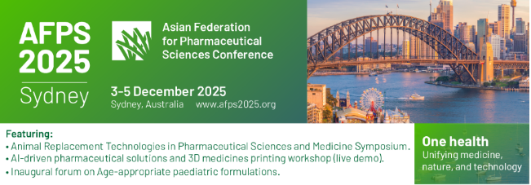

References:
(1) D’Costa, V.M., et al., Antibiotic resistance is ancient. Nature, 2011. 477(7365): p. 457-461.
(2) Høiby, N., et al., The clinical impact of bacterial biofilms. International journal of oral science, 2011. 3(2): p. 55-65.
(3) Abedon, S.T. and C. Thomas-Abedon, Phage therapy pharmacology. Current pharmaceutical biotechnology, 2010. 11(1): p. 28-47.
(4) Górski, A., et al., Phage therapy: combating infections with potential for evolving from merely a treatment for complications to targeting diseases. Frontiers in microbiology, 2016. 7: p. 1515.

