REporting and Methodological Recommendations for Observational Studies Estimating the effects of Deprescribing medications: the International Society for Pharmacoepidemiology-endorsed REMROSE-D Guidance
Kaley Hayes¹. Dept. Health Services, Policy, and Practice, Brown University¹, Providence, RI, US.

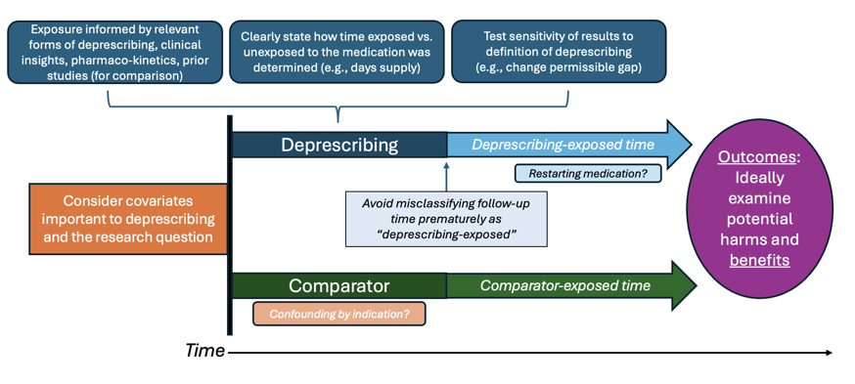
Introduction. The lack of evidence on the effects of withdrawing medications in generalizable populations is a barrier to deprescribing in clinical practice. Pharmacoepidemiologic studies can begin to address these knowledge gaps, but they are subject to reporting gaps and many methodological issues than can induce bias.
Aims. To develop expert consensus recommendations for the methods and reporting of observational studies that aim to examine the effects of deprescribing.
Methods. We formed candidate recommendations based on our prior systematic review that methodological appraised of observational studies on deprescribing. We then conducted a two-round modified Delphi process with international experts in deprescribing pharmacoepidemiology to refine, select, and reach consensus on recommendations for a checklist based on >70% agreement of their importance.
Results. Twenty-three candidate recommendations were presented to the Delphi panel. After multiple rounds of expert survey, the REMROSE-D (REporting and Methodological Recommendations for Observational Studies estimating the Effects of Deprescribing medications) guidance contains 23 recommendations for the methods and reporting of observational research on deprescribing.
Discussion. To ensure rigor and reproducibility in observational studies of the effects of deprescribing, the REMROSE-D guidance provides recommendations for important reporting and methods considerations, including time zero, precise definitions of deprescribing, addressing confounding by indication, and careful consideration of follow-up to avoid immortal time bias.

