LC-MSMS bioanalytical method for PBT2 and doxycycline quantification in mouse plasma microsamples
Viet T. Pham¹, Suzanne Parker², Steven C. Wallis², Helen Won², Mark J. Walker³, Maree T. Smith¹. School of Biomedical Sciences, The Univ of Queensland¹, Brisbane, QLD; Univ of Queensland Centre for Clinical Research, The Univ of Queensland Brisbane², QLD; Institute for Molecular Bioscience, The Univ of Queensland³, Brisbane, QLD.
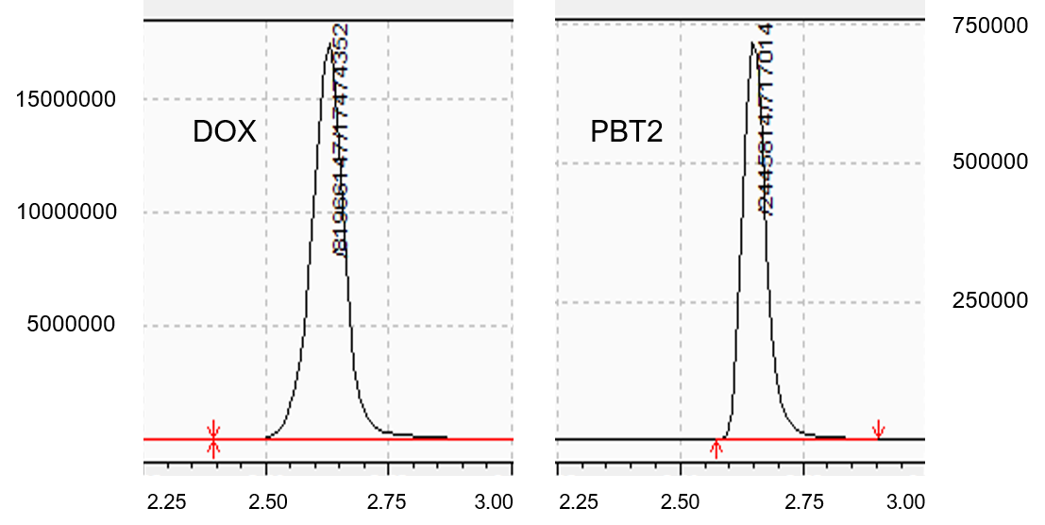
Introduction. PBT2 in combination with doxycycline (DOX) is a potential antimicrobial therapy for treating drug resistant bacterial infections. Bioanalytical methodology to simultaneously quantify PBT2 and DOX concentrations in mouse plasma samples is required to support pharmacokinetic (PK) and in vivo PK/pharmacodynamic (PD) studies.
Aims. To develop and optimise an LC-MSMS bioanalytical method for quantification of PBT2 and DOX concentrations in small volumes of mouse plasma, suitable for a murine PK study using a serial sampling approach.
Methods. The plasma sample volume analysed was 5 µL. Doxycycline-[²H₃] was used as the internal standard. The mobile phase was a gradient of 0.1% formic acid in water (A) and 0.1% formic acid in acetonitrile (B) run from 10% to 90% (as %B) across a runtime of 3.5 min. Six different stationary phases were tested for optimal retention of analytes. Quantification was performed using a Shimadzu UHPLC-MSMS 8050 with electrospray ionization, using multiple reaction monitoring (MRM) at 445.0>>428.2 for DOX, 448>>431.2 for DOX-[²H₃], and 272.75>>156.00 for PBT2.
Results. Significant peak tailing and fronting were observed for DOX with most columns tested. This issue was resolved using an InfinityLab PoroShell 120 CS-C18 to minimize the silanol effect, delivering satisfactory peak shapes for both DOX and PBT2. The method provided linear calibration lines for the concentration ranges of 2-2000 ng/mL for PBT2 (r² = 0.9943) and 25-10000 ng/mL for doxycycline (r² = 0.9978). The accuracy of all calibration standards for PBT2 and DOX was within 15%. From preliminary matrix tests performed, EDTA plasma demonstrated a matrix enhancement effect while heparinised plasma exerted a matrix suppression effect for both DOX and PBT2, but both were offset by equivalent changes to the internal standard.
Discussion. This LC-MSMS bioanalytical method is suitable to quantify PBT2 and doxycycline concentrations in mouse plasma microsamples, thereby enabling PK and PK/PD studies for this drug combination. This methodology will support serial blood sampling in mice and so reduce numbers of mice used to develop well-defined PK profiles.

