**The Interaction of CPP-functionalized Nanoparticles with Biomolecules of the Gut Corona**

**Arlene McDowell1**, Olivia Zschau1,2, Carrie A. Dator1, Ben J. Boyd3.

School of Pharmacy, University of Otago**1**, Dunedin, New Zealand;

Pharmaceutical Technology and Biopharmacy, Kiel University2, Kiel, Germany;

Drug Delivery Disposition and Dynamics, Monash Institute of Pharmaceutical Sciences, Monash University3, Melbourne, Victoria, Australia

**Background and aims.** Functionalization of nanoparticles with cell-penetrating peptides (CPPs) enhances cell uptake. We have designed a novel branched CPP (bTAT) that has higher degree of cell interaction compared to other CPP constructs (1). Following oral delivery, the interaction of nanoparticles with the complex biological fluids prior to absorption is not well understood (2). To exploit nano delivery systems, it is important to understand the interplay between nanoparticles and this biointerface.

Our aim is to investigate how biomolecules influence the characteristics of nanoparticles modified with our novel CPP construct, branched TAT.

**Methods.** We synthesized poly(lactic-*co*-glycolic) acid (PLGA) nanoparticles using the technique of microfluidics. Nanoparticles were functionalized by adding bTAT to the surface of the nanoparticle using EDC/NHS chemistry in a post-microfluidics conjugation step. Nanoparticles were incubated with different concentrations of biomolecules and changes to surface characteristics monitored.

**Results.** Upon incubation of CPP-functionalized PLGA nanoparticles (average size 213 nm ± 21 nm) with bile salts, the zeta potential followed a Langmuir isotherm model, suggesting the formation of a single layer of sodium taurocholate around the negatively charged PLGA-nanoparticle, reaching an equilibrium concentration at approximately 2.0 mM (Figure 1). Bile salts had a greater association with novel branched CPP-tagged nanoparticles compared to plain nanoparticles. Conversely, ee did not observe a difference in the adsorption of the model protein lysozyme between functionalized and plain nanoparticles.

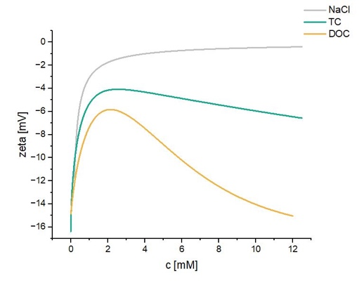

(b)

(a)

**Figure 1. (a)** Change in zeta potential of PLGA nanoparticles as a function of bile salt concentration.TC = taurocholate (green). DOC = deoxycholate (orange). **(b)** Possible interaction mechanism between PLGA nanoparticles and bile salts. Blue dashed lines symbolize electrostatic and red lines symbolize hydrophobic attraction.

**Discussion.** Interaction of nanomedicines with gut biomolecules changes the identity of the nanoparticles and can influence subsequent nano-bio interactions. Information about surface characteristics can guide the rational design of nanomedicines for oral delivery.

**References:**

(1) Streck, S. et al. (2021) ACS Applied Bio Materials 4: 3155

(2) Kihara, S. et al. (2025) Journal of Colloid and Interface Science 680: 797