**STUDY ON THE ANTIMICROBIAL ACTIVITY AND TYROSINASE INHIBITORY EFFECT OF *COSTUS PICTUS* RESIDUE TREATED WITH *LACTOBACILLUS PLANTARUM***

Kim Nguyen-Hoang-Thien1, Oanh Lam-Boi1, Nhu Nguyen-Thi-Quynh1, Nhung Pham-Thi-Tuyet1, Tuyen Vo-Thi-Thanh1, Ngan Nguyen-Thanh1, Dung Pham-Thi-Ngoc2, Thai Nguyen-Minh2*, Linh Đinh- Thị- Lan1, Lan Le- Thi- Thanh1, Nhi Nguyen-Thanh-To1

1Faculty of Pharmacy, Nguyen Tat Thanh University, Ho Chi Minh City, Vietnam.

2School of Pharmacy, University of Medicine and Pharmacy at Ho Chi Minh City1, Ho Chi Minh City, Vietnam.

*Corresponding author. Email: minhthai2511@ump.edu.vn

**Background and aim: The development of natural-origin pharmaceuticals and cosmetics is gaining interest due to their efficacy and safety. In this context, the reutilization of medicinal plant residues not only enhances bioactive potential but also contributes to solving environmental issues. Among these plants, *Costus pictus* is commonly used in Vietnamese traditional medicine, and its post-extraction residue is considered rich in valuable biological properties. Therefore, this residue can be further exploited through microbial fermentation. Notably, *Lactobacillus plantarum (L.plantarum)*, a widely applied probiotic in food biotechnology, has demonstrated robust growth on herbal residues without the need for added substrates, making it a promising candidate for the bioconversion of plant waste into bioactive compounds.**

**Materials and methods:** The 96% ethanol extract of the initial Costus pictus residue, after treatment with L.plantarum under different residue-to-medium ratios, followed by enzymatic hydrolysis and subsequent fermentation with L. plantarum, was screened for antimicrobial activity against *Methicillin-resistant* Staphylococcus aureus (MRSA), *Methicillin-susceptible* S. aureus (MSSA), Pseudomonas aeruginosa, Streptococcus pyogenes, and Candida albicans using the agar well diffusion and broth microdilution methods. Additionally, tyrosinase inhibitory activity was evaluated via its reaction with L-DOPA (3,4-dihydroxy-L-phenylalanine), and the IC₅₀ value (the concentration required to inhibit 50% of tyrosinase activity) was determined.

**Results:** The extract obtained from Costus pictusresidue after fermentation with L.plantarum, under optimal conditions (residue-to-MRS medium ratio of 1:0.5 and enzymatic treatment with cellulase and pectinase for 6 hours), demonstrated antimicrobial activity against all tested microorganisms with a MIC ≤ 5 mg/mL. Additionally, the extract showed potent tyrosinase inhibitory activity with an IC₅₀ value of 0.182 mg/mL.

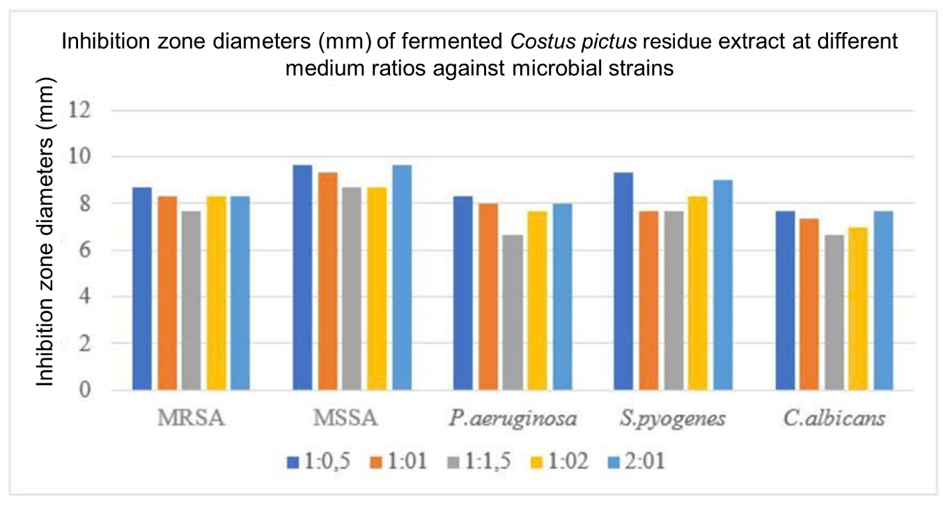

Fig 1. Inhibition zone diameter of fermented *Costus pictus* residue extract at different medium ratios against microbial strains (mm)

Table 1. Antimicrobial activity of the extract from herbal residue before fermentation

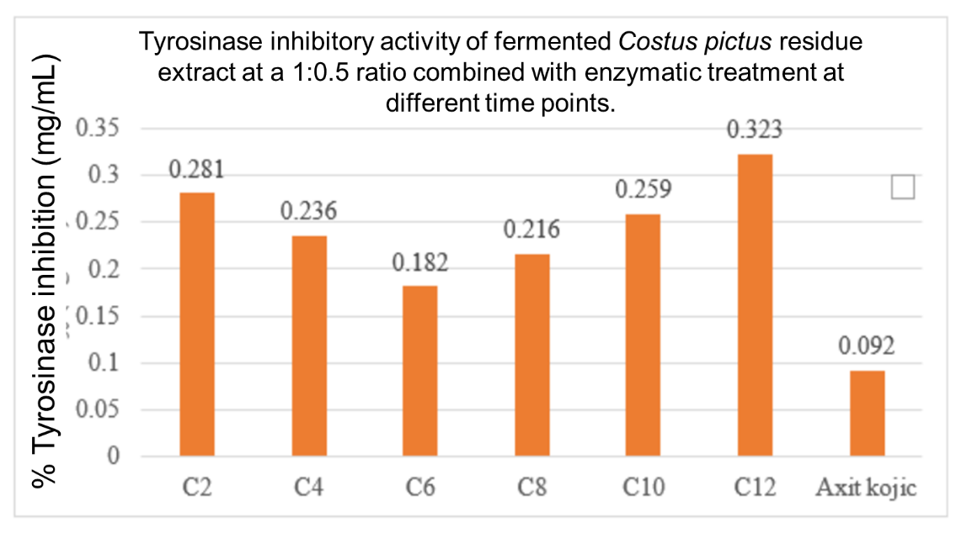

Fig 2. Tyrosinase inhibitory activity of fermented *Costus pictus* residue extract at a 1:0.5 ratio combined with enzymatic treatment at different time points.

Table 2. Tyrosinase inhibitory activity of the extract from herbal residue before fermentation

|  |  |  |
| --- | --- | --- |
| **Extract** | **Con. (mg/mL)** | **% tyrosinase inhibition BF (%)** |
| *Costus pictus* | 0.5 | 78.04 ± 1.08 |
| Axit kojic | 0.2 | 87.52 ± 0.62 |

**Conclusion:** The 96% ethanol extract of *Costus pictus* residue treated with *L. plantarum* shows a strong antimicrobial and tyrosinase inhibitory effects. The IC50 of Costus pictus residue extract at the 6-hour time point was 0.182 mg/mL, the lowest value observed, indicating the highest tyrosinase inhibitory activity.

Keywords: Costus pictus, static solid fermentation, Lactobacillus plantarum, antibacterial, antifungal, tyrosinase inhibitor.