Dracocephalum moldavica and its compound tilianin ameliorate schizophrenia-like behaviors by inhibiting PDE10A
Ye Eun Cho¹, So-Yeon Kim², So-Young Cho¹, Su-Jung Lee¹, Ye-Won Lee¹, Young-Ju Do¹, Seon-Woo Lee¹, Na-Hyun Lee¹, Se Jin Park^{1,2*}. ¹Dept of Food Biotechnol & Environm Sci, ²Agric & Life Sci Res Inst, Kangwon Natl Univ, Chuncheon, ROK
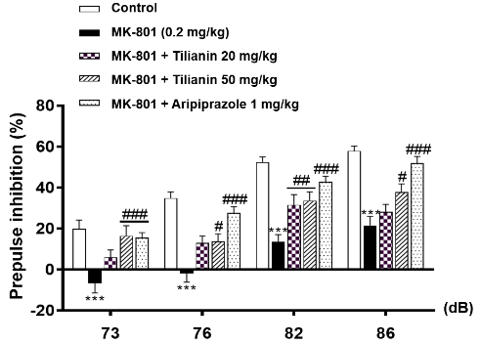
Introduction. Schizophrenia is a complex psychiatric disorder characterized by positive, negative, and cognitive symptoms, with current antipsychotics offering limited efficacy for negative and cognitive deficits and causing notable side effects. PDE10A has been proposed as a promising non-dopaminergic target for antipsychotic development. However, PDE10A inhibitors have been hindered by concerns regarding efficacy and safety, underscoring the need for alternative approaches.
Aims. In this study, we investigated the antipsychotic-like potential of the ethanol extract of D. moldavica (EEDM) and its major compound, tilianin, using an MK-801-induced schizophrenia mouse model.
Methods. We carried out behavioral tests, HPLC analysis, molecular docking, enzyme assays, and Western blotting to evaluate the effects of EEDM and tilianin.
Results. HPLC analysis revealed tilianin (27.02 ± 0.01 mg/g) as the most abundant compound in EEDM. Molecular docking predicted stable binding of tilianin to the catalytic site of PDE10A, and this was supported by in vitro enzyme inhibition assays demonstrating concentration-dependent suppression by both EEDM (IC₅₀ = 390.8 μg/mL) and tilianin (IC₅₀ = 25.20 μM). EEDM and tilianin significantly ameliorated MK-801-induced hyperactivity, prepulse inhibition deficits, cognitive dysfunction, and social impairments. Tilianin modulated PDE10A downstream signalling, particularly the PKA-GSK3β-CREB pathway, in the prefrontal cortex.
Discussion. These findings suggest that tilianin exerts antipsychotic-like effects by inhibiting PDE10A and normalizing cAMP/PKA/CREB signaling, thereby enhancing synaptic plasticity and cognitive function.

Faden, J. and L. Citrome (2023) Medical Clinics 107(1): p. 61-72

