Amiodarone with factor Xa inhibitors in atrial fibrillation: three prospective cohorts
Zi Wang¹, Qing Xu¹, Xiaoyu Li¹, Qianzhou Lv¹. Department of Pharmacy, Zhongshan Hospital, Fudan University, Shanghai, China.
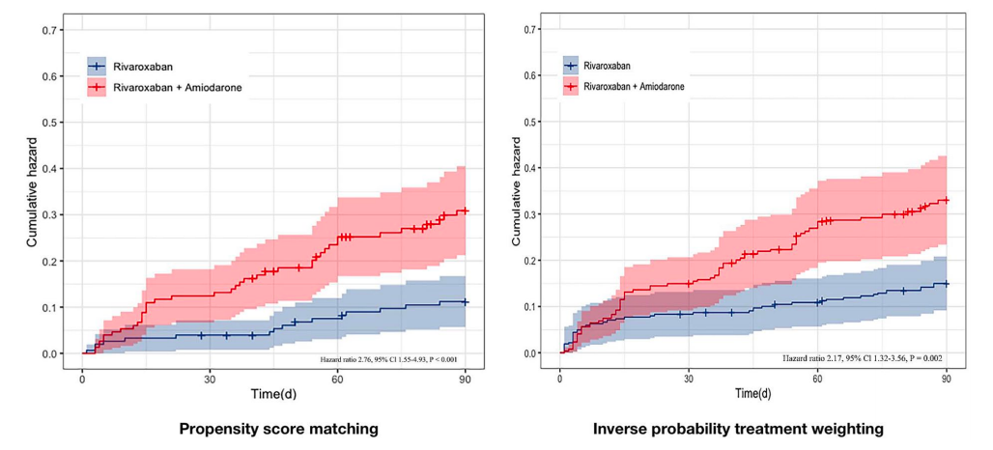
Introduction. P-glycoprotein/CYP3A4 inhibition may increase rivaroxaban exposure and bleeding.
Aims. To assess rivaroxaban exposure and bleeding risk with amiodarone and to compare bleeding risk between rivaroxaban and edoxaban with and without amiodarone, using three prospective cohorts.
Methods. Cohort-1 enrolled atrial fibrillation (AF) patients treated with rivaroxaban (alone vs with amiodarone). Cohort-2 enrolled AF patients on stable rivaroxaban (alone vs with amiodarone); trough rivaroxaban concentration (C_{trough}, 18-26 h post-dose) and prothrombin time/activated partial thromboplastin time were measured at steady state. Cohort-3 enrolled AF patients treated with rivaroxaban or edoxaban, with and without amiodarone. Propensity score methods were used where applicable. The primary endpoint was time to first ISTH-defined bleeding (major, clinically relevant non-major [CRNM], or minor).
Results. Cohort-1 (n=481; propensity score matching 154 pairs) showed higher bleeding with rivaroxaban plus amiodarone vs rivaroxaban alone (26.0% vs 10.4%; HR 2.76, 95% CI 1.55-4.93). Cohort-2 (n=174) showed higher C_{trough} with combination therapy in patients receiving rivaroxaban 20 mg (p=0.009) and with renal impairment; bleeding was higher with combination therapy (16.1% vs 6.3%; HR 2.83, 95% CI 1.05-7.66). Cohort-3 (n=910) showed higher bleeding for rivaroxaban plus amiodarone vs edoxaban plus amiodarone after propensity score matching (18.9% vs 10.2%; HR 2.015, 95% CI 1.026-3.958), driven by CRNM and more pronounced at standard doses and in renal dysfunction.
Discussion. Across three cohorts, amiodarone increased rivaroxaban exposure and was consistently associated with higher bleeding risk. These findings suggest that edoxaban may be associated with lower bleeding risk compared with rivaroxaban when combined with amiodarone.

