Creating evidence-based personas to illuminate hypertension journeys and guide education strategies
Kaylee Slater¹, Eleanor Clapham², Elizabeth Halcomb³, Ben Kostyrka⁴, Lisa Kouladjian O'Donnell¹, Florence Lopez¹, Mitchell Sarkies¹, Gautam Satheesh^{1, 4}, Mouna Sawan¹, Aletta E Schutte^{4,5}, Catherine Stephen³, Ritu Trivedi¹, Niamh Chapman^{1,2}. ¹Faculty of Medicine and Health, University of Sydney, Sydney, NSW, Australia; ²Menzies Institute for Medical Research, University of Tasmania, Australia; ³Faculty of Science, Medicine and Health, University of Wollongong, Wollongong, NSW, Australia; ⁴The George Institute of Global Health, Sydney, NSW, Australia; ⁵School of Population Health, UNSW Sydney, Sydney, NSW, Australia.
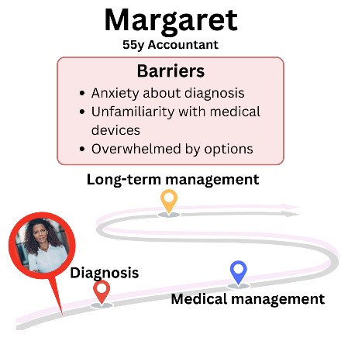
Introduction: Effective hypertension management relies on patient education, yet it is often poorly delivered. Understanding patient preferences is critical to developing timely, tailored, and person-centred education.
Aim: Identify leverage points and behavioural and cultural factors that influence the delivery and uptake of patient education for primary hypertension in primary care.
Methods: Qualitative study using semi-structured interviews with adults in Australia who self-monitor blood pressure (n=27), and with general practitioners, nurses, and pharmacists involved in hypertension care (n=12). Initial inductive coding identified themes related to the hypertension journey, including key time points, behavioural barriers, and enablers. Themes were then mapped to the capability, opportunity, motivation (COM-B) framework. Patient personas were developed by synthesising behavioural patterns across COM-B domains, informed by insights from both patient and practitioner interviews.
Results: Unique behavioural barriers and enablers to patient education emerged across key stages of hypertension management including diagnosis, treatment initiation, and long-term care. Barriers included feeling overwhelmed, inconsistent guidance, and clinician assumptions about motivation, while a strong desire to self-manage was a consistent enabler. Six distinct patient personas were developed, each reflecting different responses to these barriers and enablers, highlighting diverse needs and opportunities for tailored education strategies.
Discussion: These personas reflect the complexity of hypertension management and highlight gaps in education. They offer a practical tool for designing person-centred interventions to reduce disparities in primary care.

