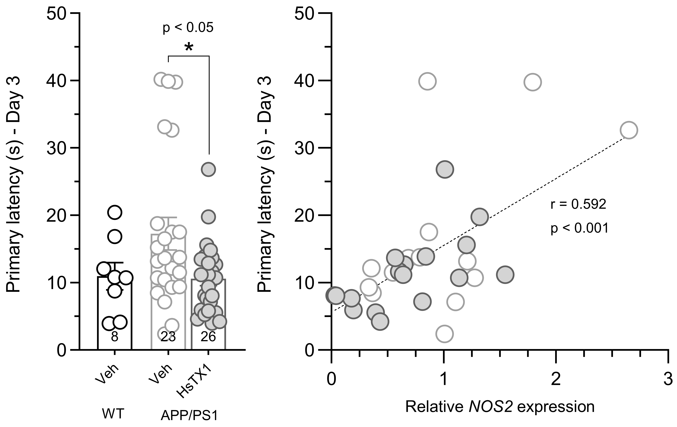
K_{V}1.3 blockade improves cognitive performance in APP/PS1 mice
Ryan J Keenan¹, Zak Monaghan¹, Michael de Veer², Raymond S Norton¹, Dorothy CC Wai¹, Joseph A Nicolazzo¹. Monash Institute of Pharmaceutical Sciences, Monash University¹, Parkville, VIC, Australia. Monash Biomedical Imaging, Monash University², Clayton, VIC, Australia.

Introduction: Alzheimer's disease (AD) is a prevalent neurodegenerative disease with no known cure. Accumulating evidence highlights a prominent neuroinflammatory component in AD driven by chronically activated microglia, which release pro-inflammatory cytokines that contribute to neuronal death. Microglia express the voltage-gated potassium channel 1.3 (K_{V}1.3) which regulates their activation, and its expression is increased in AD. We have developed HsTX1[R14A], a potent and selective K_{V}1.3 blocker, which improved cognitive function in a mouse model of sporadic AD.
Aims: Investigate the anti-inflammatory and cognitive-enhancing effects of K_{V}1.3 blockade via chronic HsTX1[R14A] administration in a mouse model of familial AD (APP/PS1).
Methods: 8.5-month-old female APP/PS1 mice were administered HsTX1[R14A] at 1 mg/kg or saline vehicle (3 µl/g) every second day by sc injection for 8 weeks. During the last 2.5 weeks of treatment, mice underwent a battery of cognitive behavioural tests including the Barnes maze. Brain and blood samples were collected for molecular analysis of Aβ pathology and markers of neuroinflammation. Positron emission tomography (PET) imaging of 64Ga-HsTX1[R14A] assessed peptide distribution in the brain for up to 85 min post sc administration.
Results: Vehicle-treated APP/PS1 mice exhibited a longer primary latency across the 4 days of Barnes maze acquisition trials compared with WT mice. HsTX1[R14A] treatment decreased primary latency to WT levels by day 3 of acquisition. HsTX1[R14A] did not decrease soluble Aβ in the brain nor cytokine levels at either a protein or gene level, although higher pro-inflammatory (IL-1β, IL-6, TNF-α, NOS2) and K_{V}1.3 (Kcna3) gene expression was correlated with poorer cognitive performance. Detectable albeit limited peptide brain uptake was observed following sc administration.
Discussion: These data further highlight the association between K_{V}1.3, neuroinflammation and cognitive decline using a mouse model of familial AD. The exact mechanism by which HsTX1[R14A] improves cognitive performance remains to be determined. Immunohistochemical evaluation of microglial K_{V}1.3 and Aβ plaques are currently in progress.

