**Multifunctional smart polyester fabric fabricated by electrodepositing ZnO**

*U.G. Mihiri EkanayakeA, Nadeesha RathuwaduB, M.M.M.G.P.G. MantilakaB,C, , Jennifer MacLeodA, Anthony P. O’MullaneA, Kostya (Ken) OstrikovA*

ASchool of Chemistry Physics and Mechanical Engineering, QUT, Brisbane, Australia; BSri Lanka Institute of nanotechnology (SLINTEC), Homagama, Sri Lanka. CPost Graduate Institute of Science, University of Peradeniya, Sri Lanka.

**Introduction**: Developing a multifunctional fluorine free low cost fabric using an easily controllable method is a great challenge. In this work, we have developed a UV blocking, superhydrophobic and photosensitive fabric by means of electrodeposition of ZnO nano/micro structures on a polyester fabric with a carbon black (CB) screen printed conductive layer. CB conductive layer was screen printed following a method reported by L. Pahalagedara *et al.* Electrochemical methods are advantages compared to the existing wet chemical methods. Even though there are reported studies on the electrochemical deposition of ZnO nano/micro structures on conductive fabrics (Ko et al. 2013, Kim et al. 2017), in all instances the fabrics were made conductive by the incorporation of metal wires and metal nano particles. For the first time, in this study, ZnO nano/micro structures were electrochemically grown on a fabric, which has been made conductive by screen printed CB layer.

**Methods:** A three electrode system was used to deposit ZnO. To identify the optimum conditions, the deposition was carried out under different concentrations of aqueous Zn(NO3)2 (5 mM, 0.5 M), deposition potential (0.0, -0.5, -1.0, -1.5, -2.0 V), deposition time (15, 30, 45, 60 min), and deposition temperature (28, 50, 60, 70 °C). EDS was carried out to analyze the deposition of ZnO. Superhydrophobicity was achieved by self-assembling stearic acid on the ZnO layer.

**Results and discussion:**

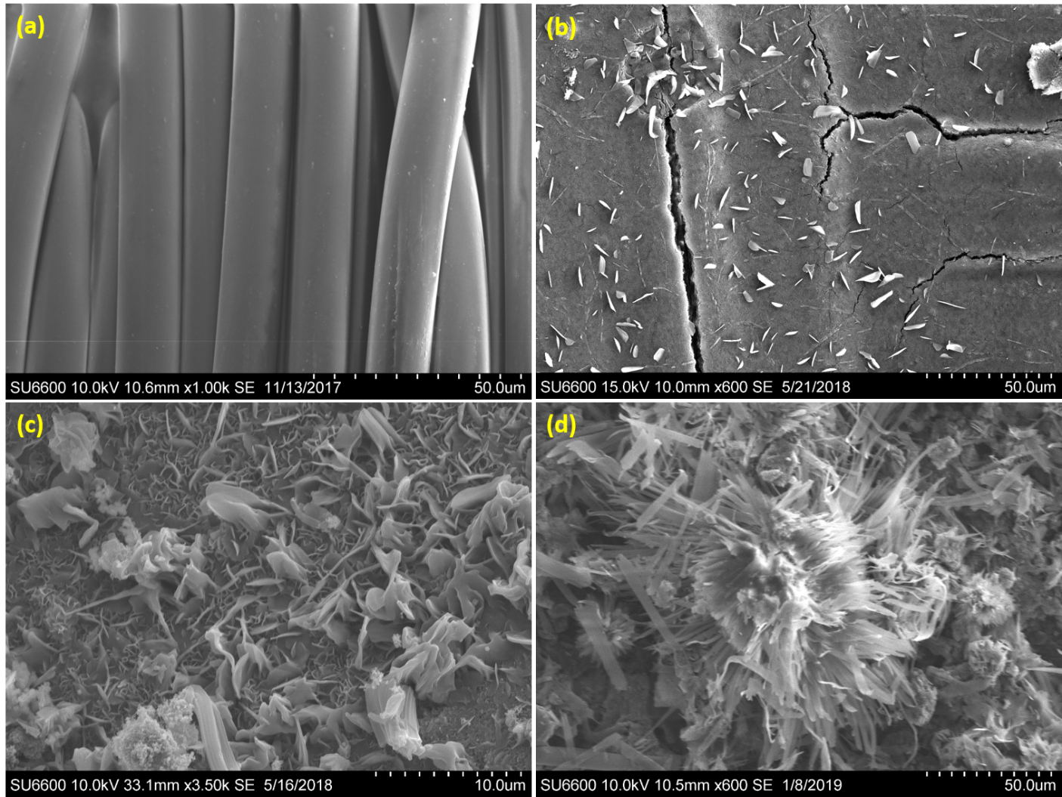

Figure 1 SEM characterization of (a) Non-treated fabric (b) Carbon black screen printed fabric (c) ZnO electrochemically deposited fabric (d) Stearic acid self-assembled fabric on ZnO layer

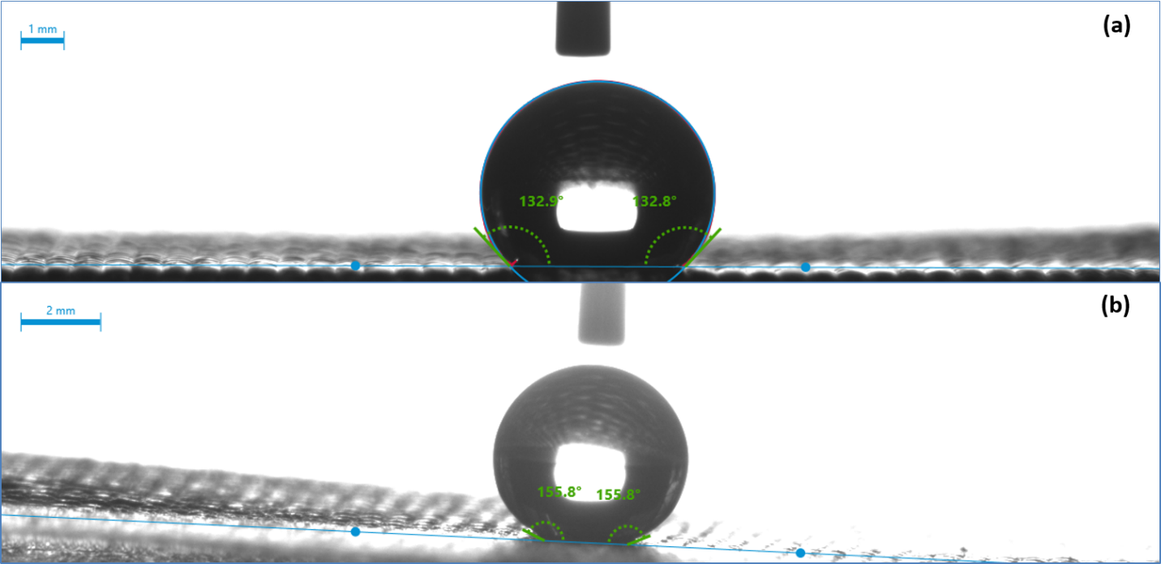

Figure 2 WCAs of (a) normal fabric (b) treated fabric

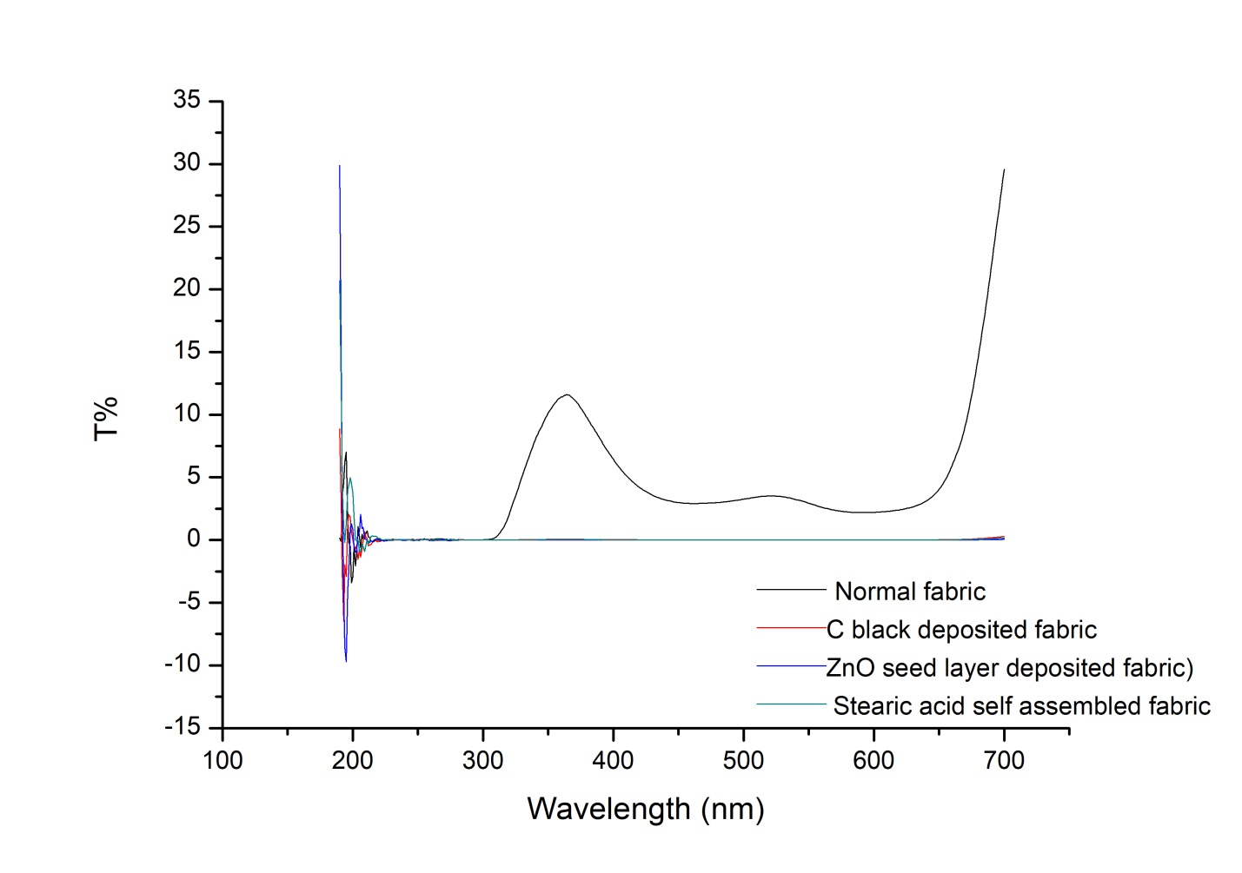

Figure 4 UV transmittance of normal fabric and treated fabrics

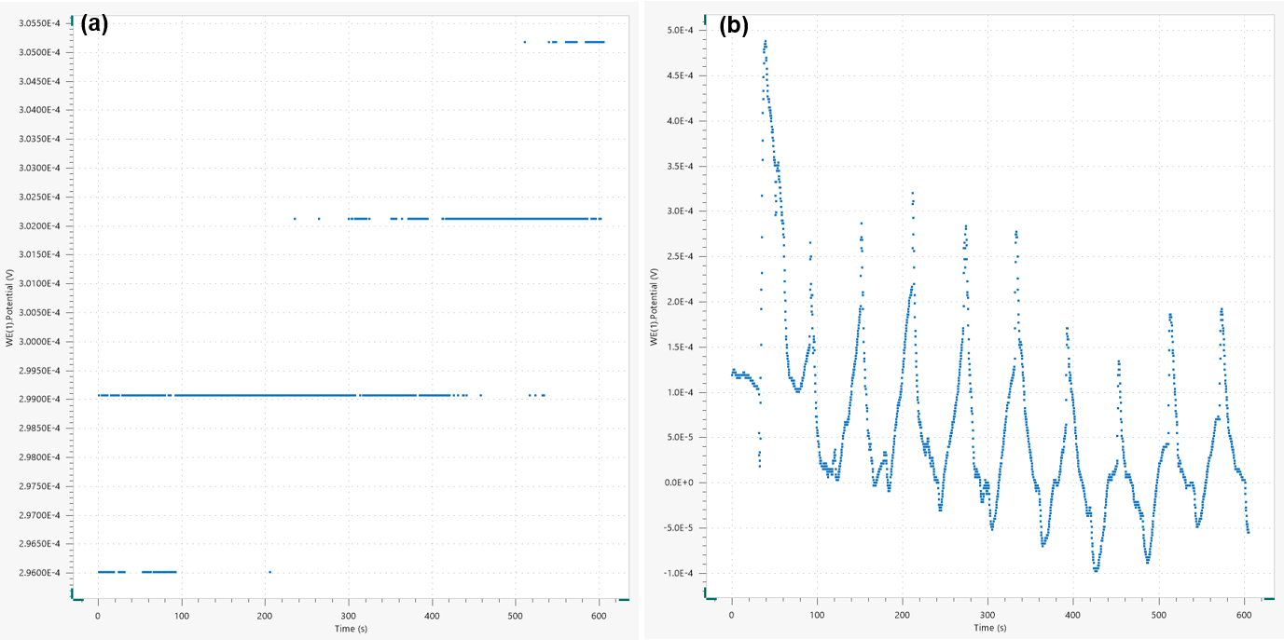

Figure 3 Photo responses of (a) Carbon black screen printed fabric (b) ZnO deposited fabric with 30 s of solar light exposed/unexposed time

**Fig 1** shows the bare fabric and the fabric covered with electrodeposited micro/nano structures and the self-assembled stearic acid layer. **Fig 2, 3** and **4** represent the WCAs of the superhydrophobic fabric, photosensing and UV blocking properties of the modified fabric respectively. We have successfully modified the polyester fabric rendering it multifunctional with various potential applications such as water repellents, flexible photo sensors.

**References**

Kim, Y. K., S.-H. Hwang, S. Kim, H. Park and S. K. Lim (2017). "ZnO nanostructure electrodeposited on flexible conductive fabric: A flexible photo-sensor." Sensors and Actuators B: Chemical **240**: 1106-1113.

Ko, Y. H., M. S. Kim, W. Park and J. S. Yu (2013). "Well integrated ZnO nanorod arrays on conductive textiles by electrochemical synthesis and their physical properties." Nanoscale research letters **8**: 28.

[*ugme12@gmail.com](mailto:*ugme12@gmail.com), n10502190@qut.edu.au