Anti-Inflammatory Role of Statins in Emerging Viral Infections: Evidence from COVID-19 Meta-Analysis
Maftuchah Rochmanti¹, Rahmi Nugraningrum², Nadira M. Tsania¹, Alivia R. Kusumowardani¹, Department of Anatomy, Histology, and Pharmacology, Faculty of Medicine, Universitas Airlangga¹, Surabaya, Indonesia; Medical Study Program, Faculty of Medicine, Universitas Airlangga², Surabaya, Indonesia.

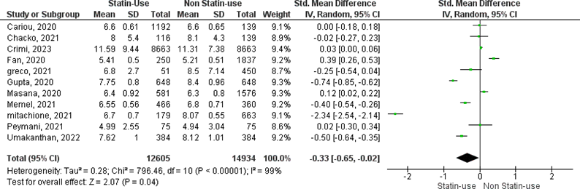
Introduction. Severe viral infections, including COVID-19, are often complicated by hyperinflammation and poor outcomes (Zhou et al, 2021). Statins, commonly prescribed for cardiovascular disease, also have anti-inflammatory and immunomodulatory effects. COVID-19 provides a model to examine their role in virus-induced inflammation (Daniels et al, 2020), though results remain inconsistent.
Aims. This study evaluates the effectiveness of statins as anti-inflammatory agents when added to standard therapy in COVID-19 patients.
Methods. Following PRISMA guidelines, we searched PubMed, ScienceDirect, Scopus, Cochrane CENTRAL, and grey literature (January–December 2024) using the keywords "statins," "COVID-19" [MeSH], and "inflammation." Outcomes included mortality, ICU admission, ventilation, inflammatory markers, and hospital stay. Data were analyzed using Risk Ratios and Standardized Mean Differences with 95% CIs (P < 0.05).
Results. Thirty-seven studies (1,348,617 participants; 32 cohorts, 5 RCTs) were included. Statins significantly reduced White Blood Cell (WBC) counts but showed no effect on mortality, ICU admission, ventilation, CRP, D-dimer, lymphocyte/neutrophil counts, or hospital stay.
Discussion. These findings in reduced WBC counts suggest that statins may exert modest anti-inflammatory effects, though further studies using specific markers are required for validation. This study highlights statins’ potential as adjunctive therapy in viral-induced hyperinflammation and underscores the need for further randomized trials to clarify their role in future outbreaks.

Daniels et al (2020). The American journal of cardiology, 136: 149–155.
Zhou et al (2021). Thrombosis research, 201: 23–29.

