**Evaluating Formulation Stability And Recyclability In Pharmaceutical Selective Laser Sintering 3D Printing**

**Angus C.F. Harrop1**, Jared A. Miles1

School of Pharmacy and Pharmaceutical Sciences, University of Queensland1, Brisbane, Queensland, Australia;

**Background and aims.** The emergence of personalized medicine is shifting pharmaceutical manufacturing from standardized, mass-produced medications toward patient-specific therapies, increasing scope for 3D printing (3DP). Selective Laser Sintering (SLS), a powder-based 3DP, enables rapid prototyping, high precision and flexible production of customizable doses, formulations and designs. While current literature emphasizes formulation design and printability, the thermal and photolytic nature of SLS raises concerns about drug-formulation stability and powder recyclability. For broader clinical and commercial adoption, SLS must demonstrate viability in cost-efficiency, process optimization and formulation stability. This study investigates the impact of powder reuse on the physical and chemical stability of several drug-containing formulations across five SLS print cycles to assess the feasibility of sustainable, personalized SLS printed pharmaceutics.

**Methods.** Powder blends containing each active pharmaceutical ingredient, thermoplastic polymer, thermo-conductive pigment and excipient filler underwent five SLS print-reuse cycles (see Figure 1). Powder flowability was assessed using Hausner ratio and angle of repose. Printed tablets were evaluated for dimensional consistency (height, diameter, weight), mechanical strength (hardness, friability) and visual integrity. Thermal properties were analyzed via differential scanning calorimetry and thermogravimetric analysis. Drug content and degradation were quantified via high-performance liquid chromatography.

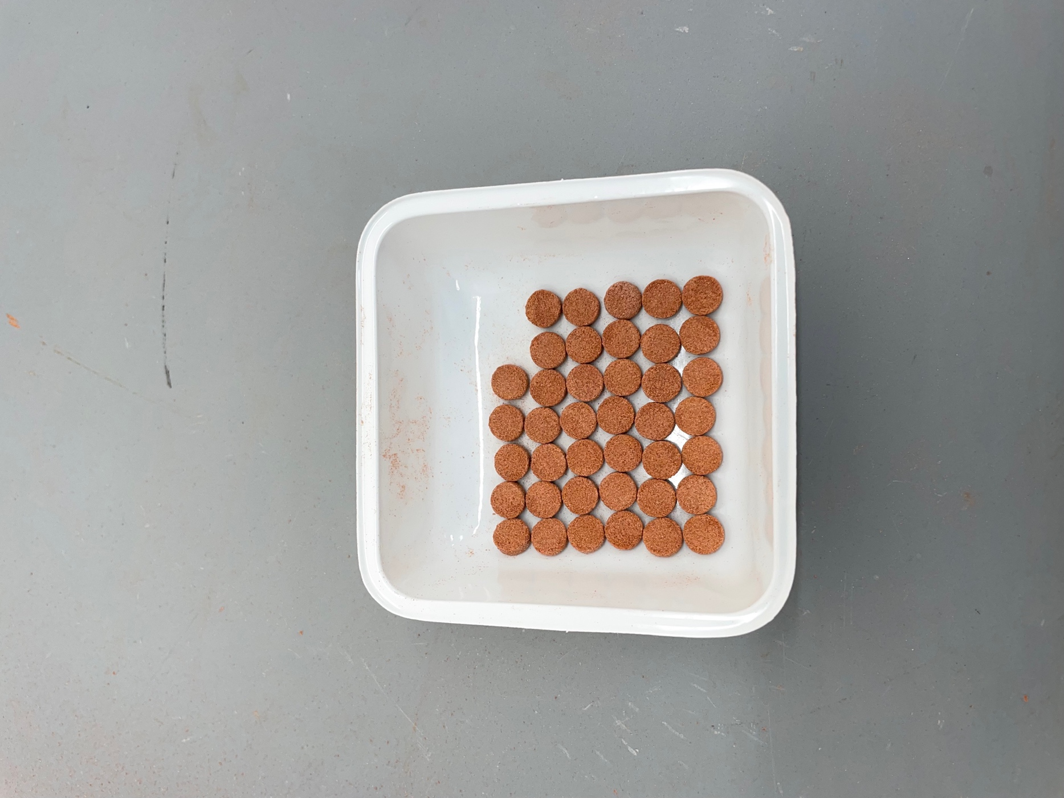

**Figure 1.** Tablets in the process of being SLS 3D printed (Left) and completed SLS 3D printed tablets (Right)

**Results.** Data trends show separating degradation patterns between physical and chemical properties of the formulations. Powder flowability and tablet characteristics showed minimal variation across cycles. DSC and TGA data reflected formulation compatibility and resilience to printing temperatures, however failed to show drug instability, which was identified post-printing via drug content analysis.

**Conclusion/Discussion.** The findings highlight the importance of determining drug-specific thermal stability for each SLS formulation. Current use of DSC and TGA underestimates the combined thermal and photolytic degradation of SLS. An area of SLS 3DP previously not investigated, feedstock recyclability and development of reuse/refresh protocols can reduce operating costs, increase commercial viability, and support broader adoption of SLS 3DP in personalized medicines.

**References:**