**Development of Seasonal Influenza Vaccine Using Needle-Free Intraepidermal Administration Device**

**Keiichi Motoyama1,2**, Masahiro Ogura1, Riru Onigahara1, Shogo Misumi1,2, Naoki Kishimoto1,2, Hirotoshi Adachi3, Masahiko Kikuchi2,4, Toru Taharabaru1, Taishi Higashi1,2.

Graduate School of Pharmaceutical Sciences, Kumamoto University1, Kumamoto, Japan;

Vaccine Development Research Center, Kumamoto University2, Kumamoto, Japan;

PassPort Technologies, Inc.3, San Diego, CA, USA;

The University of Tokyo Pandemic Preparedness, Infection and Advanced Research Center4, Tokyo, Japan.

**Background and aims.** Vaccines are robust preventive strategy against the infection. Subcutaneous or intramuscular injections are widely used for vaccination. However, there are some concerns about vaccination, such as pain during and/or after the administration and fear of needles. A needle-free intraepidermal administration device technology is a combination of the microporation device and drug-loaded dry patches (**Figure 1**)1,2). This technology enables painless and easy administration of antigens without needles. Furthermore, the target site of this technology is the epidermis which is rich in immune cells, such as Langerhans cells. Therefore, delivering the antigens to the epidermis is expected to produce highly neutralizing antibodies. In this study, we aim to develop a novel needle-free formulation of the seasonal influenza vaccine containing three strains of antigens (A/H1N1, A/H3N2, and B/Victoria).

**Results and discussion.** To prepare antigen-loaded dry patches, the three strains of influenza antigens were added to the dry patches and dried them for a day. The particle sizes of the antigens in the dry patch formulation were similar to those of the original antigens. These results suggest that the dry patch preparation process had negligible effect on the physicochemical properties of the antigens. After microporation to mice skin, the dry patches containing influenza antigens were administered boost. As a result, antibody production against each antigen were observed. In addition, administration of the dry patches did not affect the blood chemistry values. Furthermore, local inflammation at the microporation site was not observed after 24 h, suggesting the high safety of the device.

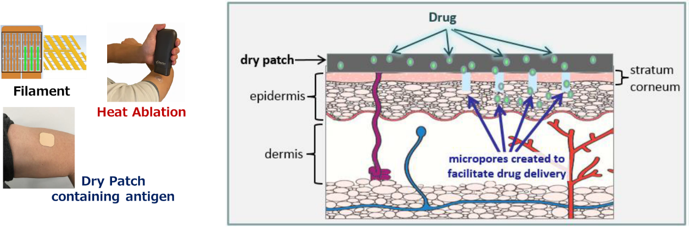

**Figure 1. Intraepidermal Delivery Device (PassPortTM).**

**Conclusion.** This Intraepidermal Delivery technology (PassPortTM) has the potential as a novel device to administer of seasonal influenza vaccine by dry patch.

**References:**

1. O. Naoto, *et al*. ***Eur. J. Pharm. Sci.***, 170, 106096 (2022).
2. J. Bramson, *et al.*, ***Gene Ther.***, 10, 251–260 (2003).