**Dissolving Microneedles Containing Solubilized Econazole Nitrate for Enhanced Transdermal Delivery**

**Ju Yeon Park1**, Young Soo Woo1, Seung Yeob Baeg1, Hyun Jong Park1, Dong Wuk Kim1

1College of Pharmacy and Research Institute of Pharmaceutical Sciences, Kyungpook National University, Daegu 41566, Republic of Korea

**Background and aims.** This study aimed to develop a dissolving microneedle (DMN) system incorporating solubilized econazole nitrate to address the drug’s low aqueous solubility and the limitations associated with conventional topical formulations such as creams and ointments. The ultimate goal was to enhance transdermal drug delivery efficiency using a minimally invasive platform.

**Methods.** The solubility-enhancing effects of various pharmaceutical polymers on econazole nitrate were evaluated through preliminary screening. Among the candidates, hydroxypropyl-β-cyclodextrin (HP-β-CD) demonstrated the highest solubilizing capacity and was selected as the key solubilizer. The DMN formulation was prepared by combining HP-β-CD with the biocompatible polymer polyvinylpyrrolidone K30 (PVP K30). The fabricated microneedles were subjected to morphological assessment, physicochemical characterization, drug content analysis, and in vitro drug release testing.

**Results.** Solubility screening revealed that HP-β-CD significantly enhanced the aqueous solubility of econazole nitrate, followed by PVP-VA64 and PVP K30. Specifically, 20% (w/v) HP-β-CD increased solubility to approximately 10,233.06 µg/mL—representing a 9.5-fold improvement over solubility in distilled water (1,069.9 µg/mL) (Fig. 1). Stereomicroscopic analysis of the microneedle arrays fabricated with HP-β-CD and PVP K30 confirmed a uniform, cone-shaped structure with an average needle length of 696 µm (Fig. 2). These characteristics indicate sufficient mechanical integrity and effective potential for stratum corneum penetration, enabling efficient transdermal delivery of the solubilized drug. As the study is ongoing, additional data will be presented in the full conference poster.

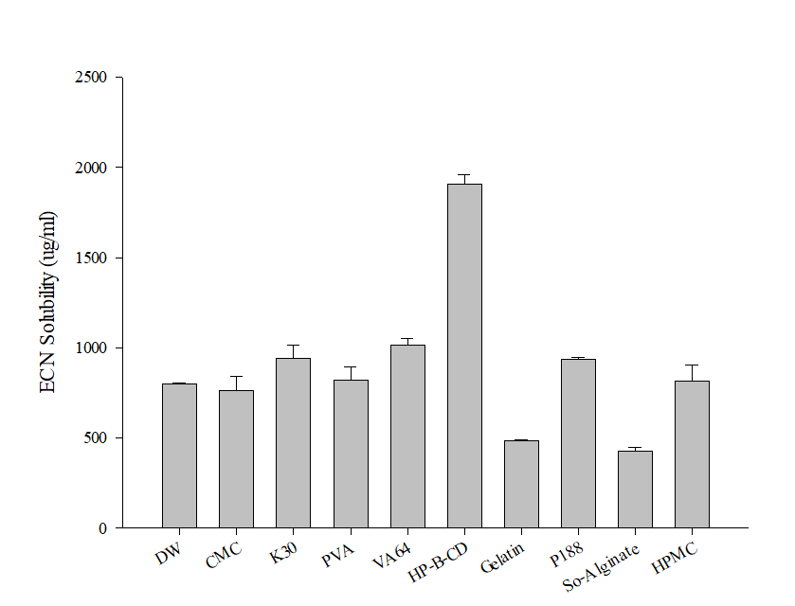 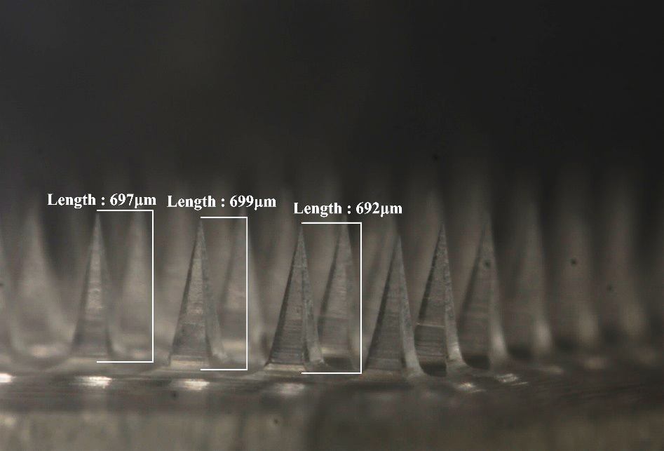

**Figure 1.** Solubility screening of econazole nitrate in various polymeric solutions (n = 3).

**Figure 2.** Stereomicroscopic image of the dissolving microneedle array containing solubilized econazole nitrate.

**Conclusion/Discussion.** This study demonstrates the feasibility of using DMN as a novel platform for delivering poorly water-soluble drugs such as econazole nitrate. The optimized combination of HP-β-CD and PVP K30 substantially improved solubility and yielded microneedles with uniform morphology capable of penetrating the skin barrier. These findings support the potential of DMNs as a patient-friendly and effective alternative to conventional topical formulations with limited skin permeability. Ongoing studies include further evaluation of mechanical strength, drug release behavior, and in vitro and ex vivo skin permeation to support future clinical translation.

**Acknowledgements:** This work was supported by the National Research Foundation of Korea (NRF) grants funded by the Korean government (No. 2020R1A5A2017323 and No. 2021R1C1C1010721).