Case studies of hypothesis validation from Taiwan
Edward Chia-Cheng Lai^{1,2}.

1. Population Health Data Center, National Cheng Kung University, Tainan, Taiwan.
2. School of Pharmacy, Institute of Clinical Pharmacy and Pharmaceutical Sciences, College of Medicine, National Cheng Kung University, Tainan, Taiwan.

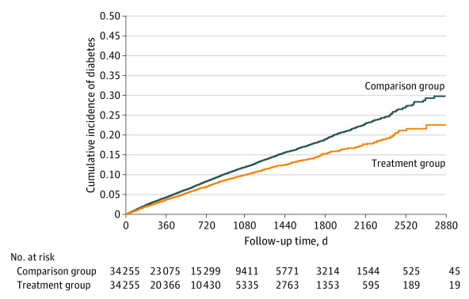
Introduction.
Denosumab, an antiresorptive medications in the treatment of osteoporosis, had been suggested to have potential effect on improving insulin sensitivity and glucose tolerance. Clinical evidence had suggested its effect on fasting plasma glucose, while its effect on reducing diabetes risk remain unclear.

Aims. To explore the possibility of additional benefits or new indications of the currently approved drug, we aimed to evaluate the association between denosumab usage and a lower risk of developing diabetes in patients with osteoporosis.
Methods. We conducted a nationwide cohort study using National Health Insurance Research Database (NHIRD) in Taiwan. We identified newly-received denosumab users for osteoporosis indication during 2012 and 2019. We categorized patients into two groups: treatment group and comparison group. Patients who initiated denosumab and were adherent to the denosumab treatment were allocated as treatment group. Patients who initiated denosumab but discontinued after initial dose were allocated as control group. We applied 1:1 propensity score matching to balance the baseline characteristics and to increase comparability between groups. We also conducted sensitivity analyses using negative control outcomes to estimate the effect of potential unmeasured confounders in our study.

Results. We included a total of 68,510 patients who had newly received denosumab, with mean age of 77.7 and 84.3% female population after propensity score matching. During a mean follow-up of 1.9 years, 2016 patients had incident diabetes in treatment group and 3220 patients had incident diabetes in comparison group (incidence rates, 35.9 vs 43.6 per 1000 person-years). After Cox proportional hazards model, denosumab is associated with lower risk of incident diabetes (HR, 0.84; 95% CI, 0.78-0.90). Several negative control outcomes analyses did not show significant difference between treatment and comparison groups.

Discussion. In our nationwide cohort study, patients who continued denosumab for osteoporosis had a lower risk of developing diabetes than patients who discontinued denosumab regimen after initial dose. Our finding suggested a potential association between denosumab therapy and lowering risk of diabetes. The finding was also supported by several sensitivity analyses including negative control outcomes and aged-stratified analyses. The study provided clinical evidence for physicians on choosing antiosteoporosis medications while also considering lowering diabetes risk. This study could also provide a good example for exploring the possibility of additional benefits of approved drugs.

Do not change the margins, the font, size or any other setup on this template. The abstract should be left-and right-justified. Line spacing must be single. The abstract must be one A5 page only. The abstract must be typed in Calibri 10 point. Do not use bold in the abstract text, only the title should be in bold. As abstract pages may be printed in black and white only, you may consider including tables and images in greyscale. Please pay particular attention to these instructions as abstracts that do not conform will not be accepted by the editors.

The text should be as informative as possible. If you have any problems please call Expert Events on +61 7 3848 2100 or ascept-apfp-apsa@expertevents.com.au

McCartney P (2001) J J 56:23-33
Starr R et al (2005) Pharmacology of FAB-4, ed Ono Y. pp 12-23, Tokyo, Abbey Road Press

