Manganese-Armed Whole-Cell Vaccine Potently Induces T Cell Immunity Against Prostate Cancer
Qianqian Guo¹, Ying Gao¹, Dangge Wang¹, Xudong Li¹. Precision Research Center for Refractory Diseases, Shanghai General Hospital, Shanghai Jiao Tong University School of Medicine¹, Shanghai, China.

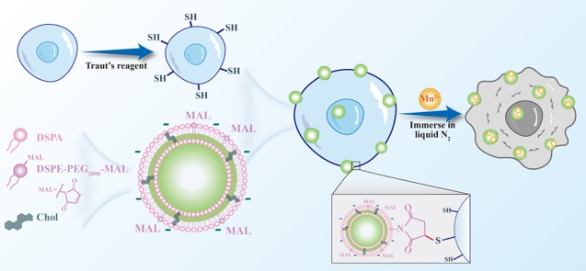
Introduction. Prostate cancer responds poorly to immunotherapy due to its immunosuppressive microenvironment. Whole-cell vaccines offer broad antigen coverage, and manganese is a potent cGAS-STING pathway agonist.
Aims. To develop a manganese-loaded whole tumor cell vaccine that co-delivers antigens and adjuvant, aiming to activate potent anti-tumor immunity against prostate cancer.
Methods. Anionic liposomes were conjugated to tumor cells via click chemistry to load manganese ions. Cells were inactivated by freeze-thaw cycles. Vaccine efficacy was evaluated in MyC-CaP and RM-1 prostate cancer mouse models.
Results. The engineered Mn²⁺-armed whole-cell vaccine exhibited prolonged retention at injection site, serving as a sustained antigen depot. This efficiently triggered robust dendritic cell maturation and antigen presentation. Consequently, this strategy induced a potent and systemic CD8⁺ T cell response against tumors, characterized by substantial clonal expansion and enhanced cytotoxic functionality. In both MyC-CaP and RM-1 prostate cancer models, this immune activation translated into a profound remodeling of the tumor microenvironment, with a striking increase in tumor-infiltrating cytotoxic T lymphocytes (CTLs), leading to significant suppression of tumor growth.
Discussion. Our Mn²⁺-armed whole-cell vaccine presents a potent strategy to overcome the "cold" immunosuppressive landscape of prostate cancer. By co-delivering a broad tumor antigen repertoire with potent cGAS-STING activator, it synergistically activates both innate and adaptive immunity, effectively turning immunologically "cold" tumors to "hot." The resultant robust and durable anti-tumor T cell response highlights its significant therapeutic potential. This broadly applicable platform offers a promising direction for cancer immunotherapy.

