Bioengineered brain targeting RVG-modified BMSCs-derived small extracellular vesicles overexpressed with miR-21 alleviate excess autophagic neuronal injury after cerebral ischemia via regulating PTEN/Akt/mTOR pathway
Yiyang Li¹, Jiacheng Hu¹, Jinfen Chen¹, Manfei Zhou¹, Mingchun Liao^{1,3}, Yayue Yang^{1,3}, Jiahao Zhou¹, Bin Wang³, Yonghua Zhao^{1, 2, *}
1. Institute of Chinese Medical Sciences, The State Key Laboratory of Mechanism and Quality of Chinese Medicine (University of Macau), Taipa, Macau SAR, China
2. Department of Pharmaceutical Sciences, Faculty of Health Sciences, University of Macau, Taipa, Macau SAR, China
3. Guangdong Institute of Intelligence Science and Technology, Zhuhai, Guangdong, China.
*Corresponding author

Background and aims. Ischemic stroke results in tragic disability and a high risk of death; however, there are limited therapeutic measures for recovering neurological function. Small extracellular vesicles (sEVs) derived from bone marrow mesenchymal stem cells (BMSCs) have recently been popular in exerting satisfactory therapeutic effects on post-cerebral ischemia treatment based on the delivery of their packed microRNA (miRNA). However, naïve sEVs have a low ratio to cross the blood-brain barrier (BBB), also, the low abundance of sEVs' cargo miRNA restricts the possibility of maximizing their regulatory functions. Rabies virus glycoprotein (RVG) has a high affinity to acetylcholine receptor (AchR), which is highly expressed in neurons, and RVG modification in sEVs can enhance their brain affinity. In this study, we first generated bio-engineered RVG-modified BMSC-sEVs to deliver overexpressed miR-21-5p into the brain to enhance ischemic stroke treatment.

Methods. sEVs miRNA-seq technology, and analysis of the miRNA-seq datasets of stroke patients’ samples in GEO database was used to figure out that miR-21-5p is decreased in stroke patients’ brains and enriched in BMSC-sEVs. Plasmid transfection based on lentivirus vector was used to overexpress RVG-Lamp2b peptide and miR-21-5p. Oxygen-glucose deprivation/re-oxygenation (OGD/R) insulted primary neurons and transient middle cerebral artery occlusion (tMCAo) mice model, in vivo bio-imaging and mice neurobehavioral tests were used to evaluate brain targeting and treatment efficacies. Dual-luciferase reporter assay, and FISH technique

Results. RVG-miR21-sEVs were characterized, and RVG-modified sEVs were verified to cross the BBB, with a high affinity to neurons. The administration of RVG-miR21-sEVs showed superior neurological function recovery and reduced brain infarction in mice tMCAo model. Additionally, RVG-miR21-sEVs inhibited neuron autophagy, mitochondria dysfunction, and apoptosis after oxygen-glucose deprivation/re-oxygenation (OGD/R) insult. Furthermore, we validated that the target of miR-21-5p is PTEN, and mechanically, we discovered that miR-21-5p antagonizes PTEN/Akt/mTOR pathway to regulate neuronal excessive autophagic injury after ischemic stroke.

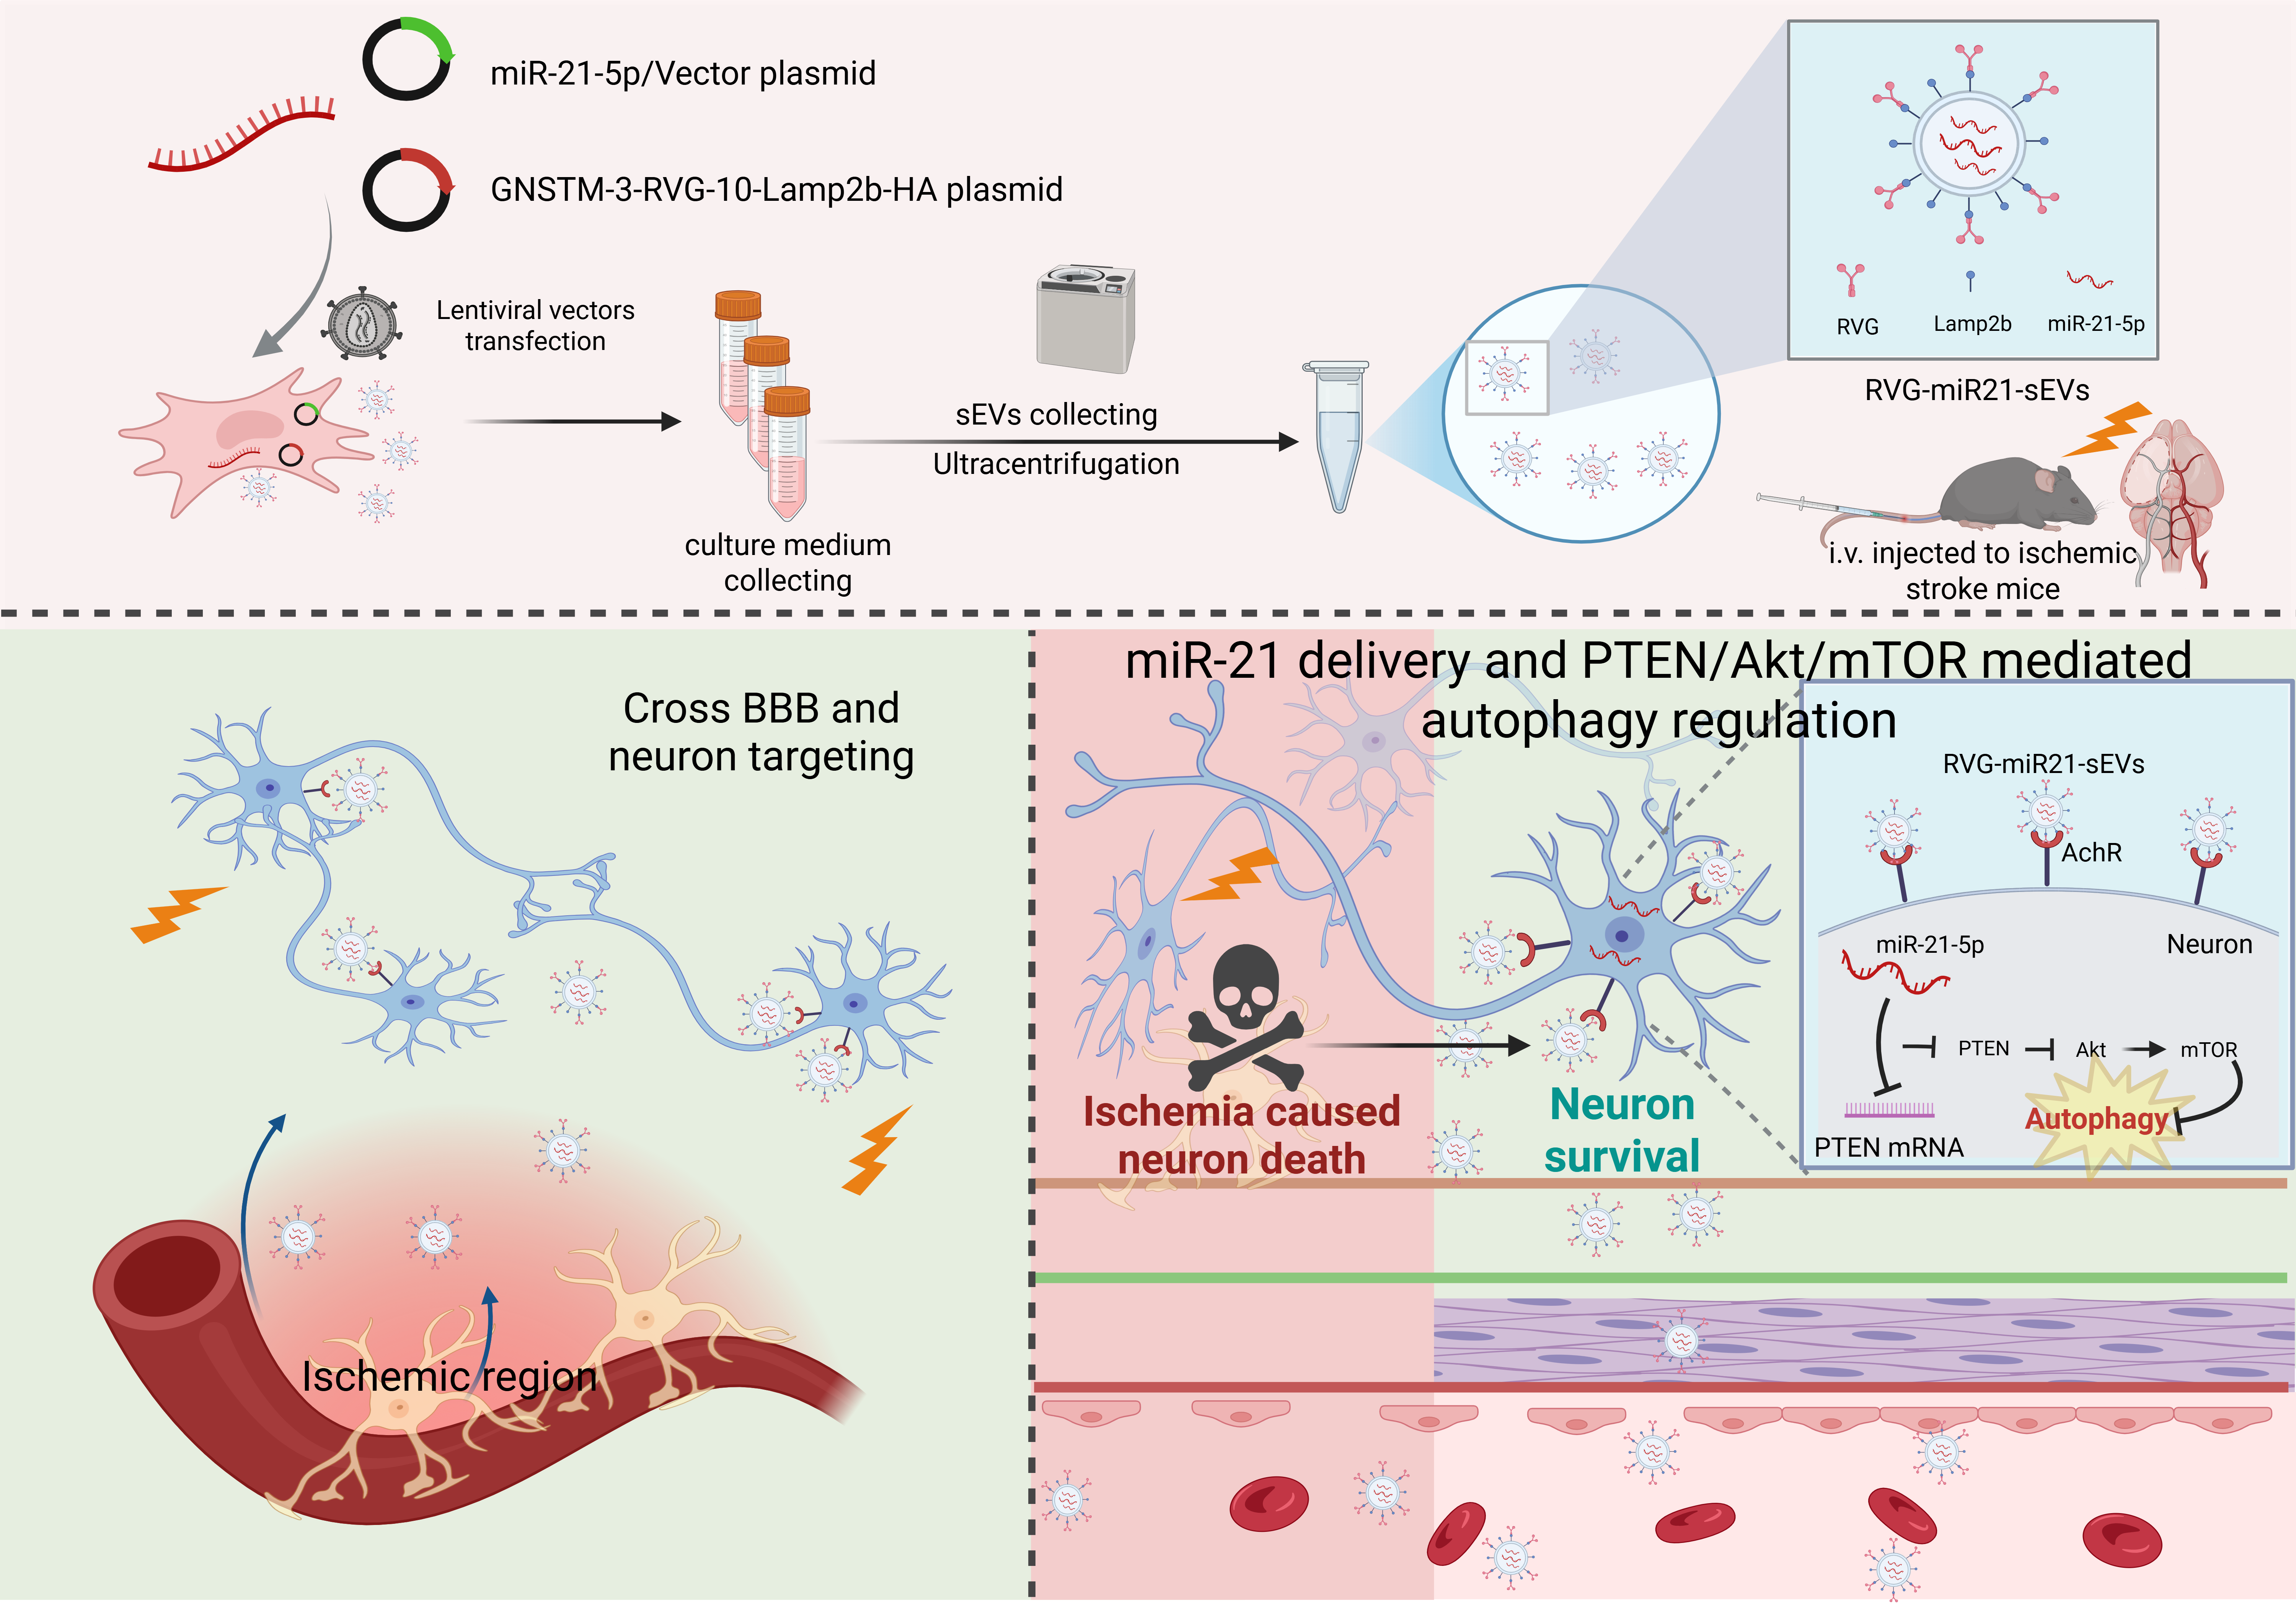

Figure 1. Graphic Abstract

Conclusion/Discussion. Collectively, our study pre-clinically demonstrated that RVG-miR21-sEVs can target transfer miR-21-5p to neurons and suppress autophagy by regulating PTEN/Akt/mTOR axis, consequently recovering neuron survival and neurological function of ischemic stroke mice.

References: This work is supported by the Guangdong Natural Science Fund (General Programme, no. 2023A1515010034), and the Science and Technology Development Fund (FDCT), Macau SAR (Reference No. 0065/2023/RIB3).

