**Screening Assay for Drug Permeability Changes Induced by Pharmaceutical Excipient–Mucin Interactions Using a Mucus-Caco-2 Model**

**Tokio Morita1**, Hiroyuki Yoshida1, Naomi Tomita1, Yoji Sato1

Division of Drugs, National Institute of Health Sciences1, Kawasaki-shi, Kanagawa, Japan.

**Background and aims.**

Pharmaceutical excipients can induce drug interactions, thereby influencing drug absorption. We have previously evaluated the impact of excipients on drug membrane permeability (1). However, the influence of excipient–mucin interactions on drug permeability remains unclear. In this study, we assessed the effects of pharmaceutical excipients on drug permeability in the presence of the mucin layer using the mucus-Caco-2 model (2).

**Methods.**

Purified porcine mucin was suspended at 2.5% in HBSS (pH 6.5), stirred overnight, and centrifuged to obtain a mucin solution. Caco-2 cells were cultured on transwell inserts, and mucin solution (100 µL/cm²) or HBSS (control) was applied (Figure 1). The effects of 10 excipients, including chitosan (1 mg/mL, positive control), on the permeability of propranolol, carbamazepine, atenolol, and sulpiride were evaluated at clinically relevant concentrations.

**Results.**

Among the tested excipients, only sodium lauryl sulfate (SLS) and chitosan changed drug permeability in the Caco-2 model. In the mucus-Caco-2 model, the permeability-enhancing effect of chitosan on atenolol and sulpiride was attenuated. Similarly, the SLS-induced permeability enhancement of atenolol and sulpiride was significantly decreased (Figure 2). The other excipients did not affect the permeability of any of the four drugs, even in the presence of mucin.

**Discussion.**

The mucus-Caco-2 model reproduced the reported attenuation of chitosan’s enhancing effect (3), suggesting it is a valuable model for evaluating excipient–mucin interactions and may serve as a potential alternative to animal testing. However, differences between purified and in vivo mucin require further study. Some binders are reported to interact with mucin (4), but none of the tested excipients, except absorption enhancers, altered drug permeability regardless of the presence of mucin. On the other hand, the effects of absorption enhancers were attenuated by the mucin layer, highlighting the necessity of mucin-containing systems for appropriate evaluation of their effects.

**References:**

1. Morita T et al (2024) Int J Pharm, 665, 124707.
2. Wuyts B et al (2015) Eur J Pharm Sci, 67, 126-135.
3. Hagesaether E (2011) Int J Pharm, 409(1-2), 150-5.
4. Pham QD et al (2021) Int J Pharm, 610, 121245

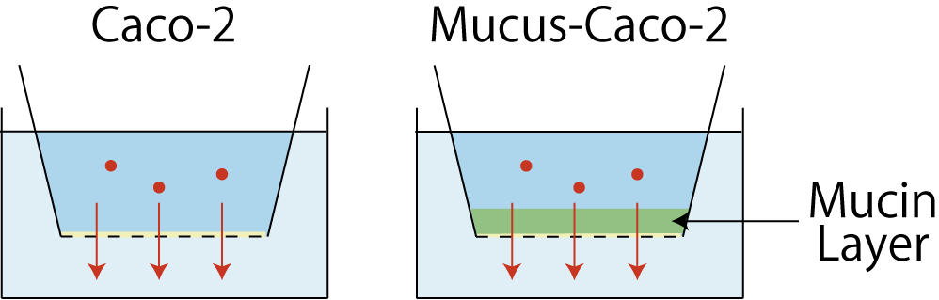

**Figure 1. Schematic Illustration of the Mucus-Caco-2 Model**

グラフ, 棒グラフ

AI によって生成されたコンテンツは間違っている可能性があります。

**Figure 2 Effects of Excipients on Atenolol Permeability**