Tilianin suppresses NLRP3 inflammasome to mitigate myocardial ischemia/reperfusion injury
Shoubao Wang, Di Wu, Tianyi Yuan, Lianhua Fang, Guanhua Du.
Institute of Materia Medica, Chinese Academy of Medical Sciences and Peking Union Medical College, Beijing, China

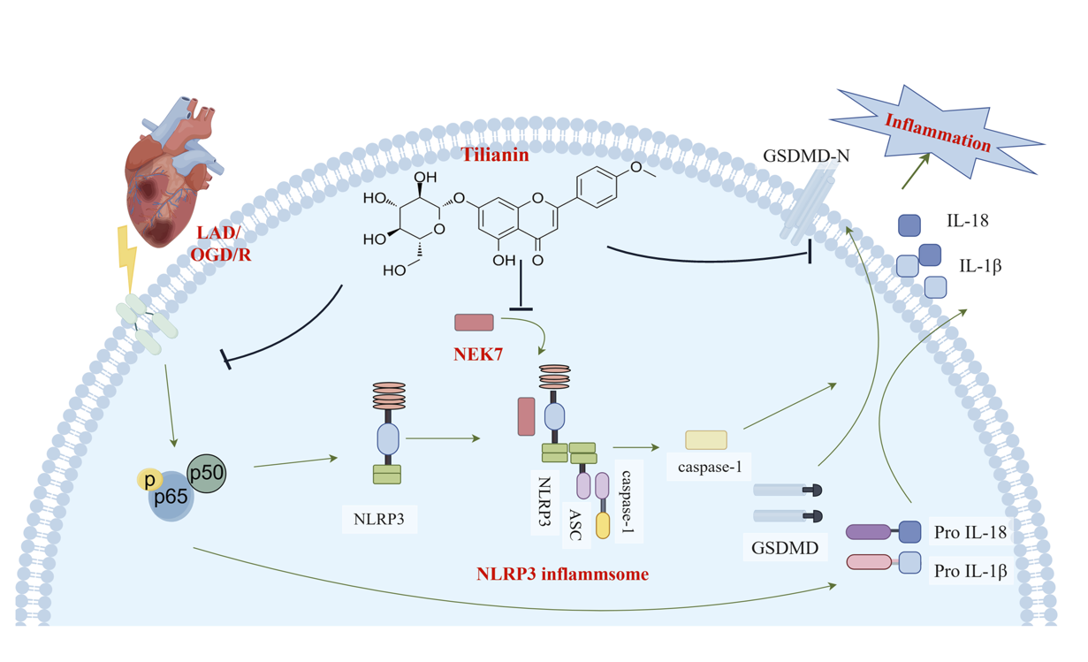
Introduction. Tilianin, a flavonoid compound derived from Dracocephalum moldavica L., is recognized for its diverse biological functionalities, in particular alleviating myocardial ischemia-reperfusion injury (MIRI).
Aims. This is aimed to investigate the effects of tilianin on NLRP3 inflammasome and explore its anti-MIRI mechanisms.
Methods. In this study, rats undergoing the ligation and subsequent release of the left anterior descending (LAD) coronary artery and H9c2 cardiomyocytes subjected to oxygen-glucose deprivation/reoxygenation (OGD/R) were used.
Results. Echocardiography, TTC staining and TUNEL staining demonstrated that tilianin remarkably improved cardiac function and mitigated myocardial damage in MIRI rats. Tilianin decreased the levels of TLR4，p-NF-B, NLRP3, and ASC in MIRI rats and H9c2 cells exposed to OGD/R, alongside a significant reduction in cleaved gasdermin D (GSDMD), mature IL-1 and IL-18. Tilianin protects cardiomyocytes from MIRI by suppressing NLRP3 inflammasome via inhibition of TLR4/NF-B and disruption of the NEK7/NLRP3 interface.
Discussion. The present study elucidated the anti-inflammatory role of tilianin against MIRI and explored its underlying mechanisms. Tilianin exerted its anti-inflammatory effects by inhibiting the expression of NLRP3 and pro-inflammatory cytokines through the suppression of TLR4/NF-κB signaling pathway. Additionally, the interaction between NEK7 and NLRP3 also mediated the anti-inflammatory activities of tilianin in the context of MIRI. These findings underscored the potential of tilianin as a promising therapeutic candidate for MIRI.

