Randomized controlled trial of pharmacogenetic-guided SSRI antidepressant therapy in major depression
Shubham Atal¹, Abhijit Rozatkar², Santenna Chenchula¹, Ratinder Jhaj¹, Tamonud Modak², Komal Kohat²
¹Department of Pharmacology, AIIMS Bhopal, M.P., India ²Department of Psychiatry, AIIMS Bhopal, M.P., India

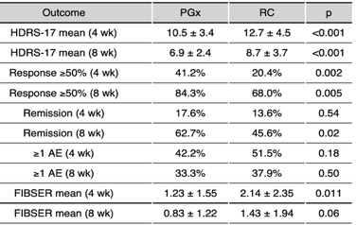
Introduction. Interindividual variability in antidepressant response is partly mediated by genetic polymorphisms in drug-metabolizing enzymes. Pharmacogenetic (PGx) guidance has been used to personalize antidepressant prescribing, but evidence from low- and middle-income country settings remains limited.
Aims. To evaluate whether PGx-guided prescribing of selective serotonin reuptake inhibitors (SSRIs) improves efficacy and tolerability compared with routine care (RC) in patients with major depressive disorder (MDD).
Methods. In this single-centre, randomized, double-blinded controlled trial, adults with newly diagnosed MDD were assigned (1:1) to PGx-guided treatment or RC for 8 weeks. CYP2D6 and CYP2C19 genotypes were interpreted as per CPIC guidelines. Outcomes included HDRS-17 change, response, remission, treatment modifications, and adverse events (AEs)/FIBSER scores. Intention-to-treat and conservative sensitivity analyses were performed. (CTRI/2022/08/044982)
Results. A total of 205 participants were randomized (PGx n=102; RC n=103) and assessed. With baseline characteristics and medication adherence balanced, HDRS-17 scores decreased more in PGx at 4 weeks (10.5 vs 12.7, p<0.001) and 8 weeks (6.9 vs 8.7, p<0.001). Response was higher in PGx at week 4 (41.2% vs 20.4%, RR 2.02, 95% CI 1.29–3.16) and week 8 (84.3% vs 68.0%, RR 1.24, 95% CI 1.06–1.45). Remission was greater at week 8 (62.7% vs 45.6%, RR 1.38, 95% CI 1.06 – 1.78). Early treatment modifications for non-response were fewer in PGx (22.5% vs 35.9%, p=0.035). AEs were also numerically fewer in PGx, with lower FIBSER at week 4 (1.23 vs 2.14, p=0.018). Sensitivity analyses with stricter criteria attenuated effects but preserved direction, with HDRS scores at both time points and week-4 (33.3% vs 20.4%) and week-8 response (79.4% vs 68.0%) as well as remission at week 8 (39.2% vs 27.2%) remaining borderline significant.
Discussion. PGx-guided prescribing led to higher early response, greater remission by week 8, fewer treatment modifications, and improved tolerability compared with routine care. Sensitivity analyses confirmed robustness of these findings though with reduced effect sizes. This first RCT from India supports the clinical utility of integrating pharmacogenetic testing into SSRI treatment pathways for MDD in real-world LMIC contexts.

