**Activation and allosteric modulation of the human GLP-1R by small-molecule ligands**

Xin Zhang1,2, Hariprasad Venugopal3, Samantha McNeill1, Matthew J. Belousoff1,2, Patrick M. Sexton1,2, Denise Wootten1,2. Drug Discovery Biology1, and ARC CCeMMP2, Monash Institute of Pharmaceutical Sciences, and Ramaciotti Centre for Cryo-Electron Microscopy3, Monash University, Melbourne, VIC, Australia.

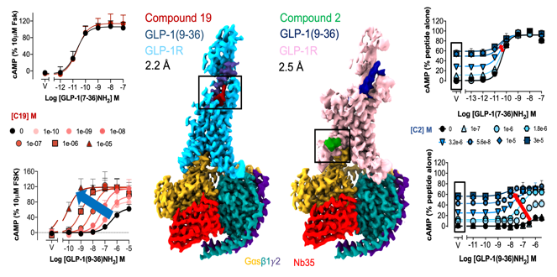**Introduction.** The glucagon-like peptide 1 receptor (GLP-1R) is a well-established clinical target for type II diabetes and obesity. A variety of GLP-1R non-peptidic agonists and positive allosteric modulators (PAMs) have been identified, however, how they bind and modulate GLP-1R function is poorly understood.

**Aims**. Determine structures of GLP-1R-Gs complexes bound to different endogenous peptide agonist (GLP-1, GLP-1(9-36)NH2, oxyntomodulin), biased small-molecule agonists (PF 06882961, CHU-128) or PAMs (compound 19, compound 2), and correlate these with their pharmacological profiles.

**Methods**. Structures of GLP-1R-Gs complexes were determined using cryo-electron microscopy (cryo-EM). Pharmacological profiles were assessed using assays of well-studied downstream signalling (cAMP production and calcium mobilisation) and regulatory (arrestin recruitment, internalisation) events.

**Results.** The binding site for PF 06882961 exhibits substantial overlap with that of endogenous peptide agonists within the receptor core. In contrast, CHU-128 displays limited overlap, which aligns with its divergent pharmacological properties (Deganutti et al 2022, Zhang et al 2020). Surprisingly, compound 19 engages at the extracellular side of the receptor, while compound 2 binds to the intracellular end. This correlates with the probe dependent properties of these PAMs, which differently modulate the metabolite signalling of endogenous peptides (Figure 1).

**Discussion.** Structural differences can be correlated to functional data revealing molecular insights into activation and modulation of small-molecule ligands. These findings will facilitate rational structure-based discovery of non-peptidic drugs targeting the GLP-1R and other related class B1 G protein-coupled receptors.

Deganutti G*, Liang YL*, Zhang X* et al (2022) Nat Commun 13:92; Zhang X et al (2020) Mol Cell 80:1–16