**AI‑Guided Identification of Microbial Signatures Linking Androgen Modulation to Accelerated Diabetic Wound Healing**

**Ziyang Sun1**, Qian Tan1, Yiwei Wang1,2

Department of Burns and Plastic Surgery, Nanjing Drum Tower Hospital, Clinical College, Nanjing University of Chinese Medicine1, Nanjing, Jiangsu, China.

Jiangsu Provincial Engineering Research Center of TCM External Medication Development and Application, School of Pharmacy, Nanjing University of Chinese Medicine2, Nanjing, Jiangsu, China.

**Background and aims.** Chronic diabetic wounds remain a clinical challenge due to persistent inflammation and impaired tissue repair. Androgen deprivation (via surgical castration) has shown potential in enhancing wound healing, however, the impact of androgen levels on the wound microbiome remains poorly understood. In this study, we combined high-throughput 16S rRNA sequencing with explainable AI modeling to investigate how castration reshapes the wound microbiota and to identify bacterial taxa that promote or hinder healing.

**Methods.** Male db/db mice were randomised into castration and control groups. Seven days post-castration, a 1 cm² full-thickness dorsal wound was created. Wound closure was photographed on days 3, 7 and 14. Serum testosterone and dihydrotestosterone levels were quantified via LC-MS/MS. Histological analysis included H&E, Masson’s Trichrome, PCNA, CD206 staining was also conducted. Wound tissue were analysed by RT-qPCR for Il1b, Il6, Il10, Arg1 and Mrc1, and by 16S rRNA sequencing with PICRUSt2 functional prediction. Genus-level log-abundances, time points and wound closure rates were merged, filtered by LASSO, modelled using random-forest regression and interpreted with SHAP. Latent associations were validated using linear mixed-effects (LME) and generalised additive models (GAM).

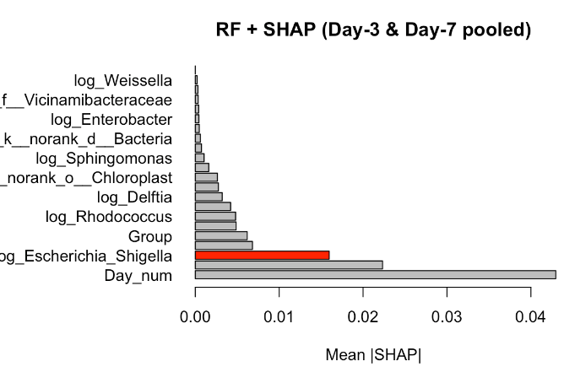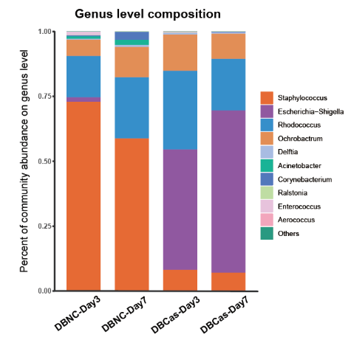**Results.** Castration significantly increased day-14 closure (81.8 ± 1.4% ) compared to controls (64.0 ± 4.9%) (p < 0.01). Alpha diversity indices (Chao and Shannon) increased by 1.5-fold. *Escherichia–Shigella* abundance increased, while *Staphylococcus* and *Rhodococcus* decrased, alongsie enrichment of energy- and carbohydrate-metabolism pathways and suppression of pathogen-associated pathways. qPCR showed sharp reductions in *Il1b* and *Il6* by day 3 and significant upregulation of *Il10* and *Mrc1* by day 7, indicating an early and sustained anti-inflammatory shift. SHAP ranked *Escherichia–Shigella* as the top pro-healing genus (LME marginal R² = 0.914, GAM adjusted R² = 0.956). Histological analysis confirmed faster re-epithelialisation, denser collagen deposition and increased CD206⁺ (M2) macrophages after castration (see Figure 1, Figure2).

**Figure 1.** Genus-level composition of wound microbiota across castrated (DBCas) and non-castrated (DBNC) diabetic mice at Day 3 and Day 7

**Figure 2.** SHAP summary plot of top predictors from Random Forest model (Day-3 & Day-7 pooled).

**Conclusion/Discussion.** Androgen deprivation enhances diabetic wound healing by diversifying the wound microbiome, suppressing early inflammation, promoting M2 macrophage polarization, and enriching beneficial metabolic pathways while reducing pathogenic taxa. The integrated LASSO–RF–SHAP framework explained over 96% of the variance in healing outcomes, offering robust microbial biomarkers to inform precision therapies targeting the endocrine to microbiome axis.

**References:**

(1) Xu Z.et al(2025). Unlocking the role of wound microbiome in diabetic, burn, and germ-free wound repair treated by natural and synthetic scaffolds. Acta Pharmaceutica Sinica B.