**Feasibility study of -cyclodextrin polymer as a therapeutic agent for Alzheimer’s diseases**

**Yuto Kubohira**, Nanami Okano, Toru Taharabaru, Taishi Higashi, Keiichi Motoyama.

Graduate School of Pharmaceutical Sciences, Kumamoto University, Kumamoto, Japan.

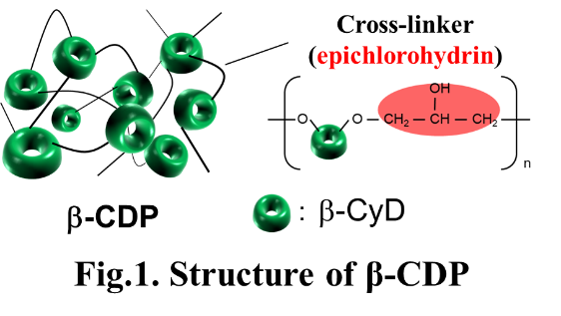**Background and aims.** In Alzheimer's disease (AD), which is characterized by neurological disorders, cholesterol accumulation in the brain and associated autophagy dysfunction are involved in the exacerbation of the pathology. Therefore, therapeutic agents designed to reduce cholesterol accumulation in the brain are attracting attention. Cyclodextrins (CyDs) can solubilize cholesterol in the cells and reduce intracellular cholesterol accumulation due to their inclusion properties. In particular, hydroxypropyl b-CyD (HP-b-CyD) is expected to be effective as a therapeutic agent for AD.1 However, high doses and long-term administration are required because of the low blood retention of HP-b-CyD. Thus, there is concern that HP-b-CyD might induce adverse effects such as ototoxicity and lung damage.2 The water-soluble b-CyD polymer (b-CDP) (Figure 1), in which b-CyD is cross-linked with epichlorohydrin, has high blood retention and cholesterol inclusion activity. Hence, b-CDP is expected as a therapeutic agent for AD. In the present study, we evaluated the potential of b-CDP as a therapeutic agent for AD.

**Figure 1.** Structure of b-CDP

**Methods.** Solubility phase diagrams were prepared to investigate the cholesterol solubilizing ability of b-CDP. The reducing effect of b-CDP on cholesterol accumulation was evaluated by detecting the intracellular cholesterol by filipin III staining. The autophagy normalizing ability of b-CDP in neuroblastoma cells treated with the cholesterol transport inhibitor was investigated by Western blot. In addition, the blood retention of b-CDP after the subcutaneous administration in healthy mice was evaluated by measuring the fluorescence intensity of labelled b-CDP in plasma. In addition, blood biochemistry tests of b-CDP were conducted for safety assessment.

**Results.** b-CDP showed higher cholesterol solubilizing ability than HP-b-CyD. In human neuroblastoma cells, b-CDP was less toxic at high concentrations. Furthermore, b-CDP decreased cholesterol accumulation and normalized autophagy in a concentration-dependent manner in cholesterol-accumulating neuroblastoma cells. b-CDP showed longer blood retention in mice than HP-b-CyD without affecting blood biochemical values after its subcutaneous administration.

**Conclusion/Discussion.** These results suggest that b-CDP has the potential as a therapeutic agent for AD. In the future, the development of b-CDP delivery technique to the brain and evaluation of therapeutic effect in the AD model mice are necessary.

**Acknowledgements:**

This work was supported by Nihon Shokuhin Kako Co. LTD, of Japan and JST SPRING, Grant Number JPMJSP2127.

**References:**

(1) Barbero-Camps, E. et al (2018) Autophagy 14:1129-1154

(2) Crumling, M.A. et al (2017) Front. Cell. Neurosci. 8:355