Self-sampling for precision dosing in oncology-preliminary data
Mirjana Radovanovic¹, Raina Naik², Sarah Glewis², May Darwish², Jennifer H Martin¹, Marliese Alexander².
Centre for Drug Repurposing and Medicines Research, University of Newcastle¹, Callaghan, NSW, Australia; Peter MacCallum Cancer Centre², Melbourne, VIC, Australia.

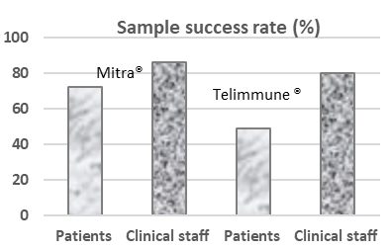
Introduction. Precision dosing using therapeutic drug monitoring (TDM) has demonstrated improved outcomes for patients receiving 5-fluorouracil (5FU), however the optimal testing time is when a patient is usually at home, complicating compliance. Finger-prick microsampling self-collection could improve compliance if adequate sample quality can be achieved.
Aims. To assess the quality of microsampling using a 2-sampler Mitra® device & a Telimmune® UNO card, informed by initial PRECISION trial experience with longitudinal 5FU testing (ACTRN12624000079549).
Methods. Patients (N=26, 48 TDM rounds) receiving a 5FU infusion had finger-prick samples taken both by themselves and by clinical staff, up to four samples per patient. Sample quality was visually assessed by a trained scientist. Mitra® devices were adequate if polymer tips were fully saturated with blood without the white mesh visible, no excess blood present on plastic holders, or dark spots of dried coagulated blood was present on the tips. Telimmune® UNO cards were adequate if the paper disc was evenly covered by a clear liquid smear without excess dried residue. Patients received education via product guides, commercial and in-house videos and instruction leaflets.
Results. Overall sampling success by clinical staff was 86% (38/44; 66% for both samples) with Mitra® and 80% (36/45) with Telimmune®UNO, compared to 72% (30/42; 43% for 2 adequate samples) and 49% (19/39) respectively, for patient-collected samples. The reasons for rejection of both Mitra® samples (18 instances, 36 tips) were due to underfilling (53%) and overfilling (47%). For the Telimmune®UNO devices, sample inadequacy was mainly due to underfilling (45%, 38/84), followed by haemolysis (21%, 17/84) and overfilling (20%, 16/84).
Discussion. Although the success rate of microsampling was higher when clinical staff performed the collection for both devices, poor sample quality produced by patients when using the Telimmune® cards, suggests the need for a comprehensive education programme or a more effective device before it can be implemented in clinical settings. This work was funded by The Australian Medical Research Future Fund (MRFFMMIP000011).

