Cocrystallisation as an Odour-masking Strategy in the Development of Palatable Medicines
Diba Keyhanfar^{1,2}, Dejan-Krešimir Bučar²; Catherine Tuleu¹
¹ UCL School of Pharmacy, , London, UK
² UCL Department of Chemistry, London, UK

Background and aims. Palatability, including taste, texture, and smell, is essential for patient compliance with oral medications.¹ While taste-masking strategies are well established, little work has explored methods to mask unpleasant pharmaceutical odours. Crystal engineering offers a promising approach to modifying solid-state properties of active pharmaceutical ingredients (APIs), including palatability.² Cocrystallisation, the formation of multi-component crystalline solids, is one such method.³ When an API is combined with a pharmaceutically acceptable coformer, the resulting pharmaceutical cocrystal can exhibit altered physical properties.
This study investigates the potential of cocrystallisation as an odour-masking strategy, a relatively unexplored area. Vitamin B compounds, commonly associated with unpleasant smells due to sulphur-containing groups, were selected as model APIs. Their structural diversity and hydrogen-bonding functionality make them suitable candidates for crystal engineering. The focus was placed on three compounds: thiamine (thi), nicotinic acid (na), and pyridoxine (py).

Methods. Cocrystal screens were accomplished through crystallisation methods that are known for their efficiency, namely neat grinding, liquid-assisted grinding and solution-mediated phase transformation. Solids made were analysed using powder X-ray diffraction and discovered cocrystals were then structurally characterised using single crystal X-ray diffraction.

Results. Two different smell masking strategies have been undertaken. The first approach was to use aroma chemicals as coformers with the aim of introducing a pleasant-smelling compounds into the crystal structure. The second strategy involved the use of hydrogen bonding coformers to involve the API in strongly hydrogen bonded networks, thereby reducing the vapour pressure of the API in the new crystal form. Overall, eight new crystal forms have been obtained and crystals suitable for single crystal X-ray diffraction analyses were grown and their structures were determined using this technique. Figure 1 shows examples of these structures
a
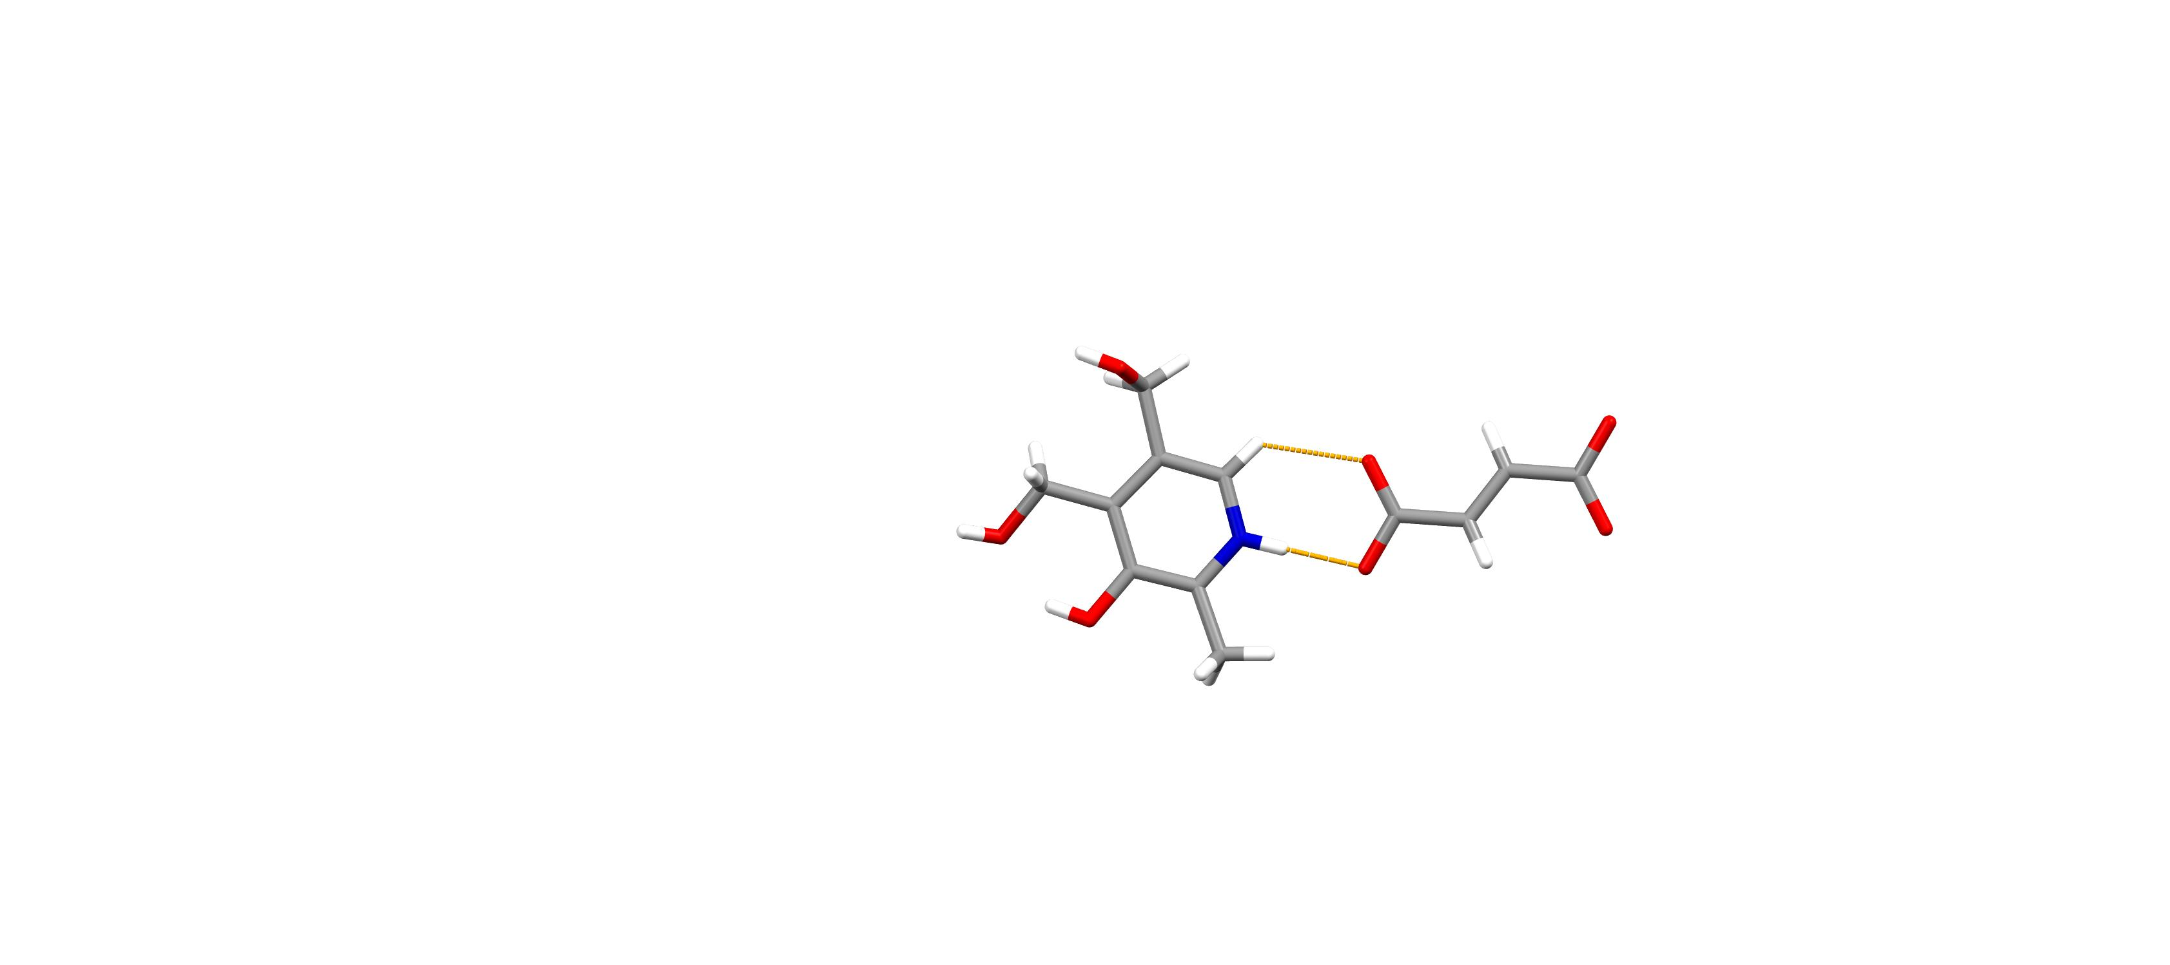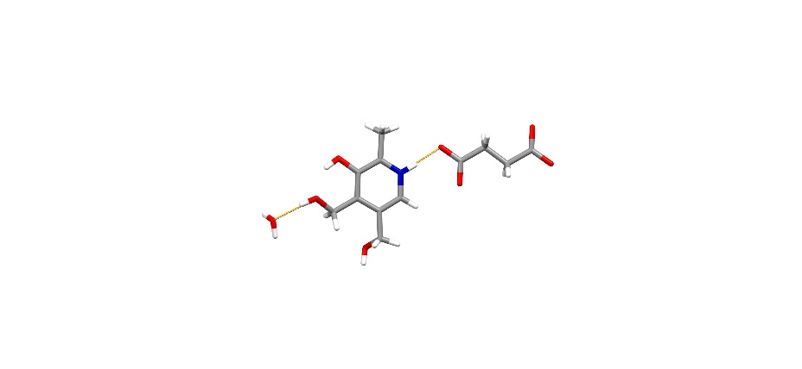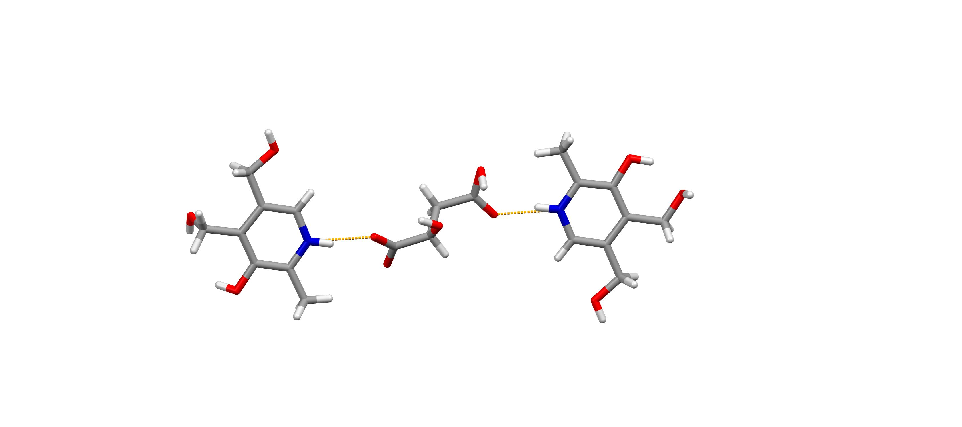
c
b
Figure 1. Single crystal X-ray structures of: a) (py)⁺·(fumaric acid) ̶ salt, b) (py)⁺·(succinic acid) ̶ ·(H₂O) salt hydrate, c) (PY)⁺·(adipic acid) ̶ salt
Conclusion and future work. This study demonstrates the successful formation of new cocrystals of vitamin B compounds and provides preliminary insights into their potential for odour masking. To confirm that cocrystallisation is an effective odour-masking strategy, a human sensory (smell) panel is required [UCL Research Ethics Committee Project ID Number: 4612/034]. Further exploration into optimising both odour and taste characteristics is warranted to improve patient acceptability and experience.
Acknowledgements. Funding and support from the EPSRC (EP/S023054/1) and the Transformative Pharmaceutical Technologies CDT are gratefully acknowledged.
References:

