**Medical Applications of Ultrafine Bubbles Generated with Bioactive Gases**

**Kaori Fukushige1**, Naoyuki Hatayama1, Takao Takeuchi1, Eiichi Goto1, Munekazu Naito1.

Department of Anatomy, Aichi Medical University1, Nagakute, Aichi, Japan;

**Background and aims.** Bioactive gases such as oxygen (O₂), nitric oxide (NO), and carbon monoxide (CO) function as signaling molecules and hold therapeutic potential. However, their pharmaceutical formulation remains technically challenging due to their gaseous nature. Ultrafine bubbles (UFBs), defined as gas particles <1 μm in diameter, enable stable dispersion of gases in aqueous media and may serve as intracellular delivery carriers. Unlike conventional drug delivery carriers, UFBs consist solely of gas cores without solid shells, which are expected to be useful in minimally invasive, gas-based therapeutic approaches. This study investigated the pharmaceutical formulation and medical applicability of UFBs generated with various bioactive gases.

**Methods.** UFBs containing each gas (O₂-UFBs, NO-UFBs, and CO-UFBs) were generated using a custom-designed closed venturi-type system based on cavitation. Sterile UFBs approximately 110 nm in diameter and exceeding 2×10⁹ particles/mL can be obtained. Depending on the evaluation system, appropriate dispersion media such as ultrapure water, saline, or cell culture media were used. Particle size, concentration, and zeta potential were measured using nanoparticle tracking analysis (NTA) and electrophoretic light scattering (ELS). O₂-UFBs were evaluated for their effects on proliferation and maintenance of pluripotency in induced pluripotent stem cells (iPSCs). NO-UFBs were assessed for cytotoxicity and vasodilatory function using H9c2 cardiomyoblasts in vitro and intravenous administration in dogs. CO-UFBs were evaluated for organ preservation using both cultured cells and rat models.

**Results.** The physicochemical properties of UFBs—including particle size and particle concentration—varied significantly depending on　 the gas species and dispersion medium, influencing both formulation stability and filterability. O₂-UFBs promoted iPSC proliferation by 5–10% without impairing pluripotency. NO-UFBs exhibited no cytotoxicity and significantly reduced intracellular Ca²⁺ levels in H9c2 cardiomyoblasts. In vivo, repeated intravenous administration of NO-UFBs in dogs resulted in dose-dependent hypotensive effects without observable toxicity. CO-UFBs demonstrated beneficial effects on organ preservation in both cultured cells and rat organ models.

**Conclusion/Discussion.** These findings support the potential utility of bioactive-gas-based UFBs in diverse biomedical applications, offering new avenues for gas-mediated cellular modulation, drug delivery, and therapeutic strategies.

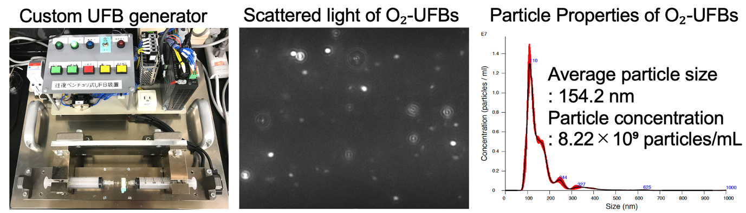

**Figure 1.** The left panel shows the custom-designed UFB generation device developed for medical use. The center and right panels show the analysis of O₂-UFBs dispersed in DMEM, prepared using the device shown on the left. The sample was diluted 10-fold and measured using NanoSight NS300 (Malvern). The center panel displays a scattered light image (visualization of O₂-UFBs), and the right panel presents the particle size distribution, including average particle size and particle concentration.