Active Learning with Thompson Sampling for hERG Risk Modelling in Drug Development
Slade Matthews, CPT Lab, Sydney Pharmacy School, The University of Sydney, Sydney, NSW, Australia

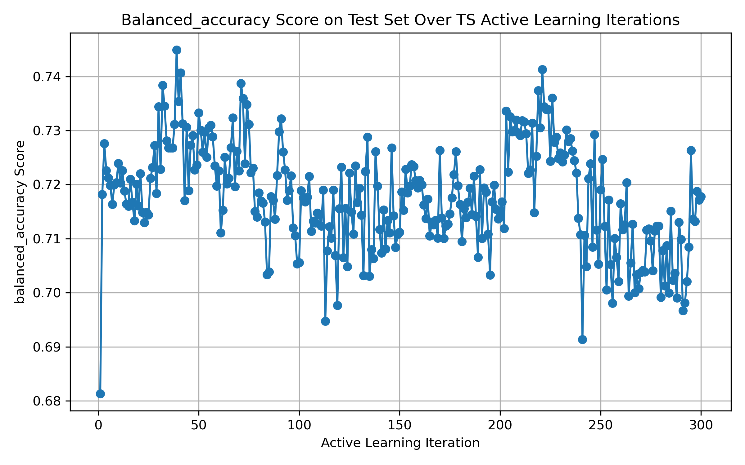
Introduction. The human Ether-à-go-go-Related Gene (hERG) encodes a potassium channel critical for cardiac repolarization. Making hERG binding a key component of the standard preclinical safety assay battery. Traditional machine learning approaches train over an entire dataset, potentially limiting efficiency when data are scarce, or labelling is costly.
Aims. To improve hERG prediction with active learning approaches.
Methods. This work builds on previous active learning experiments with the addition of Thompson sampling (TS). TS is an active learning approach where epistemic uncertainty is within the model itself rather than in the training loop (prediction outputs) presented at ASCEPT 2024. To approximate Bayesian inference a Bayesian neural network with Monte Carlo (MC) dropout is used. MC Dropout is applied during inference creating a predictive posterior distribution consisting of several possible models arising from the stochastic dropout mask. Data (pCI50 >6) from Konda et al., 2019 and Pytorch for model generation was used.
Results. Preliminary results generated using 300 queries for code development. The balanced accuracy on the training data reached over 74% (Figure 1) and on hold-out test set 71.8% with precision and recall of 0.559, and 0.535 respectively. Performance is anticipated to improve when the final model is presented with 3000 queries.
Discussion. The significance of development of active learning models, including Thompson sampling, is that they typically require fewer data points than traditional approaches. Data availability remains a challenge in the development of in silico toxicity models making the efficient use of existing data a high global priority. The move away from animal-based toxicity assessments positions in silico toxicity assay models at the forefront of toxicology in the 21st century.

Konda et al (2019) Computational Toxicology, 12.
Ramirez-Loaiza et al (2016) Data Mining and Knowledge Discovery, 31(2), 287-313.

