Effect of SGLT2 Inhibitors on UTI Incidence in Patients with T2DM. Systematic Review
Dixxie Rhentsia Regina Teopilus¹, Abraham Simatupang^{2*}. Ida Bagus Eka Utama³. Undergraduate Study Program, Faculty of Medicine-Universitas Kristen Indonesia¹, Jakarta, Indonesia; Department of Pharmacology & Therapy, Faculty of Medicine-Universitas Kristen Indonesia², Jakarta, Indonesia; Department of Pediatric, Faculty of Medicine-Universitas Kristen Indonesia³, Jakarta, Indonesia

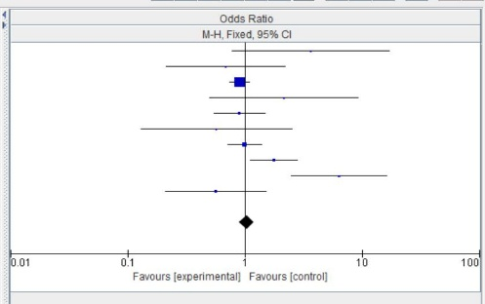
Introduction. Sodium Glucose Transporter 2 Inhibitors (SGLT-2i) are FDA-approved drugs for lowering blood glucose levels in T2DM patients, offering additional benefits such as reducing cardiovascular events and slowing the progression of chronic kidney disease. However, the use of SGLT-2i has also been associated with a potential risk of urinary tract infections (UTI).
Figure 1. Forest plot
Aims. This study aimed to evaluate the effect of SGLT-2 inhibitor use on the incidence of UTI in patients with T2DM.
Methods. This was a quantitative systematic review study. Systematic literature searches covering the years 2014–2025 were carried out using scientific databases such as PubMed, Cochrane Library, Scopus, and Google Scholar. Following a thorough selection procedure that included duplication removal, title/abstract relevance, and inclusion/exclusion criteria, 19 of the 952 initially found articles satisfied the requirements for additional analysis utilizing Review Manager 5.4 software.
Results. The meta-analysis of the 19 studies revealed no statistically significant difference between the SGLT-2 inhibitor user group and the control group regarding the incidence of UTI. The aggregate odds ratio (OR) was 0.99 (95% CI: 0.96 – 1.02) with a p-value of 0.59.
Discussion. The use of SGLT-2 inhibitors is not significantly associated with an increased or decreased risk of UTI incidence. Nevertheless, factors such as female gender and initial duration of use (12-24 weeks) may influence UTI incidence in certain individuals.

*Corresponding author: abraham.simatupang@uki.ac.id

