Medicines safety in heart failure virtual wards: a qualitative study
Ali A Hosin^{1,2}, James Gamble², James Fullerton^{1,2}, Erin Hannink^{1,2}. Nuffield Department of Orthopaedics, Rheumatology & Musculoskeletal Science, University of Oxford¹, UK; Oxford University Hospitals NHS Foundation Trust², Oxford, UK.

Introduction: Heart Failure Virtual Wards (HF VWs) are expanding across the UK¹ to deliver hospital-level care at home, including high-risk therapies such as intravenous diuretics. Evidence on medicines safety in this model remains limited.
Aims: To explore healthcare professionals’ experiences of medication‑related processes and risks in HF VWs.
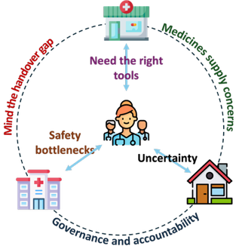
Methods: Semi‑structured interviews were conducted with 15 healthcare professionals working in HF VWs across the UK and Ireland. Interviews were transcribed verbatim and analysed using reflexive thematic analysis.²
Results: Six medicines safety-related themes were developed:
- The dilemma of governance and accountability: unclear risk ownership across organisations and concerns about remote decision-making.
- Rapid optimisation needs the right tools: specialist-led, rapid medication titration depended on reliable monitoring equipment and clear escalation thresholds.
- Safety bottlenecks: delayed blood results and limited access to point-of-care testing (POCT) reduced confidence in VW safety.
- The handover gap: Shared records mitigated risk, but IT problems impacted continuity.
- Medicines supply concerns: delays between prescribing decisions and medicines reaching home.
- Uncertainty of home-based administration: challenges in confirming correct administration at home (dose/time taken, documentation) and reliance on carers.
Discussion: Medicines safety in HF VWs reflects a tension between rapid specialist-led optimisation and reduced control in home-based care. Participants described variable governance, monitoring limitations, supply delays and documentation ambiguity across sites. Strengthened accountability structures, interoperable records, reliable supply pathways and access to POCT may improve safety. Further work is needed to quantify medication-related harms in HF VWs, which may be achieved using electronic health records and safety reporting data.

¹Department of Health and Social Care (2025) Fit for the future: 10 Year Health Plan for England
²Braun and Clarke (2006) ‘Using thematic analysis in psychology’, Qualitative Research in Psychology, 3(2), pp. 77–101

