**How Do They Stack Up? Reconstitution and Quality Comparison of Piperacillin/Tazobactam Injectables**

Yunmei Song1, Souha H. Youssef1, Hartley Atkinson2, Sanjay Garg1

Clinical and Health Sciences, University of South Australia, Adelaide1, Australia

R&D Division, AFT Pharmaceuticals Pty Ltd2, Sydney, NSW, Australia

**Background and aims.** Piperacillin 4 g/Tazobactam 500 mg is a commonly used broad-spectrum antibiotic combination for the treatment of infections requiring intravenous (IV) therapy. In clinical settings, timely and consistent reconstitution of injectable antibiotics is critical to ensure rapid drug availability, maintain dosing accuracy, and support workflow efficiency. This study aimed to evaluate and compare the reconstitution characteristics of three commercially available Piperacillin/Tazobactam products, with a focus on reconstitution characteristics and key quality attributes.

**Methods.** Three brands of Piperacillin/Tazobactam IV injections (AFT, Sandoz, and Fresenius-Kabi) were assessed. Each vial was reconstituted with sterile water for injection as per pamphlet instructions and agitated at a controlled speed of 200 revolutions per minute to standardise the mixing process. The reconstitution time was measured, defined as the time required to obtain a clear, particle-free solution. Additional assessments included pH measurement immediately after reconstitution and qualitative analysis of particulate matter using light microscopy (10x).

**Results.** AFT showed the shortest and most consistent reconstitution times (4.51 ± 0.29 min), followed by Sandoz (13.69 ± 1.71 min) and Fresenius-Kabi (16.38 ± 1.47 min) (Figure 1). pH measurements also varied significantly (p < 0.0001), with AFT exhibiting the highest pH (6.37 ± 0.03), followed by Sandoz (6.14 ± 0.05) and Fresenius-Kabi (5.96 ± 0.01). All products showed complete dissolution under microscopy, with no visible particulate matter.

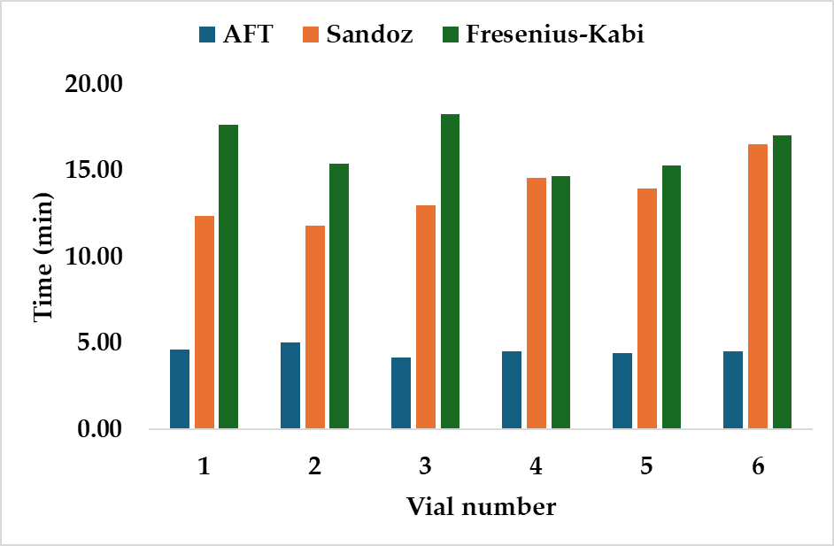

**Figure 1.** Reconstitution times of Piperacillin-Tazobactam injectable vials sourced from different brands

**Conclusion/Discussion.** This study demonstrated significant differences in reconstitution time and pH among the three products. AFT product consistently reconstituted fastest and most uniformly, with a stable pH and clear solution, suggesting practical advantages in clinical settings where rapid, reliable preparation is essential.

**References:**

(1) Traub-Hoffmann, K. et al (2020) J Pharm Sci 109(1):211–215.

(2) Zhang, X. et al (2024) Antib Ther 7(1):67–76.