Nanosized shikonin: An effective therapeutic agent against sepsis and other inflammation-related disease
Yuqing Miao¹, Haifa Qiao^{1,2}. Shaanxi Collaborative Innovation Center of TCM Technologies and Devices, Shaanxi University of Chinese Medicine, Xianyang, Shaanxi, China; Shaanxi Key Laboratory of Integrated Acupuncture and Drugs, College of Acupuncture and Tuina ², Shaanxi University of Chinese Medicine, Xianyang, Shaanxi, China.
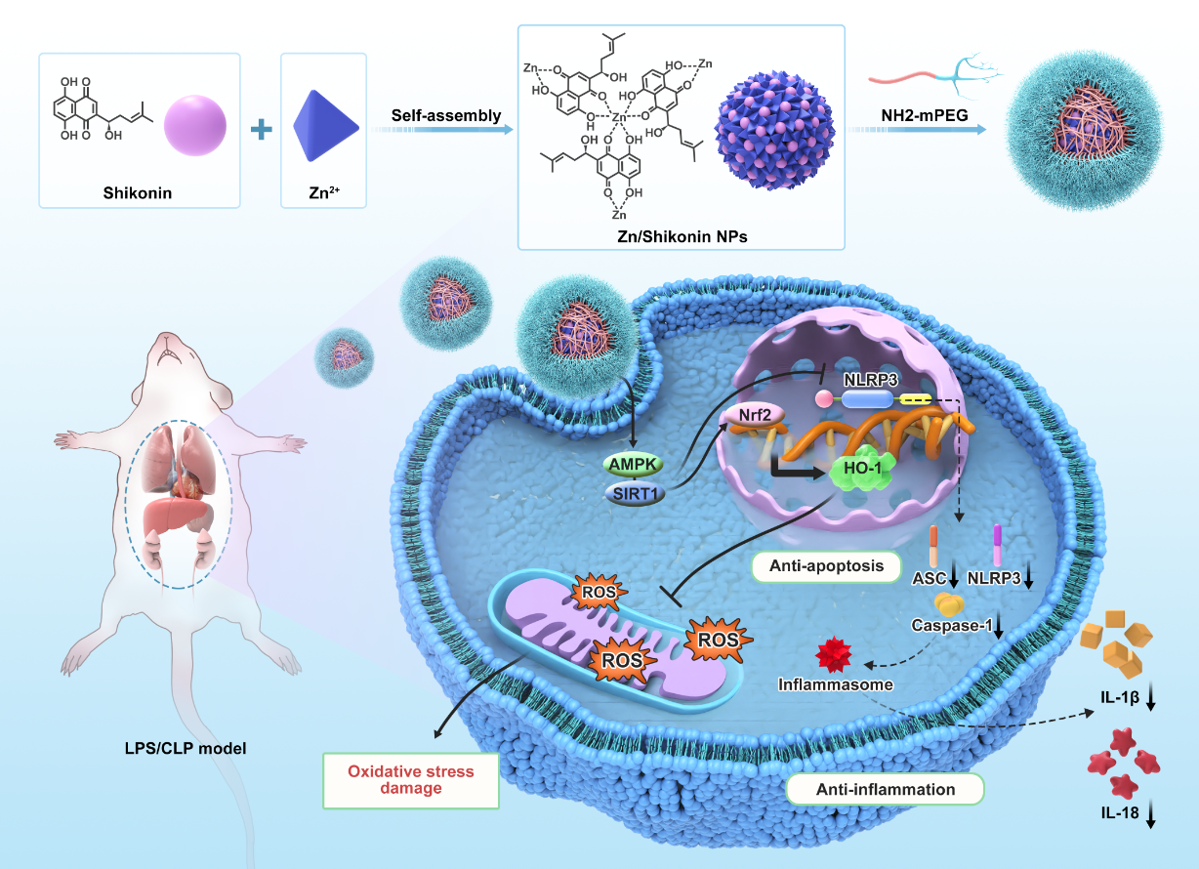
Introduction. Previous studies have reported that shikonin (Shik), a component of Chinese herbal medicine, also known as “Zi-cao”, possess prominent anti-inflammatory and antioxidant effects and holds promise as a potential therapeutic drug for inflammation related disease, such as sepsis and diabetic foot ulcers. However, the poor water solubility and the relatively high toxicity of shikonin hamper its clinical application.
Aims. A metal-polyphenol coordination-based organic-inorganic hybridization strategy was used to improve the efficacy and further decrease toxicity.
Methods. we constructed nanosized shikonin, based on an organic-inorganic hybridization strategy of metal-polyphenol coordination to improve the aqueous solubility and biosafety of shikonin. The therapeutic efficacy of Zn-Shik-PEG nanoparticles was evaluated by in vitro and in vivo experiments.
Results. Nanosized shikonin effectively improved the aqueous solubility and biosafety of shikonin. Mechanistic studies suggest that Shikonin NPs could effectively clear intracellular ROS via regulating the Nrf2/HO-1 pathway, meanwhile Shikonin NPs could inhibit NLRP3 inflammasome-mediated activation of inflammation and apoptosis by regulating the AMPK/SIRT1 pathway. As a result, the Shikonin NPs demonstrated excellent therapeutic efficacies in sepsis and diabetic foot ulcers model.
Discussion. These findings suggest that Nanosized shikonin may have therapeutic potential for the treatment of sepsis and other inflammatory diseases.

