High-throughput mutagenesis towards a comprehensive AGTR1 missense variant library
Felipe de J. Navarro Vela,¹ Harald Janovjak,¹ Joshua G. Dubowsky¹. Flinders Health and Medical Research Institute, Flinders University¹, Adelaide, SA, Australia.

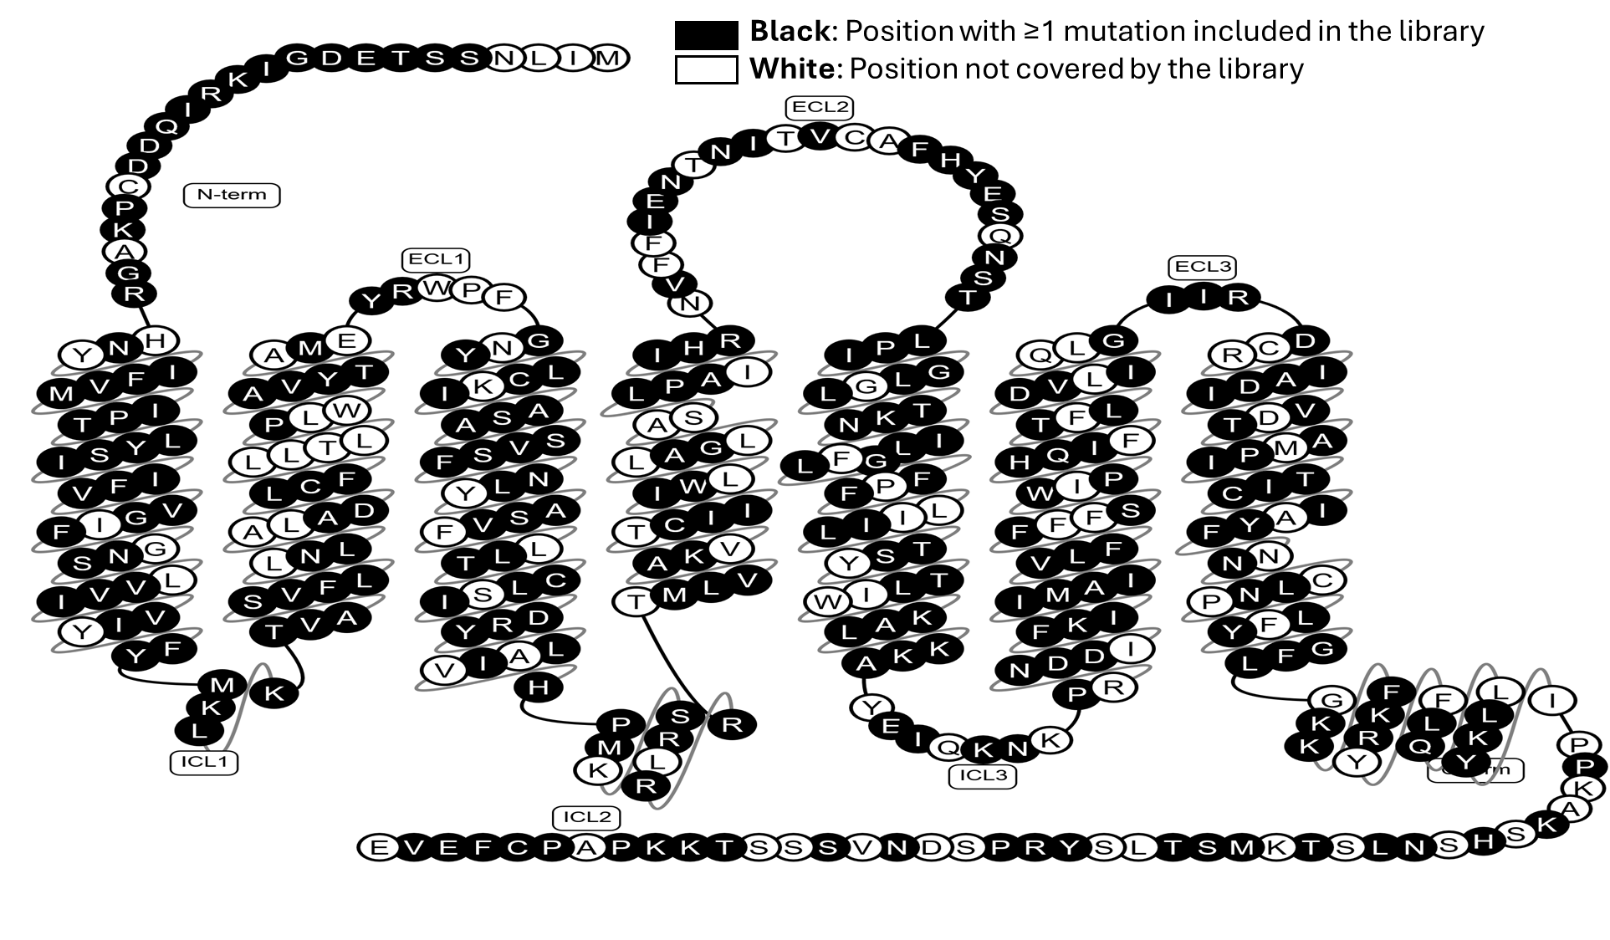
Introduction. Over 400 million individuals worldwide require antihypertensive drugs (AHD), with an estimated 600,000 carrying a missense variant in AGTR1, the primary target of these therapies. Hundreds of AGTR1 missense variants have been documented in the global population, yet most remain uncharacterised regarding their impact on AHD effectiveness. A significant obstacle for pharmacogenomic research is the time and resource intensive production of large mutant libraries. The high-throughput, discretely arrayed method of site-directed mutagenesis utilised here allows rapid, reproducible and precise dissection of mutations.
Aims. To develop an arrayed plasmid library of more than 400 AGTR1 missense variants for downstream cell based functional analysis.
Methods. All AGTR1 missense variants reported in gnomAD were compiled and mutagenesis primers were designed accordingly. Leveraging an in-house, high-throughput cloning pipeline, 405 arrayed mutant constructs were generated in less than two weeks. The presence of the intended missense mutations was confirmed through long-read sequencing and bioinformatic analysis of the open reading frames.
Results. A single round of mutagenesis yielded 99.7% of AGTR1 missense variants reported in gnomAD. Functional screening of selected variants is underway to evaluate receptor responsiveness to angiotensin II and antihypertensive drugs using Ca²⁺ assays.
Discussion. This high-throughput approach enables rapid, systematic functional analysis of missense variants, facilitating pharmacogenomic studies of AGTR1 and other genes. These advances support translational outcomes for precision medicine through systematic characterisation of genetic variants.

