**DoE-Based Optimization of Hexosome Formulation for Nose-to-Brain Delivery: In Vitro Evaluation of Permeability and Stability**

**Yeon sil Lee1**, Heejun Park1.

Pharmaceutical Research Laboratory, Department of Pharmacy, Duksung Women’s University, Seoul, South Korea1

**Background and aims.** Intranasal administration offers a non-invasive approach to bypass the blood–brain barrier (BBB) for the treatment of neurological disorders, including Alzheimer’s disease. This study employed Donepezil (DPZ), a BCS class II drug, to investigate the potential for brain delivery via the nose-to-brain (N2B) pathway. Hexosome lipid nanocarriers, a subclass of lyotropic liquid crystal nanoparticles (LCNPs), were optimized using a design of experiments (DoE) approach and characterized for physicochemical stability, particle size distribution (PSD), and in vitro permeability through PAMPA and nasal epithelial cells.

**Methods.** The hexagonal (HⅡ) gel was prepared by mixing glyceryl monooleate (GMO) and oleic acid (OA) at defined weight ratios, followed by the addition of deionized water. The mixture was equilibrated at 45 °C for 3 days to allow phase formation. The resulting gel was dispersed in 0.5% Poloxamer 407 solution to obtain Hexosome. A Box–Behnken design (BBD) was applied to optimize the formulation by varying the GMO:OA ratio (3–9), lipid content (70–90% w/w), and external-to-internal phase ratio (10–30% w/w).

**Results.** The BBD identified the optimal HⅡ gel composition as GMO/OA/DW = 77.2/12.8/10 (w/w%) with DPZ incorporated at the optimal ratio. Hexosome with an external/internal phase ratio of 10% retained the HⅡ structure, as confirmed by SAXS. After 6 months, PLM showed preserved birefringence and morphology. The optimized formulation exhibited PSD parameters within the acceptable range and encapsulation efficiency (EE%) >90%. PAMPA and RPMI 2650 cell studies demonstrated sustained drug release, supporting its potential for nose-to-brain delivery.

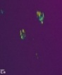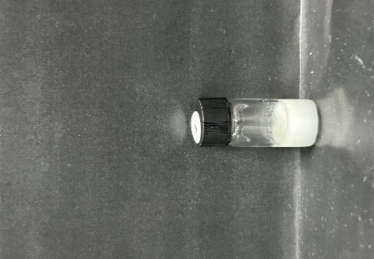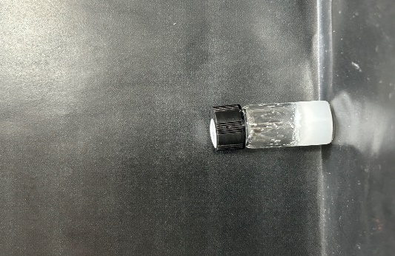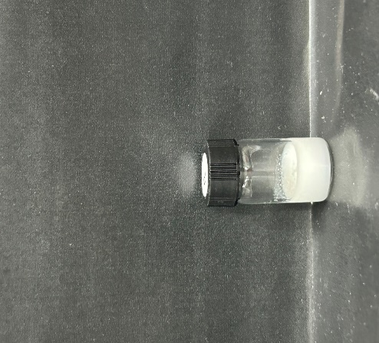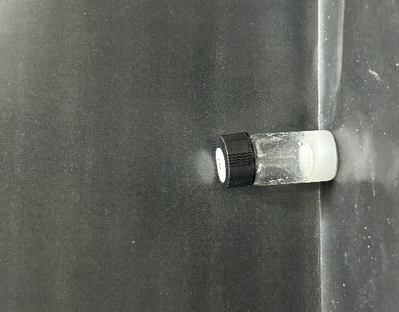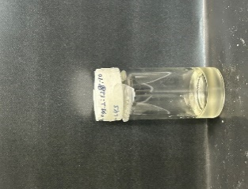

**HⅡ gel**

**1 month**

**3 month**

**5 month**

**6 month**

**PLM**

**Visual  
Observation**

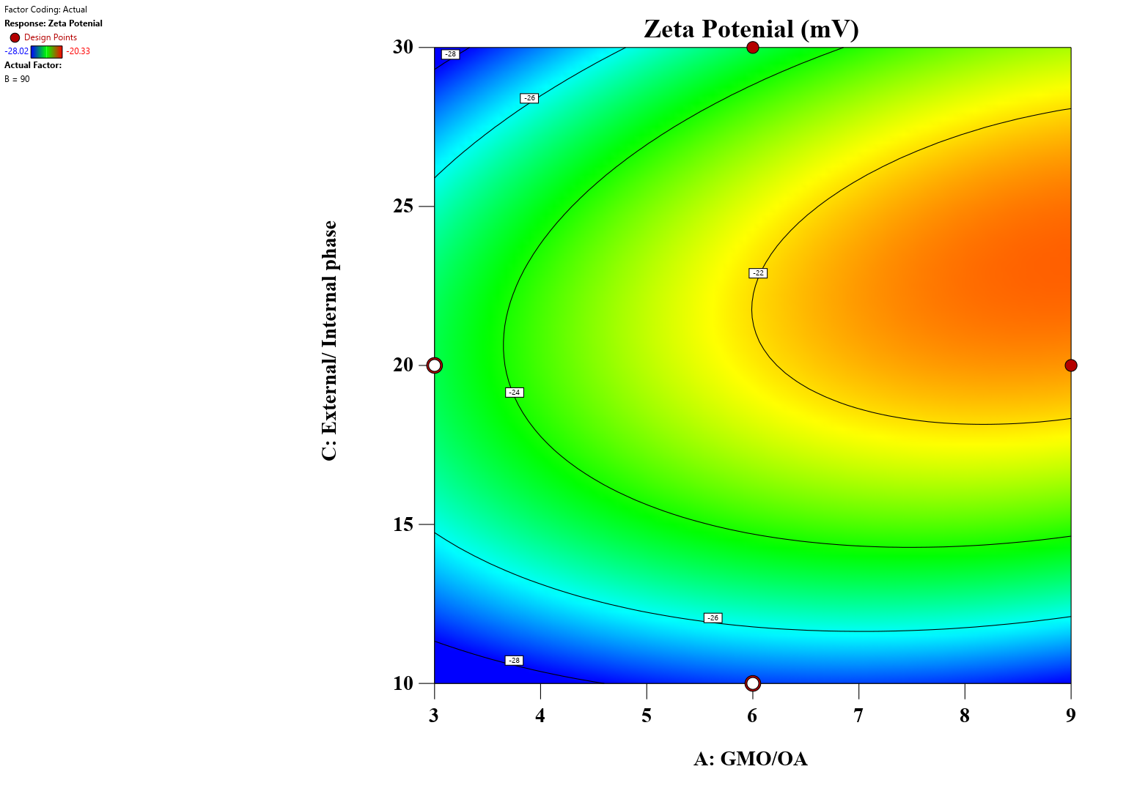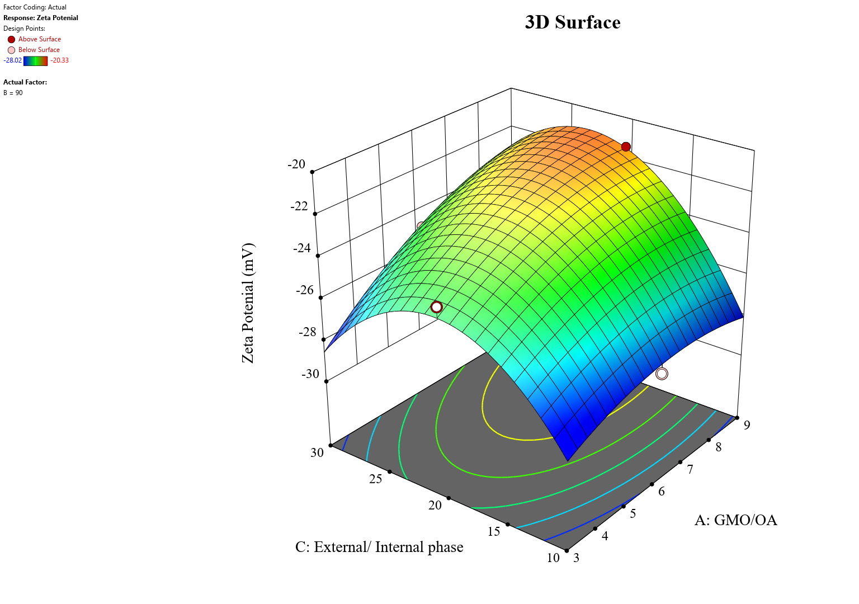

**(a)**

**(b)**

**Figure 1.** (a) PLM images showing stability of the optimized hexosome during 6‑month storage. (b)2D and 3D response surface plots for zeta potential (ZP) generated by the BBD.

**Conclusion/Discussion.** The optimized hexosome demonstrated stability, high encapsulation efficiency, and sustained drug release. These findings support its potential as an intranasal nanocarrier to enhance DPZ nose-to-brain delivery and improve therapeutic outcomes in Alzheimer’s disease.

**Acknowledgements:** This work was supported by the National Research Foundation of Korea (NRF) grant funded by the Korea government (MSIT) (No.2022R1C1C1010130). This work was supported by the Korea Basic Science Institute (National Research Facilities and Equipment Center) grant funded by the Korea government (MSIT) (No.RS-2024-00404864). This research was supported by the Technol-ogy Innovation Program (RS-2025-11572968), funded by the Ministry of Trade, Industry and En-ergy (MOTIE, Korea).

**References:**

(1) Agrawal, M. et al. (2018) *J. Control. Release* 281:139–177.

(2) Milak, S. and Zimmer, A. (2015) *Int. J. Pharm.*478(2):569–587.  
(3) Dinh, L. et al. (2024) *J. Pharm. Investig.* 54(4):539–554.  
(4) Lee, D. Y. et al. (2022) *Pharmaceutics* 14(6):1226.