**Lead-free halide perovskites and variants for low-cost optoelectronic and electronic device applications**

*Miaoqiang Lyu, Jung Ho Yun, Mehri Ghasemi and Lianzhou Wang*

*School of Chemical Engineering and Australian Institute for Bioengineering and Nanotechnology, The University of Queensland, Brisbane, QLD, 4072, Australia*

**Introduction**

Lead halide perovskites have been intensively studied in photovoltaics in the past few years with efficiencies surging from 3.8% to over 24% in a very short period. Accompanying the breakthroughs in the photovoltaic areas, a number of optoelectronic and electronic applications based on the lead halide perovskites have been attracting tremendous attention in the scientific and industrial communities, including light-emitting diodes (LEDs), lasers, memory devices, photodetectors and radiation detectors. Nevertheless, the toxicity issue of the lead in these best-performing halide perovskites is becoming an increasing concern in all of those research areas, leading to imperative demand for development of lead-free and environmentally-benign alternatives as replacements.

In addressing the lead-toxicity issue, this presentation focuses on the development of a series of lead-free halide perovskites and variants and their potential applications in photovoltaic and electronic device applications. In the electronic device, this presentation will demonstrate the metal halide perovskites based resistive random access memory device taking advantages of the solution-process and interesting intrinsic properties of the materials.

**Results and Discussions**

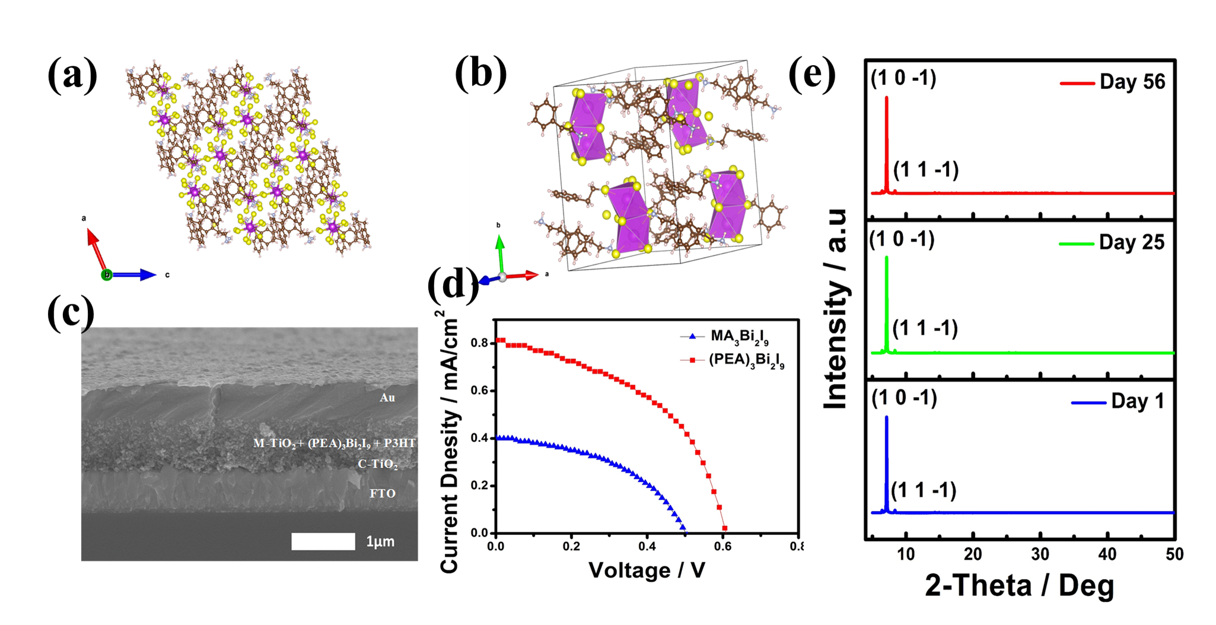

Figure 1. Phenethylammonium bismuth iodide ((PEA)3Bi2I9) (a-b) crystal structures; (c) Photovoltaic device SEM image, (d) Current-voltage characteristics of solar cells based on (PEA)3Bi2I9 and (e) XRD of the (PEA)3Bi2I9 thin-film stored in the ambient conditions.

Figure 1 just gives an example of the lead-free candidate based on (PEA)3Bi2I9, which shows photovoltaic effect and excellent ambient stability. In the presentation, more examples will be demonstrated, including methylammonium bismuth iodide single-crystals and photovoltaic devices based on its thin-films, double-perovskite (Cs2AgBiBr6) thin-film and its application in solar cells and memory devices. Also, we`ll briefly introduce the first demonstration of the lead halide perovskite based memory devices in comparison.

**Conclusion**

Lead-free metal halide perovskites and variants based on non-toxic bismuth are promising candidates in address the lead-toxicity and stability issues. Although the current performance in photovoltaics is not competitive, these new semiconducting materials shows promise for solution-processable electronic device applications.

**References**

1. M. Lyu, J.-H. Yun, M. Cai, Y. Jiao, P. V. Bernhardt, M. Zhang, Q. Wang, A. Du, H. Wang, G. Liu and L. Wang, Nano Res., 2016, 9, 692-702.

2. E. J. Yoo, M. Lyu, J. H. Yun, C. J. Kang, Y. J. Choi and L. Wang, Adv. Mater., 2015, 27, 6170-6175

3. M. Lyu, J.-H. Yun, P. Chen, M. Hao and L. Wang, Adv. Energy Mater., 2017, 7, 1602512.

4. M. Ghasemi, M. Lyu, M. Roknuzzaman, J.-H. Yun, M. Hao, D. He, Y. Bai, P. Chen, P. V. Bernhardt, K. Ostrikov and L. Wang, J. Mater. Chem. A, 2019, DOI: 10.1039/C9TA07454F.