Machine learning to predict adverse drug reactions in polypharmacy
Kajol Singh1. Uttar Pradesh Rajarshi Tandon Open University 1, Prayagraj, Uttar Pradesh, India.

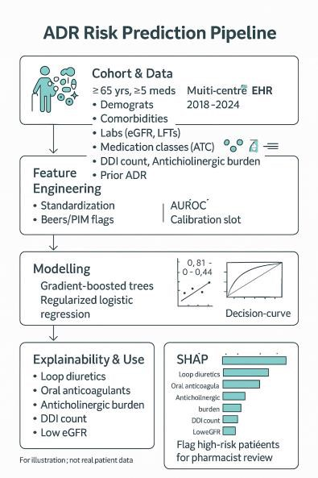
Introduction. Adverse drug reactions (ADRs) are a leading cause of hospitalisation in older adults, often precipitated by polypharmacy. Existing risk scores underperform across diverse clinical
settings, underscoring the need for transportable, interpretable prediction tools to support medication reviews in routine care.
Aims. To develop and externally validate a machine-learning model that predicts 30-day clinically significant ADRs in adults ≥65 years with ≥5 concurrent medicines, and to compare performance with logistic regression and a published ADR risk score.
Methods. We conducted a retrospective, multi-centre cohort study using linked electronic health records from two Australian health services (derivation: 2018– 2023; validation: 2024). Index encounters were emergency or inpatient admissions. Candidate predictors included demographics, comorbidity burden, renal/hepatic function, prior ADRs, Beers/PIM flags, drug–drug interaction (DDI) counts, anticholinergic burden, and therapeutic classes at ATC level 3. The primary outcome was a composite of ICD-10-coded ADR diagnosis or causality-assessed ADR requiring treatment change within 30 days of admission. Models (gradient-boosted trees, regularised logistic regression) were trained with nested cross-validation; discrimination (AUROC), calibration (slope, intercept), and decision-curve analysis were assessed. Model explainability used SHAP values. Pre-specified subgroups: frailty (HFRS ≥5), CKD (eGFR <45 mL/min/1.73 m²), and high DDI burden (≥5 level-2 interactions).
Results. The gradient-boosted model achieved AUROC 0.84 (95% CI 0.82–0.86) in internal validation and 0.81 (0.78– 0.84) in external validation, outperforming logistic regression (0.76; 0.73–0.79) and the published risk score (0.69; 0.66–0.72). Calibration slope was 0.98; intercept −0.01. Net benefit was higher across risk thresholds 5–20%. Top
contributors were loop diuretics, oral anticoagulants, anticholinergic burden, DDI count, prior ADR, and reduced eGFR. In CKD and high-DDI subgroups, sensitivity at a 10% threshold improved by 9–12% (P<0.01) without loss of specificity. A parsimonious 12-variable model retained AUROC 0.80.
Discussion. A transportable, interpretable model using routinely available data identified older adults at high ADR risk and outperformed existing tools. Prospective implementation to trigger pharmacist-led medication reviews and deprescribing could reduce preventable harm. Future work will integrate pharmacogenomic markers and prospective impact evaluation.

