Angiotensin receptors: signaling and receptor interactions
Mariela M. Gironacci. Department of Biological Chemistry, IQUIFIB (UBA-CONICET), Faculty of Pharmacy and Biochemistry, University of Buenos Aires, Argentina
Renin-angiotensin system (RAS)
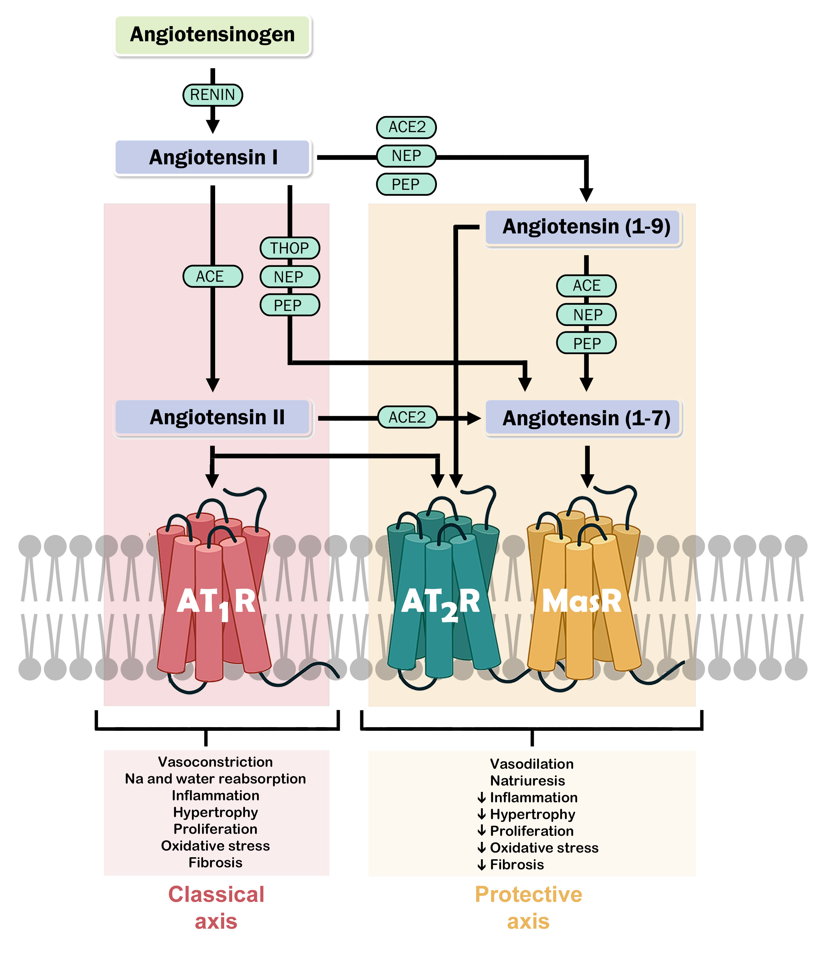
Introduction. G protein-coupled receptors (GPCRs) are a remarkably multifaceted family of transmembrane proteins that exert a variety of physiological effects. GPCRs operate not only as monomers, but they can also function in dimeric (homo and hetero) or higher-order oligomeric states. Due to the interaction with other receptors, GPCR affinity, trafficking, signalling and its biological function may be altered, providing a newly recognized means of modulation of receptor function. Accordingly, GPCR heteromerization represents an important and increasingly recognized mechanism for the dynamic regulation of receptor function. Biological responses mediated by receptors of the RAS, that is the AT1, AT2 and Mas receptors, are influenced by interaction with other GPCRs.
Aims. to investigate how the functional properties of the RAS receptors are influenced by interaction with other GPCRs.
Methods. Transfected HEK293T and human macrophages cells were used. Fluorescence resonance energy transfer and coimmunoprecipitation were employed to assess receptor interactions. Biological response, receptor affinity and signalling were measured.
Results. AT1, AT2 and Mas receptor affinity, signalling and biological response are modulated by interaction with other GPCRs. In addition, the anti-inflammatory actions of Mas receptor were mediated by interaction with other GPCRs that do not belong to the RAS. Interactions with other receptors induced alterations in Mas receptor trafficking, signaling and an increase in the ligand affinity of Mas receptor.
Discussion. GPCRs heteromerization not only brings forth a plethora of drug target combinations but also gives an opportunity to carefully tweak the structure and function of one or more GPCRs involved in the complex, with the final goal of improving therapeutic strategies.

