**Berberine Protects Cerebral Vessels and Alleviates Diabetic Encephalopathy by Inhibiting the Production of δ-Valerobetaine in the Gut Microbiota**

Zheng-Wei Zhang1, Wei-Ping Wang1, Jia-Chun Hu1, Jin-Yue Lu1, Shao-Feng Xu1, Ling Wang1, Xiao-Liang Wang1,2, Jian-Dong Jiang1, **Yan Wang1**.

State Key Laboratory of Bioactive Substance and Function of Natural Medicines, Institute of Materia Medica, Chinese Academy of Medical Sciences & Peking Union Medical College1, Beijing, China;

State Key Laboratory of Druggability Evaluation and Systematic Translational Medicine2, Tianjin, China.

**Background and aims.** Hyperglycemia in diabetes causes cognitive impairment, called diabetes encephalopathy (DE). Pathogenesis of DE closely relates to angiopathy and effective treatment is highly desirable. Botanic agent berberine (BBR) effectively lowers blood glucose in diabetic patients.

**Methods.** The type 2 diabetic encephalopathy KK-Ay mice model and fluorescent micro-optical sectioning tomography (fMOST) were used to determine the efficacy of BBR in improving cognitive function and integrity of brain vessels. Fecal microbiota transplantation (FMT), targeted metabolomics, 16s rRNA gene sequencing analysis and western blot were performed to explore the underlying mechanisms of BBR protecting cerebrovascular vessels through gut microbiota.

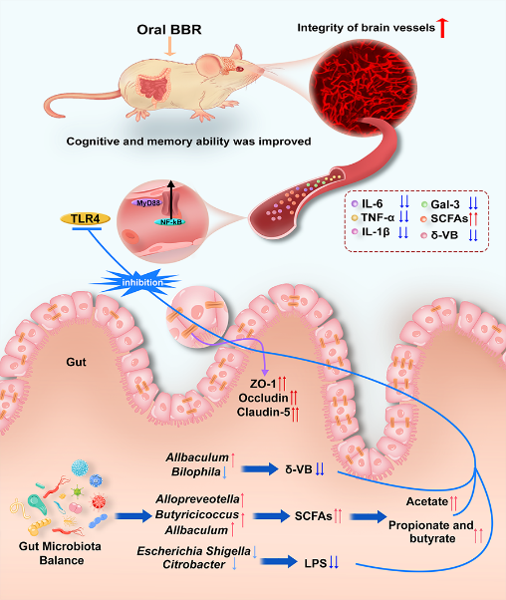**Results.** We showed for the first time that BBR significantly improved cognitive function in DE mice. High-resolution imagining by fMOST revealed that integrity of brain vessels was improved by BBR treatment. The improvements of average vessel diameter, vessel length, and total vessel volume were significant in the PtA, as well as in the CA1 and CA3 regions. Mechanism study showed that oral BBR inhibited δ-valerobetaine (δ-VB, a metabolite of gut microbiota) production in the intestine. As the intestinal δ-VB could enter circulation and activate the TLR-4/MyD88/NF-κB inflammatory pathway in epithelial cells of blood vessels through interacting with TLR-4, BBR might reduce the intestinal level of δ-VB to protect the cerebral blood vessels of DE mice and improved their brain function. FMT using the gut microbiota from BBR-treated mice confirmed the vital role of gut microbiota. With a wide-ranging action on gut flora, BBR also increased short-chain fatty acids (SCFAs) production and decreased lipopolysaccharide (LPS) in the intestine via adjusting the abundance of SCFAs- or LPS-producing bacterial. The observed therapeutic efficacy in vivo represented a synergistic effect of BBR on gut microbiota.

**Figure 1.** Graphic abstract.

**Conclusion/Discussion.** Our findings revealed an association between gut microbiota and blood vessels, of which intestinal δ- VB might be a chemical link. Mainly working through down-regulating δ-VB in the intestine, BBR protected cerebral vessels and alleviated DE.