**Microencapsulation of Purple Sweet Potato Leaf Extract (*Ipomoea batatas* L.) Antin-3 Variety as an Effort to “Taste Mask” the Active Ingredients of Antioxidant Chewable Tablet**

**Damaranie Dipahayu1**,Timbul Partogi H Simorangkir1, M.Si, Muhammad Raafi Al Ghifary1

Technology Formulation Pharmacy, Military Pharmacy Faculty of Republic Indonesia Defense University1, Sentul Bogor, West Java, Indonesia

**Background and aims.** Purple sweet potato leaf extract (Ipomoea batatas (L.)) variety Antin-3 has flavonoid and polyphenol content of 4.83±0.07% and 16.98±0.07% and has strong antioxidant activity, namely IC50 value of 47.99 ppm so that it has the potential as an active ingredient in antioxidant preparations (1). Children need antioxidant intake in the form of nutraceuticals that are fun and practical to consume, namely chewable tablets. Antioxidants are needed to protect body cells from damage, increase endurance and support brain development. Antin-3 extract has a bitter taste so that taste masking is needed so that this antioxidant nutraceutical is liked by children. One of the taste masking efforts is by blocking the bitter taste receptors for the active ingredient. One example is the microencapsulation of the active ingredient with maltodextrine (2). The nutraceutical is attempted to have a good taste so that children like it so that it will increase compliance in taking medication in pediatric patients (2).

**Methods.** Antin-3 thick extract was dispersed in maltrodextrin solution at a ratio of 2:1; 1:1; 1:2 accompanied by stirring at 350 rpm followed by trifugation at 4000 rpm for 30 minutes each. The filtrate was filtered through 0.45 μm and then freeze-dried with a freeze dryer for 74 hours at a temperature of -80 0C to produce Antin-3 extract microencapsulation (3). The chewable tablet formulation used the direct compression method, the additional ingredients used were mannitol, mg stearate, PEG 400, Avicel pH 102, and taro flavor (4). The chewable tablet preparation was evaluated for organoleptic, weight uniformity, size uniformity, tablet hardness, friability test, disintegration test, hedonic test and antioxidant activity test compared to the extract form and pure vitamin C (5)

**Result:**

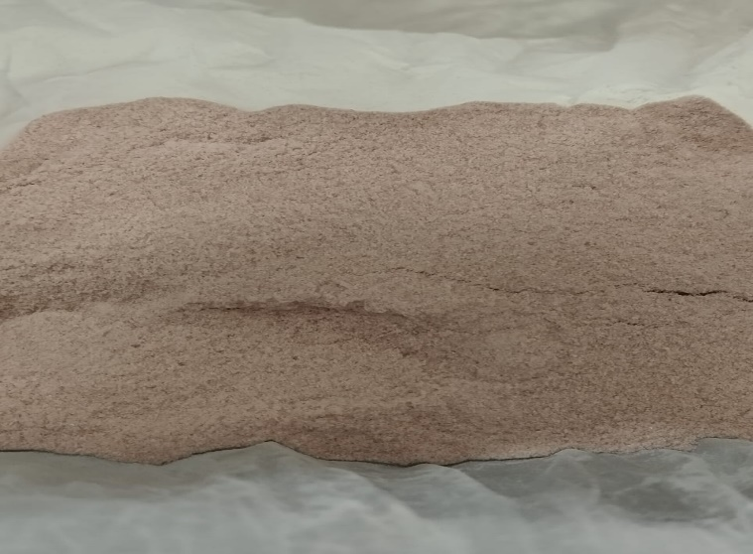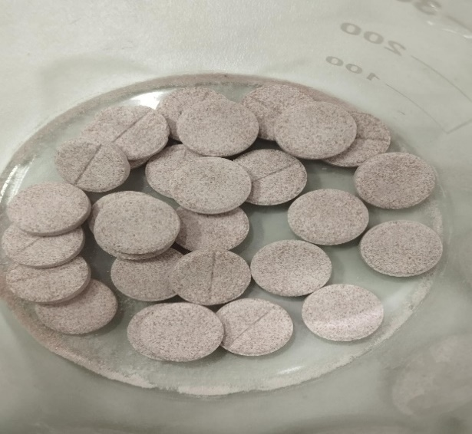

**Figure 1. Microencapsule ekstrak Antin-3 and chewable tablet**

|  |  |  |
| --- | --- | --- |
| **No** | **Sample** | **Nilai IC50** |
| 1 | Microencapsul F1  (Antin-3 extract: maltrodekstrin = 1:0.5) | 33.94 ± 0.10 |
| 2 | Microencapsul F2  (Antin-3 extract: maltrodekstrin = 1:1) | 35.08 ± 0.20 |
| 3 | Microencapsul F3  (Antin-3 extract: maltrodekstrin = 1:1.5) | 36.87 ± 0.20 |
| 4 | Ascorbic Acid | 14.32 |

**Table 1. IC 50 value of mikroencapsul Antin-3 and chewable tablet**

|  |  |  |  |  |  |  |
| --- | --- | --- | --- | --- | --- | --- |
| **No** | **Sample** | **Nilai IC50** | **Uji kerapuhan tablet** | **Uji kekerasan tablet** | **Uji waktu hancur tablet** | **Uji hedonis rasa tablet** |
| 1 | Chewable tablet F1 | 35.33 ± 3.48 | 0.94 % ± 0.06 | 14.05 ± 3.48 | 5.59 ± 2.13 | 60 percent vote for neutral taste |
| 2 | Chewable tablet F2 | 42.93 ± 2.78 | 0.94 % ± 0.03 | 14.10 ± 3.07 | 4.43 ± 1.83 | 55 persent responden percent vote for neutral |
| 3 | Chewable tablet F3 | 58.08 ± 3.05 | 0.98 % ± 0.02 | 14.50 ± 3.33 | 4,14 ± 1.93 | 55 percent vote for sweet taste |

**Table 2. IC50 value, physical characteristic and hedonic result**

**Conclusion/Discussion.**

The effort to cover the bitter taste of the extract by coating the extract with maltodextrin was quite successful. This is indicated by the hedonic value obtained, namely the majority of the bitter taste has been covered. The more maltodextrin added, the higher the percentage of respondents who expressed their liking for the tablet (tending to be sweet). In this study, the use of maltodextrin at least stated a neutral hedonic result, which illustrates that the tablet has no taste. This taste masking effort has been proven to still produce physical characteristics of the tablet that meet the requirements and antioxidant activity that is still relatively strong. From the results of this study, it can be concluded that this taste masking effort can be applied to bitter-tasting drug preparations to increase the acceptability of the preparation for children.

**Thanks to Military Pharmacy Faculty, Republic Indonesia Defense University for fundings to this research**

**References:**

(1) Damaranie Dipahayu; Galuh Gondo Kusumo (2020). Antioxidant Activity, Phenolic and Flavonoid Contents in The Leaves Extract of Purple Sweet Potatoes (Ipomoea batatas (L.)) Antin-3 Variety in Different Ethanol Concentration as a Solvent. In: The 3 rd Joint Conference Unair- USM, International Conference of Pharmacy and Health Sciences 2020 Non Proceedings.

(2) Abraham J and Mathew F.( 2013). Taste Masking of Pediatric Formulation: A Review on Technologies, Recent, Trends and Regulatory Aspect. IJPS: 6 (1): 12-19

(3) Pudziuvelyte, L., Marksa, M., Sosnowska, K., Winnicka, K., Morkuniene, R., & Bernatoniene, J. (2020). Freeze-drying technique for microencapsulation of *Elsholtzia ciliata* Ethanolic extract using different coating materials. *Molecules*, *25*(9). <https://doi.org/10.3390/molecules25092237>

(4) Tiyas Sawiji, R., Murrukmihadi, M., & Aisyah, S. (2019). Formulasi Tablet Kunyah Ekstrak Kelopak Bunga Rosella (Hibiscus Sabdariffa L.) Dengan Variasi Konsentrasi Pvp Sebagai Bahan Pengikat Terhadap Sifat Fisiknya. Dalam *Acta Holist. Pharm*, 1 (1).

(5) Dipahayu D and Safira A I. (2025). Aktivitas Antioksidan Sediaan Nutraceutical Tablet Hisap Ekstrak Daun Ubi Jalar Ungu (*Ipomoea batatas* L.) Varietas Antin-3. Borneo Journal of Pharmascientech, 09 (1): 29-34