ERO1α overexpression in triple-negative breast cancer links to EMT and mitochondria-dependent inhibition
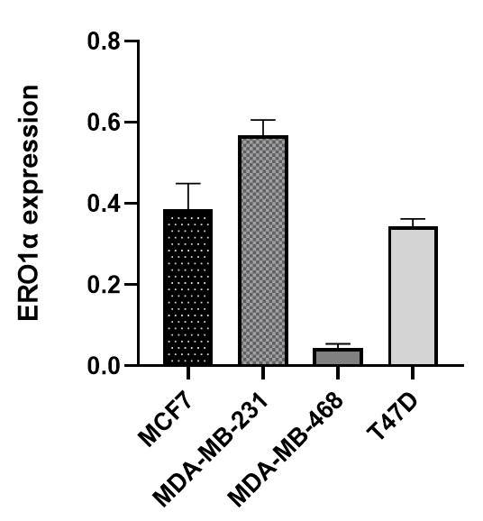
Mohamad Aljofan^{1,2}, Kamilla Khojayeva¹. Department of Biomedical Sciences, School of Medicine, Nazarbayev University¹, Astana, Kazakhstan; Drug Discovery and Development, Center of Life Sciences, National Laboratory Astana², Astana, Kazakhstan.

Introduction. Endoplasmic reticulum oxidoreductin-1α (ERO1α) is an oxidase involved in protein folding and Reactive Oxygen Species (ROS) generation (Shergalis et al, 2020). It promotes epithelial-mesenchymal transition (EMT) (Chen et al, 2024) and links ER redox regulation to mitochondrial function and cancer progression (Bassot et al, 2023).
Aims. To evaluate ERO1α expression in breast cancer cell lines and assess the effect of the inhibitor EN460.
Methods. Western blotting was used to analyze ERO1α expression in MCF-7, T47D, MDA-MB-231, and MDA-MB-468 cells. Treatment with 40 µmol/L of EN460 was tested in normal and mitochondria-depleted MDA-MB-231 cells.
Results. ERO1α expression was highest in MDA-MB-231 cells, showing a ~1.5-fold increase over MCF-7 and T47D, and ~14-fold higher than MDA-MB-468 (ANOVA, P < 0.01). EN460 treatment reduced ERO1α in normal MDA-MB-231 cells to 0.25 ± 0.06 (31% of control, P < 0.01), but had no effect in mitochondria-depleted cells.
Discussion. These findings suggest that ERO1α overexpression drives the aggressive phenotype of MDA-MB-231 cells, and that EN460 inhibits ERO1α via a mitochondria-dependent mechanism. Targeting this pathway may offer a strategy to suppress EMT and invasiveness in breast cancer.

Bassot A et al (2023) Cell Rep. 42:111899.
Chen P et al (2024) J Exp Clin Cancer Res. 43:71.
Shergalis AG et al (2020) Pharmacol Ther. 210:107525.

