**Spectroscopy of Single Nanocrystals**

*Paul Mulvaney*

ARC Centre of Excellence in Exciton Science, School of Chemistry, University of Melbourne,

Parkville, VIC., 3010 Australia.

Semiconductor nanocrystals exhibit size-tunable, emission spectra. However, their luminescence is punctuated by blinking, i.e. random on-off events and spectral diffusion. This is partly due to ionization of the nanocrystal which leads to formation of trions – negatively or positively charged particles. These trions emit weakly due to Auger recombination. However, a second pathway is possible to account for blinking - recombination through surface traps. I show that both have different statistical signatures and that these co-exist.

In the first part of the talk, I discuss the two mechanisms that account for quantum dot blinking. I show that both mechanisms can be operative in the same nanocrystal. I will also show that a micro-mirror can be used to deliberately modulate the blinking. Indeed, non-blinking can be achieved, albeit with low quantum yield.

In the second part, I present results on the systematic injection of electrons into CdSe quantum dots to create trions.  Under a high cathodic bias, injection becomes diffusion limited and the number of electrons being injected can be calculated from the Cottrell equation. Electron injection is reversible, showing that deep traps are relatively rare in CdSe nanocrystals.

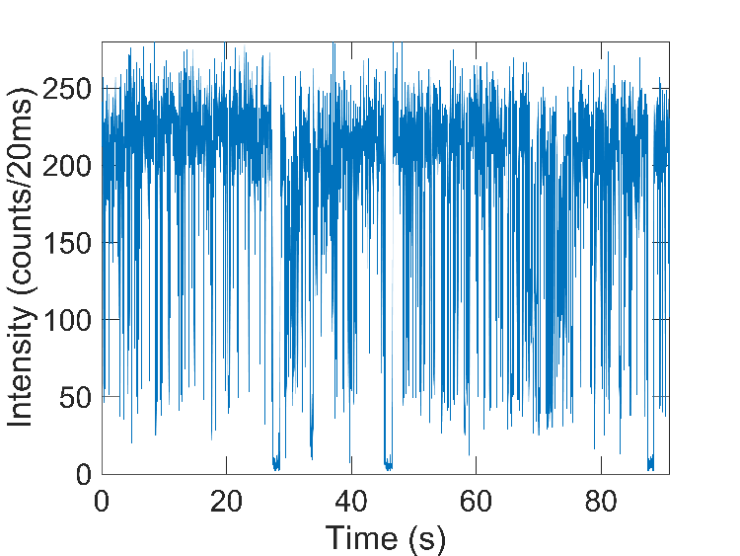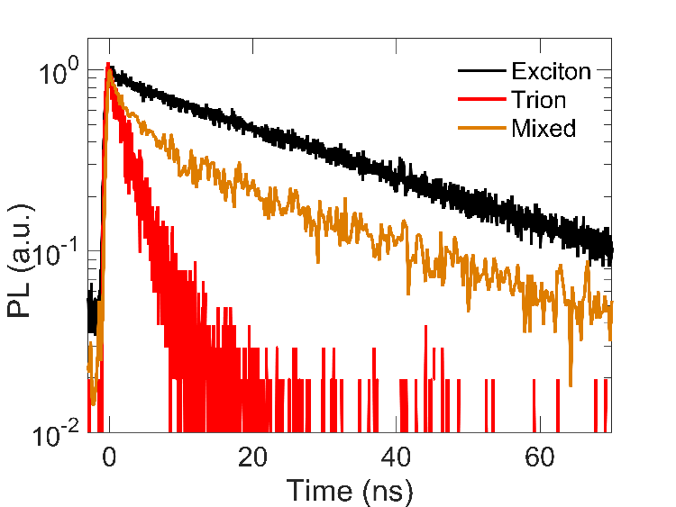

**PL time trace**

**X**

**X\***

**PL decays**

**X**

**X\***

Figure 1: Typical time traces for a single CdSe quantum dot showing fluctuations in intensity and lifetime.

**Acknowledgement**

Financial support from the Australian Research Council through grant CE170100026 is greatly appreciated.

**References**

1. Yuan, G.; Gómez, D.; Kirkwood, N. & Mulvaney, P. (2018). Tuning single quantum dot emission with a micromirror. Nano Letters 18, 1010–1017.
2. Yuan, G.; Gómez, D.; Kirkwood, N.; Boldt, K.; & Mulvaney, P. (2018). Two mechanisms determine quantum dot blinking. ACS Nano 12, 3397–3405.