Micro-solid bubble assembly for ultralight, strong, and superelastic materials

Pil Jin Yoo^{A}
^{A} School of Chemical Engineering, Sungkyunkwan University (SKKU), Suwon, Korea.

Advanced materials with low density and high strength have transformative impacts in construction, aerospace and automobile industries. These materials are realized with integrating well-designed modular building units into interconnected structures. Here, we present a hierarchical design strategy to demonstrate a new class of carbon-based closed-cellular structures (CCS). The building units are prepared by a multi-scale approach starting from functionalized graphene oxide nanosheets, leading to the microfluidic synthesis of solid-shelled bubbles with shape diversity at the micro-scale, followed by the assembly into meso-scale 3D structures. Subsequently, these are transformed into self-interconnected and structurally-reinforced CCS, resulting in graphene lattices with rhombic dodecahedral honeycomb structures at the centimeter-scale. The 3D suprastructure simultaneously exhibits the Young’s modulus above 300 kPa while retaining a light density of 7.7 mg/cm3 and the elasticity against up to 80% of the compressive strain. The fabricated 3D CCS opens a new pathway for designing lightweight, strong, and superelastic materials.

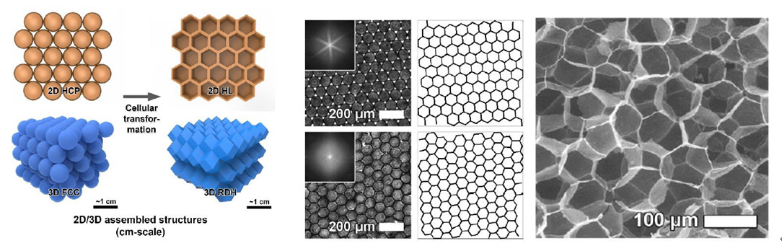
Figure 1. Formation of complete-space-filling 3D structures using micro-solid bubble assembly

References
- Yeo, S. J., Oh, M. J. & Yoo, P. J. (2018). Structurally controlled cellular architectures for high performance ultra-lightweight materials. Adv. Mater. 30, 1803670.
- Yeo, S. J. & Yoo, P. J. et al. (2018) Plesiohedral cellular network of graphene bubbles for ultralight, strong, and superelastic materials. Adv. Mater. 30, 1802997.
- Ho, D. H. & Yoo, P. J. et al. (2019) Ultra-lightweight strain-responsive 3D graphene network. J. Phys. Chem. C. 123, 9884-9893.

