What lies beneath - PBPK modelling to support subcutaneous administration of Anakinra in preterm neonates
Jia Li¹, Carl Kirkpatrick¹. Monash Institute of Pharmaceutical Sciences, Monash University¹, Melbourne, VIC, Australia
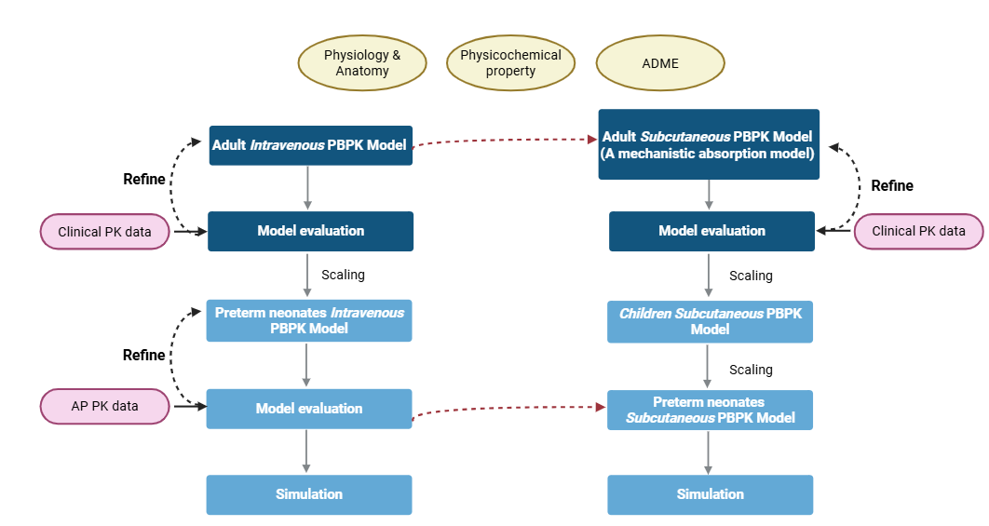
Introduction. Anakinra (IL1Ra) is approved for subcutaneous (SC) administration for chronic inflammatory diseases in adults & paediatric populations. There is growing evidence that IL1Ra may ameliorate complications associated with inflammation of prematurity i.e., 24-28 weeks post menstrual age. However, the distinct physiological features of premature neonates in skin composition, perfusion & organ function, can significantly alter absorption, distribution, metabolism & excretion (ADME) processes, particularly influencing drug absorption via SC route. Indeed, due to skin fragliity current clinical practice does not recommend SC in preterm neonates.
Aim. To develop a physiologically based pharmacokinetic (PBPK) model of IL1Ra in preterm neonates (preterm) to support the dose posology for an intravenous (IV) to SC switch at >2 weeks PNA.
Methods. Using PK-Sim and MoBi, a preterm IV PBPK model of IL1Ra to characterise the elimination was developed by scaling an optimised whole-body PBPK model. A preterm SC PBPK model was then developed incorporating a mechanistic absorption model, including adjusted lymphatic flow, capillary density, and SC site volume.
Results. The scaled PBPK models with mechanistic absorption described the pharmacokinetics (PK) of IL1Ra following IV and SC dosing. At birth, the kidney plasma clearance of IL1Ra in preterm neonates was 23.3% relative to adults, i.e., 0.03 L/h/kg and 0.15 L/h/kg, respectively. The SC model predicted an earlier time to maximum concentration (T_{max}) in neonates compared to adults (i.e., 3 h vs. 4 h).
Discussion. This PBPK model for IL1Ra describes IV and SC dosing, providing valuable insights for PK and dose posology in preterm neonates. The model provides a quantitative foundation to guide future clinical development and optimised dosing strategies in this vulnerable population.

