**ZnO nanostructures for gas sensing of formaldehyde: effect of surface oxygen**

*Michelle J S Spencer*

ASchool of Science, RMIT University, GPO Box 2476, Melbourne Victoria 3001 Australia.

corresponding author: michelle.spencer@rmit.edu.au

**Introduction**

Detection of pollutant gases, such as formaldehyde (HCHO), in our homes and environment is of high importance for health and safety. Zinc oxide (ZnO) is one of the most widely used metal oxides in sensing devices to detect gaseous pollutants such as HCHO, which is readily present around us (Spencer 2010). ZnO has traditionally been used as a thin film in sensing devices, which operates by measuring a change in conductivity due to the interaction between the gas and the surface of the sensor material. The development of nanostructures of ZnO as gas sensors has become of great interest due to their cheap synthesis methods, high structural and electrochemical stability. The adsorption of HCHO on a number of non-defect ZnO nanostructures has been examined (Tran and Spencer 2017), however, the effect of surface defects, which play an important role in the gas-surface reactions, is largely unknown.

**Aims**

Density functional theory calculations are used to determine the effect of pre-adsorbed oxygen on the gas-sensor surface reaction of HCHO on ZnO nanowires (NW) and facetted nanotubes (FNT).

**Methods**

Density functional theory calculations are performed using VASP, Quantum Espresso and SIESTA, using a generalised gradient approximation (GGA) with the Perdew, Burke and Ernzerhof (PBE) functional, and PAW pseudopotentials. Van der Waals forces were calculated using Grimme’s D3 method. *Ab initio* molecular dynamics calculations were performed using VASP.

**Results & Discussion**

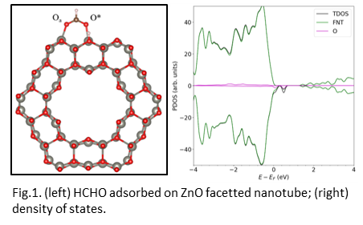CHCO adsorbs in multiple sites and orientations on the ZnO nanowire and facetted nanotube, associatively and dissociatively. In the molecularly adsorbed form, both singly and doubly coordinated adsorption geometries are stable (Fig.1). In general, the presence of the pre-adsorbed O atom was shown to enhance the stability of the adsorbed structures, having stronger binding energy values compared to the stoichiometric structures. On the FNT, the application of temperature can remove the pre-adsorbed oxygen, “cleaning” the ZnO surface through the reaction with HCHO, thus enhancing the recyclability for gas sensing applications.

**Conclusion**

The surface reaction of HCHO with ZnO nanostructures is not simple and cannot be classified using just one reaction. This work has shown that it can be influenced by the nanostructure morphology as well as the presence of defects on the surface of the nanostructure. This information should be useful for further experimental development of nanosensors for sensing of formaldehyde.

**References**

1. Spencer, M J S (2010). Gas sensing applications of 1D-nanostructured zinc oxide: Insights from density functional theory calculations. Progress in Materials Science, 57, 437-486.
2. Tran, H T T, Spencer, M J S (2017). Zinc oxide for gas sensing of formaldehyde: Density functional theory modelling of the effect of nanostructure morphology and gas concentration on the chemisorption reaction. Materials Chemistry and Physics, 193, 274-284.