Mechanism underlying lactate release from astrocytes in brain ischemic tolerance
Yuri Hirayama¹, Schuichi Koizumi^{2,3}, Naohiko Anzai¹. Dept. Pharmacol., Grad. Sch. Med., Chiba Univ.¹, Chiba, Japan; Dept. Neuropharmacol., Interdisciplinary Grad. Sch. Med., Univ. Yamanashi², Yamanashi, Japan; GLIA center, Univ. Yamanashi³, Yamanashi, Japan.

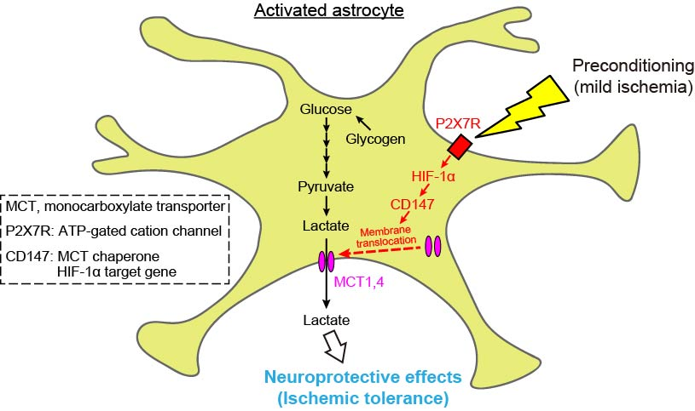
Introduction. Brain ischemic tolerance refers to an endogenous neuroprotective phenomenon whereby a non-lethal ischemic episode, termed preconditioning (PC), induces resistance to a subsequent severe ischemic injury. We have previously reported that PC activates astrocytes and subsequently upregulates P2X7 receptors (P2X7Rs), thereby leading to ischemic tolerance. However, the downstream signals of P2X7Rs that are responsible for PC-induced ischemic tolerance remain unknown.
Aims. To clarify a molecular mechanism underlying astrocytic P2X7R-mediated ischemic tolerance.
Methods. In in vivo experiments, unilateral transient focal ischemia was induced in mice by right middle cerebral artery occlusion (MCAO). Using an MCAO mouse model combined with a microdialysis technique, we measured extracellular lactate levels by inserting a probe into the ipsilateral striatum. In in vitro experiments, we used primary cultures of astrocytes.
Results. Extracellular lactate levels during severe ischemia were significantly increased in mice who experienced PC; this increase was dependent on P2X7Rs. In addition, the intracerebroventricular injection of lactate protected against cerebral ischemic injury. In in vitro experiments, although stimulation of astrocytes with the P2X7R agonist BzATP had no effect on the protein levels of monocarboxylate transporter (MCT) 1 and MCT4 (which are responsible for lactate release from astrocytes), BzATP induced the plasma membrane translocation of these MCTs via their chaperone CD147. Importantly, CD147 was increased in activated astrocytes after PC, and CD147-blocking antibody abolished the PC-induced facilitation of astrocytic lactate release and ischemic tolerance.
Discussion. Our findings suggest that astrocytes induce ischemic tolerance via P2X7R-mediated lactate release.

