Integrative Pharmacogenomics and Structural Equation Modeling Reveal Genetic Determinants of DOAC Therapy
Thi-Phuong-Thao Pham ¹, Hai-Anh Ha ², Chin-Chuan Hung ^{1,3}
¹ Department of Pharmacy, College of Pharmacy, China Medical University, Taichung, 406040, Taiwan.
² Faculty of Pharmacy, school of Medicine and Pharmacy, Duy Tan University, Danang 550000, Vietnam.
³ Department of Pharmacy, China Medical University Hospital, Taichung, 404332, Taiwan.

Background and aims. Genetic variability plays a critical role in determining the pharmacokinetics and clinical efficacy of direct oral anticoagulants (DOACs), yet pharmacogenomic guidance is still lacking in clinical practice. This study systematically evaluates how specific gene polymorphisms influence DOAC therapy, aiming to advance precision medicine in anticoagulation.

Methods. A systematic review adhering to PRISMA-2020 guidelines (PROSPERO ID: CRD42024592412) analysed 31 studies. Structural Equation Modelling (SEM) in R Studio (v2024.12) was used to examine genetic variants related to DOAC pharmacokinetics and treatment outcomes. PCA clustering further strengthened the analysis.

Results. SEM result (see Figure 1) revealed that genetic factors positively influenced drug concentration dynamics (β = 0.24), which in turn strongly impacted clinical outcomes (β = 1.10), while higher drug exposure (Cmax/Cmin) was associated with increased bleeding risk (β = 1.00), and gene variants were inversely related to ischemic stroke (β = –0.17). The structural equation model demonstrated high fit (CFI = 0.997, RMSEA = 0.037, see Table 1). Variants in ABCB1, CES1, ABCG2, CYP3A4, and SLCO1B1 were associated with altered drug exposure and bleeding or stroke risk. Specific alleles reduced clinical event risks to below 20 – 40%, depending on the DOACs and genotype (see Figure 2). PCA identified two patient clusters (see Figure 3): Low Risk (stable pharmacokinetics, minimal adverse events) and Moderate Risk (variable drug exposure, elevated complications).

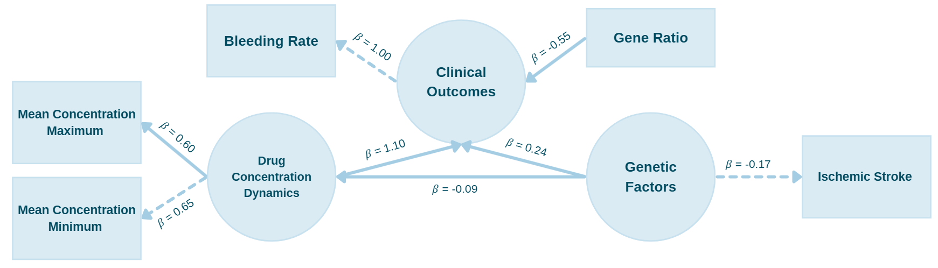  Figure 1. SEM of Genetic Influence on DOACs Outcomes. |  | Table 1. SEM Model Fit Summary  Parameter Value  CFI / TLI 0.996 / 0.986  RMSEA (90% CI) 0.047 (0.000–0.104)  p (RMSEA ≤ 0.05) 0.445  SRMR 0.031
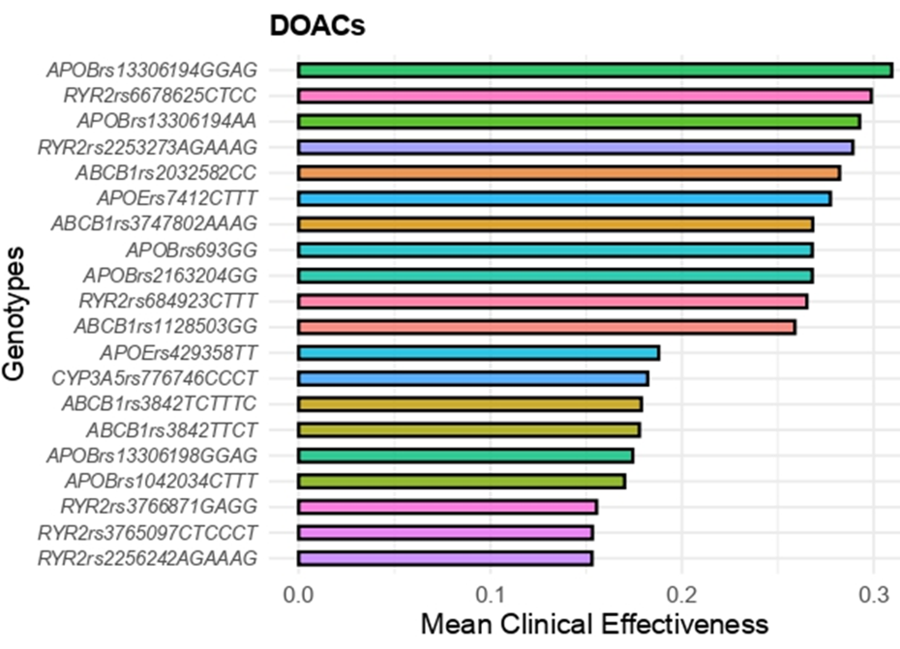  Figure 2. Top Genotypes Associated with DOACs Clinical Effectiveness | 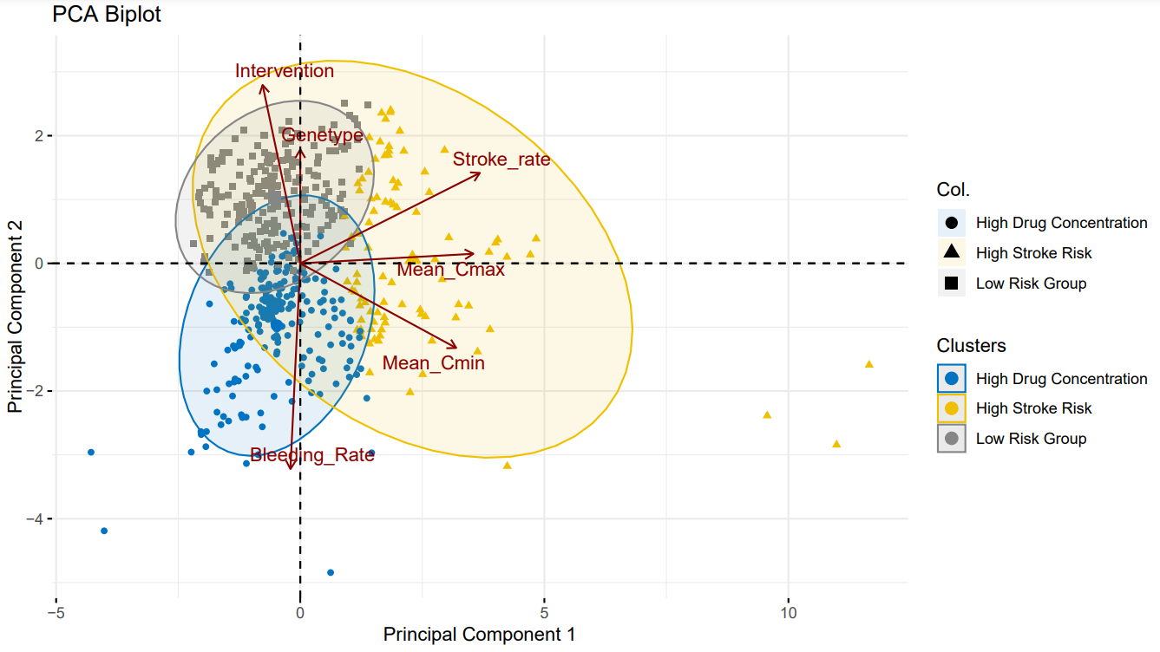  Figure 3. PCA Plot with Cluster Annotations

Conclusion/Discussion. Genetic polymorphisms significantly influence DOACs response. Integrating pharmacogenomic testing with therapeutic drug monitoring can enhance treatment precision, paving the way toward more personalized anticoagulation strategies.
References:
- Shi, J., et al. (2023). Journal of Clinical Pharmacology, 63, 277–287.
- Wu, T., et al. (2023). Human Genomics, 17, 59.
- Raymond, J., et al. (2019). Journal of Personalized Medicine, 9, 7.
- Cullell, C., et al. (2018). Oncotarget, 9, 10115–10127.

